The Kenya Reptile Atlas
A free, downloadable atlas of Kenya’s reptiles. This is a free source of regularly updated information on Kenya’s Reptiles. Authors: Stephen Spawls, Beryl Bwong, Patrick Malonza, Vincent Muchai, Victor Wasonga
Obtainable under ‘downloads’ at Kenyareptileatlas.com
This project is funded by the Rufford Foundation under the auspices of the National Museums of Kenya; Department of Herpetology.

The Kenya Reptile Atlas offers you:
Pictures of Kenya’s reptiles
Distribution maps by quarter-degree-square
A description of the species

Click on any of the titles listed under the downloads tab to download for free. The various families will be added as the accounts are completed.

If you have any observations of Kenya’s reptiles, any distribution records, or any other data, or any digital pictures, we would like to receive them! Send them to Kenyareptileatlas@gmail.com
And if you live or travel in Kenya, and find any dead reptiles, please preserve them and take them to the Herpetology Section, at the National Museum, Museum Hill, Nairobi.
The team thanks those who kindly commented upon the text or loaned us pictures; including Sanda Ashe, Bill Branch, Anthony Childs, Tomas Mazuch, David Modry, Eduardo Razzetti, Roberto Sindaco, Jan Stipala, Royjan Taylor, Colin Tilbury, Lorenzo Vinciguerra.
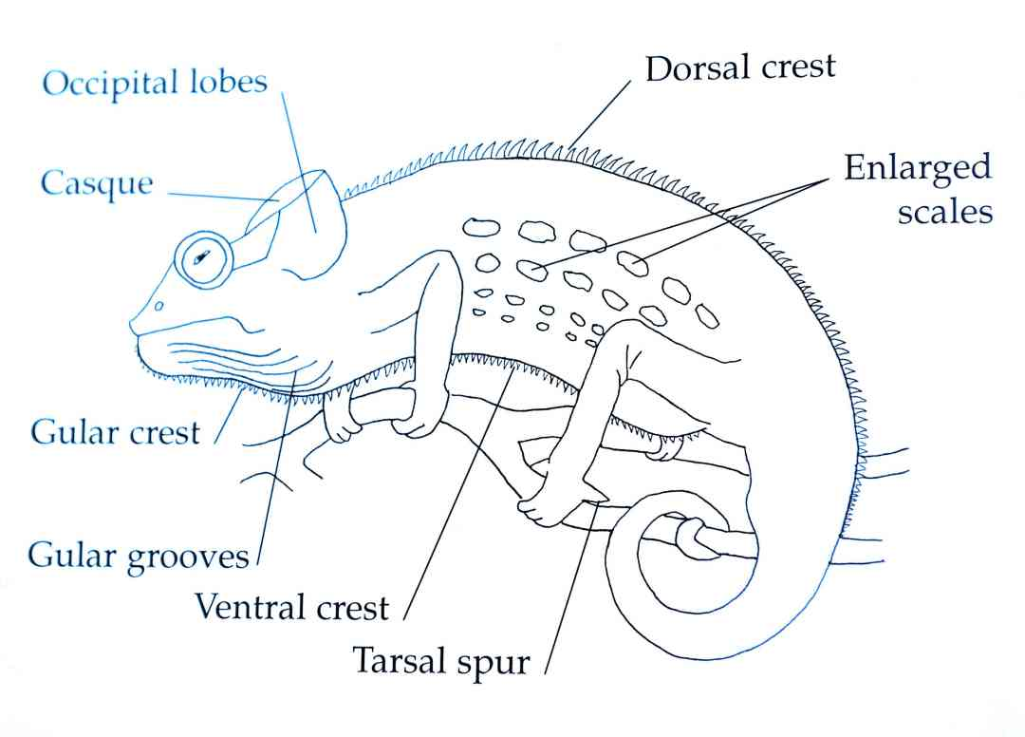
Some essential points of chameleon anatomy. (© Jonathan Spawls; after de Witte)
Chameleons in Kenya:
Chameleons are unusual lizards; they have a prehensile, non-sheddable tail, a telescopic tongue longer than their bodies, to shoot at prey. They have clawed grasping feet and independently swivelling eyes. They can change colour, usually to express their emotional state but also to help blend into the background; angry chameleons often show vivid or dark colours. Their slow movements and unusual shape contribute to their mystique; many people are afraid of chameleons, believing that they may bring some sort of bad luck, while some believe they are venomous. In reality, all chameleons are harmless and beneficial, they eat insect pests.
So far, about 115 species of chameleon are recorded in Africa, and 85 or so in Madagascar. Evidence from DNA (and the absence from Madagascar of the sister group Agamidae) indicates that chameleons originated in Africa and rafted (probably twice) to Madagascar. Some 24 species of chameleon are presently known for certain from Kenya, (and possibly one introduced species), but of these 24, seven have been described in the last 20 years and four recently recorded for the first time, so it is certain that undiscovered and undescribed chameleon species occur within the country; we discuss this in the second chameleon file; Atlas Chameleons 2.
Several species of Kenyan chameleon have strange head ornamentation; horns and nasal protuberances. The purpose of these is debated; horns may be used for fighting, or serve as camouflage, to break up the head outline. Kenyan chameleons can often be identified fairly easily by a combination of size, head ornamentation (or the lack of it) and locality; no less than 15 species of Kenyan chameleons have quite small ranges.
Chameleons1: Pygmy chameleons, and chameleons of the genus Kinyongia and Chamaeleo.
Pygmy Chameleons: A group of small, short-tailed, largely brown chameleons that occur in sub-Saharan Africa and Madagascar, mostly in forests and woodlands of the southeast, often on mountains (one species, Rieppeleon kersteni has adapted to savanna). Their taxonomy has changed over the years. Arthur Loveridge placed all species in the genus Brookesia. In 1986, Charles Klaver and Wolfgang Boehme restricted the name Brookesia to Malagasy chameleons, and placed all African Brookesia in the genus Rhampholeon. Conrad Matthee, Colin Tilbury and Ted Townsend, in 2004, further split this into two genera, Rhampholeon and Rieppeleon, the former containing three subgenera. At last twenty species of Rhampholeon are known (one in Kenya); Rieppeleon has three species, two known from Kenya. More will soon be described; see our notes at the end of Chameleons 2.
Boulenger’s Pygmy-Chameleon Rhampholeon boulengeri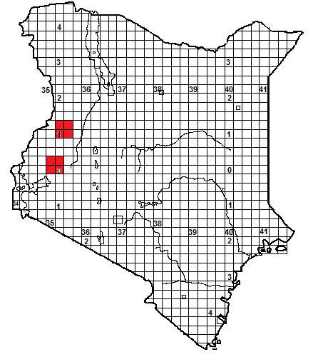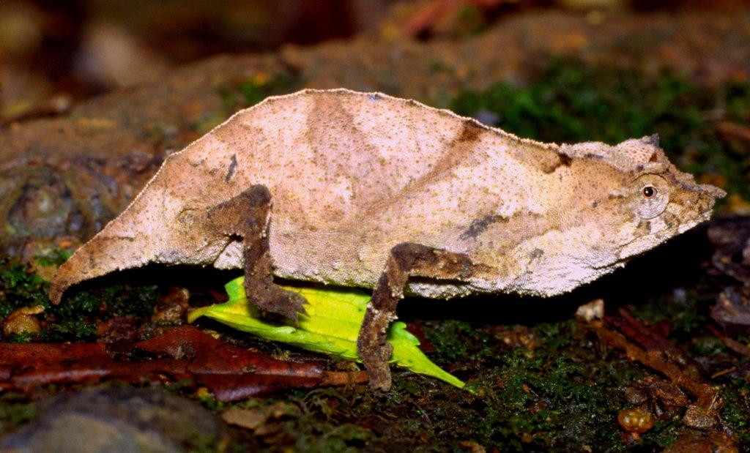
Identification: A tiny brown, grey or pinky-brown chameleon with a small soft horn and a prominent spiky crest above each eye. Tail very short. Average size 5-7 cm, maximum about 8 cm.
Distribution: A forest species, in Kenya known from Kakamega Forest, the North Nandi Forest and the forested slopes of the Cherangani Hills. Elsewhere occurs in Uganda and eastern Congo; some Congo specimens are very dark in colour.
Natural History: Usually on the ground by day, at night climbs into low vegetation. Said to be associated with streams and clearings in the forest. Moves slowly, may sham death, if handled will produce a burst of vibrations, like an electric shock, caused by exhaling minute amounts of air. Lays from 1-3 eggs, eats a range of small arthropods.
Conservation Significance: Protected in Kakamega Forest, and in the National Parks of southwest Uganda.

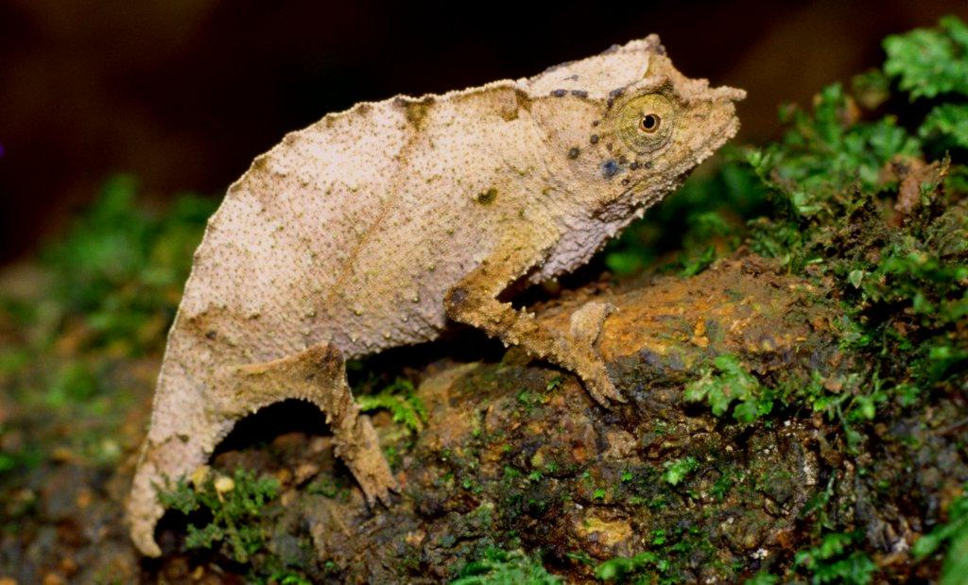
All photographs: Kakamega Forest; © Colin Tilbury

Bearded Pygmy-Chameleon Rieppeleon brevicaudatus
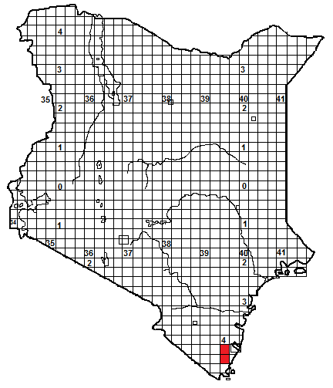
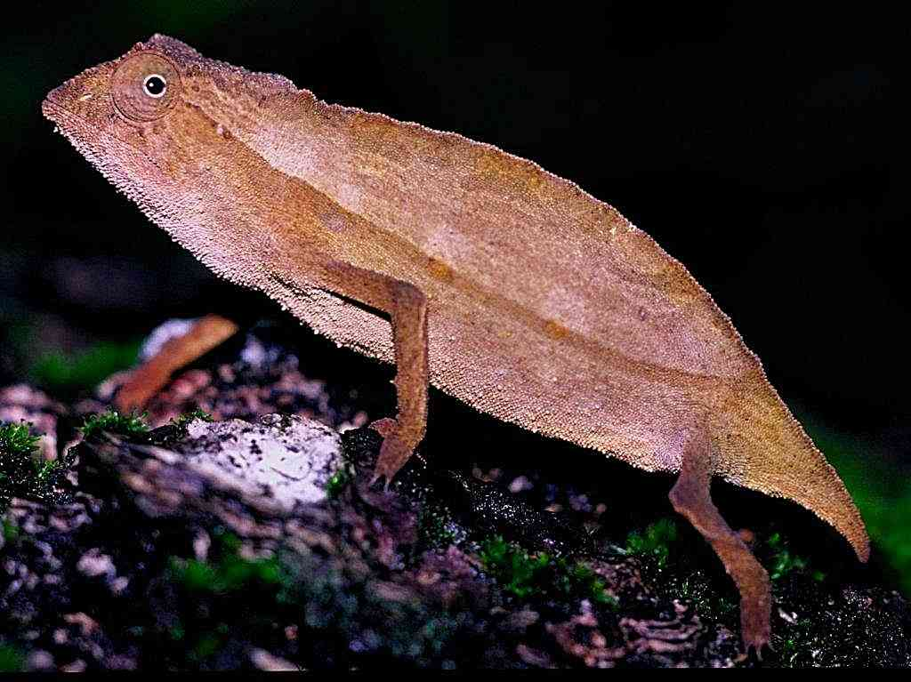
Female: Shimba Hills © Colin Tilbury

Local Names: Probably called Kanakalumbwe (Mijikenda), as this is also used for Rieppeleon kersteni.
Identification: A small, striped brown or pinky-brown chameleon without horns but with a tiny chin tuft of spiky scales. Tail very short, and thick in males. Average size 5-8 cm, maximum about 9 cm.
Distribution: In evergreen forest and coastal thicket. In Kenya, known only from the Shimba Hills. Elsewhere occurs in coastal and south-east Tanzania.
Natural History: Usually on the ground by day, climbing into low vegetation at night. Moves slowly, may sham death, if handled will produce a burst of vibrations, like an electric shock, caused by exhaling minute amounts of air. Lays up to 9 eggs, gravid females in Tanzania were found in September/October. Eats small arthropods.
Conservation Significance: Protected in the Shimba Hills National Park.
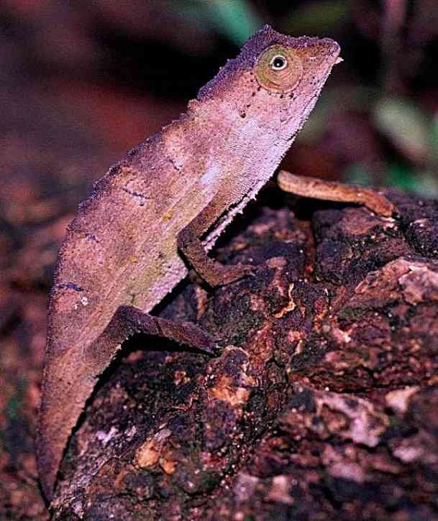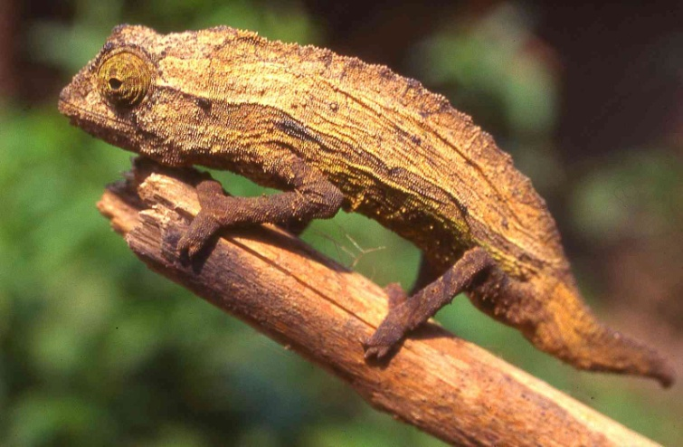
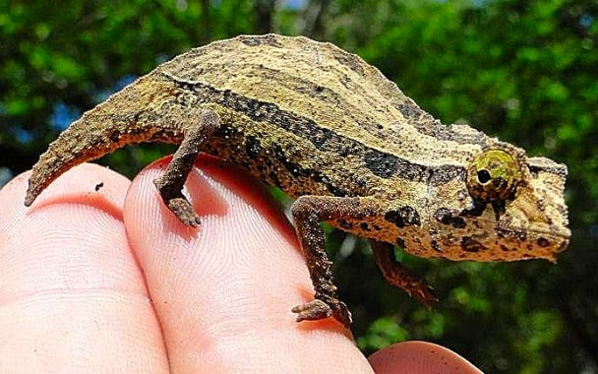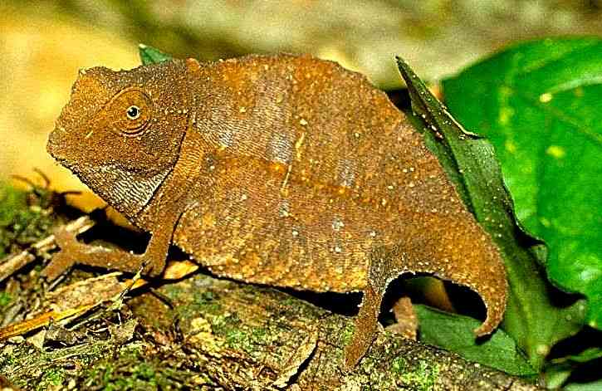
Photographs © Colin Tilbury, except above right (Stephen Spawls) and bottom left © Royjan Taylor, all specimens from Shimba Hills except top right Usambara Mountains; all males except bottom right).
Kenya Pygmy-Chameleon Rieppeleon kersteni
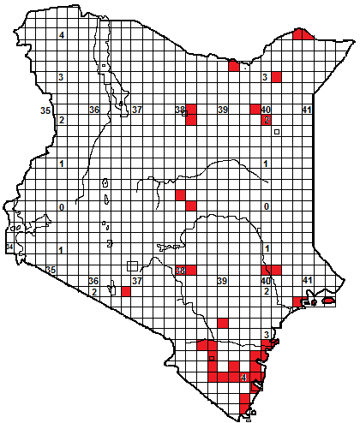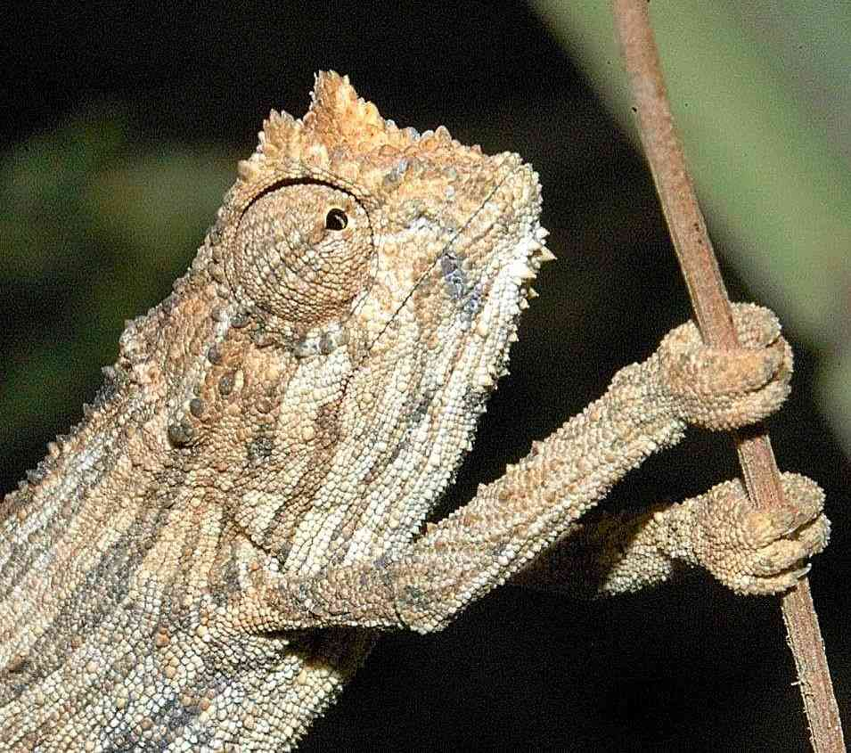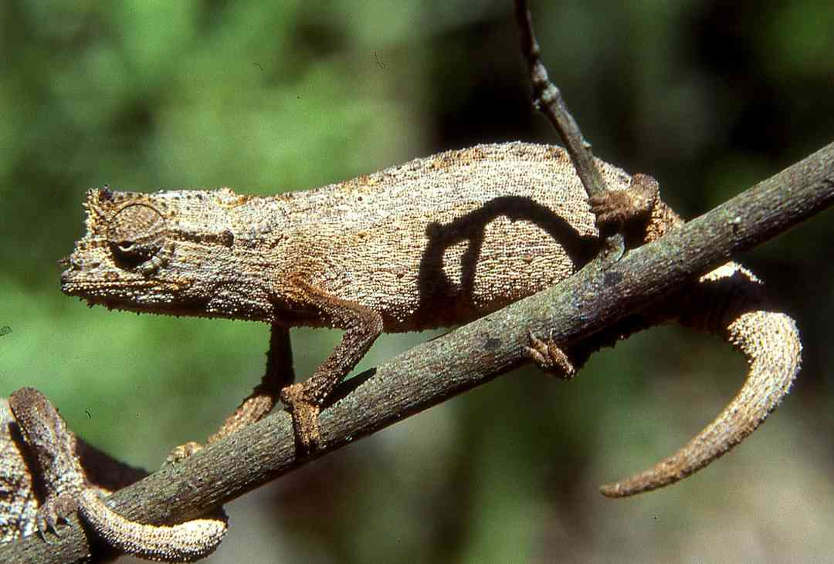
Local Names: Kanakalumbwe (Mijikenda), Lumvivi (KiPokomo), Jirjiroolaha (Somali), Garrara lafa (Boran).
Identification: A small brown, tan, grey or pinky chameleon, often striped, without horns but has little tufts of spiky scales on the tail, the chin, face and prominent raised eyebrows. Tail short, and thick in males. Average 5-8 cm, maximum about 10 cm.
Distribution: Coastal woodland and thicket, moist and dry savanna and semi-desert. Occurs along the coast, inland records include south-east Kenya, parts of Tsavo National Park, westernmost record Elangata Wuas. Sporadic records from northern Kenya, probably much more widespread but undetected. Those from Kenya’s northern border represent the subspecies Rieppeleon kersteni robecchii (some researchers regard it as a full species) with larger ‘eyebrows’ and vivid striping. Elsewhere, found in northern Tanzania, Somalia and eastern Ethiopia.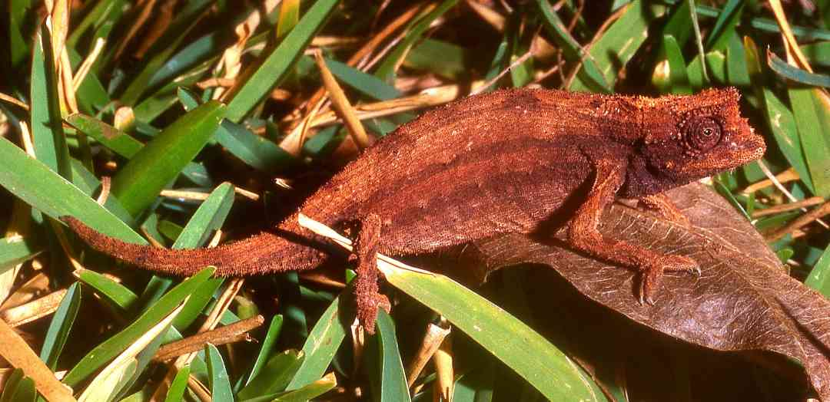
Natural History: Usually on the ground by day, at night climbs into low vegetation. Moves slowly, may sham death, if handled will produce a burst of vibrations, like an electric shock, caused by exhaling minute amounts of air. Lays up to 9 eggs, gravid females in Tanzania were found in September/October. Eats small arthropods.
Conservation Significance: Protected in the following national parks: Shimba Hills; Tsavo East, Tsavo West, Malka Murri. Its huge distribution across northern Kenya, in areas that are essentially unexploited, means it is unlikely to be under any threat. 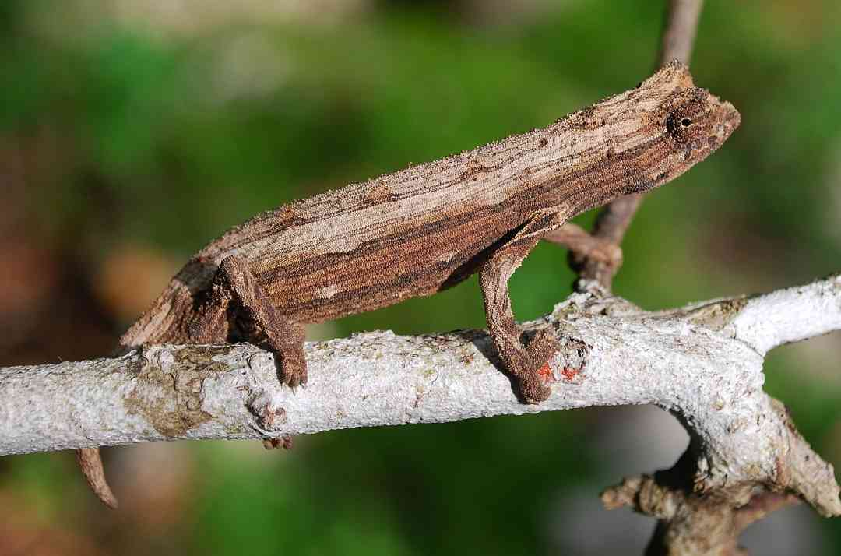
Photographs: Top Ethiopian specimen R. k. robecchii, (picture © Tomas Mazuch), Lower Top and above; Watamu, S Spawls, middle northern Tanzania © Lorenzo Vinciguerra.
East African Chameleons: Kinyongia
A genus of about 18 chameleons, found in highland East Africa and the eastern Congo. Over 10 species occur in the Eastern Arc Mountains of Tanzania and southern Kenya, and several of these were regarded as forms of the species Chamaeleo fischeri. Five species of Kinyongia occur in Kenya. The generic name, a Latinisation of the Swahili word kinyonga, meaning chameleon, was coined in 2006 by Colin Tilbury, Krystal Tolley and Bill Branch in a paper in the journal Zootaxa (1363; pp 23-38); before this all members of the genus were in Chamaeleo, (some were also placed in Bradypodion). Several species in the genus have elaborate projections or horns on their noses.
Mt Nyiro Bearded Chameleon Kinyongia asheorum
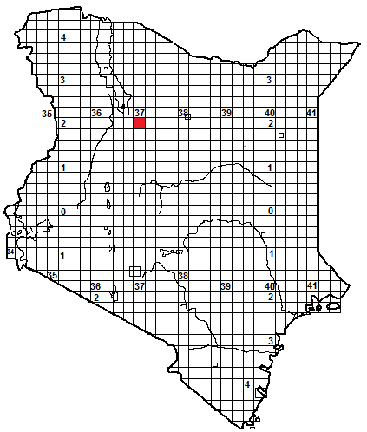
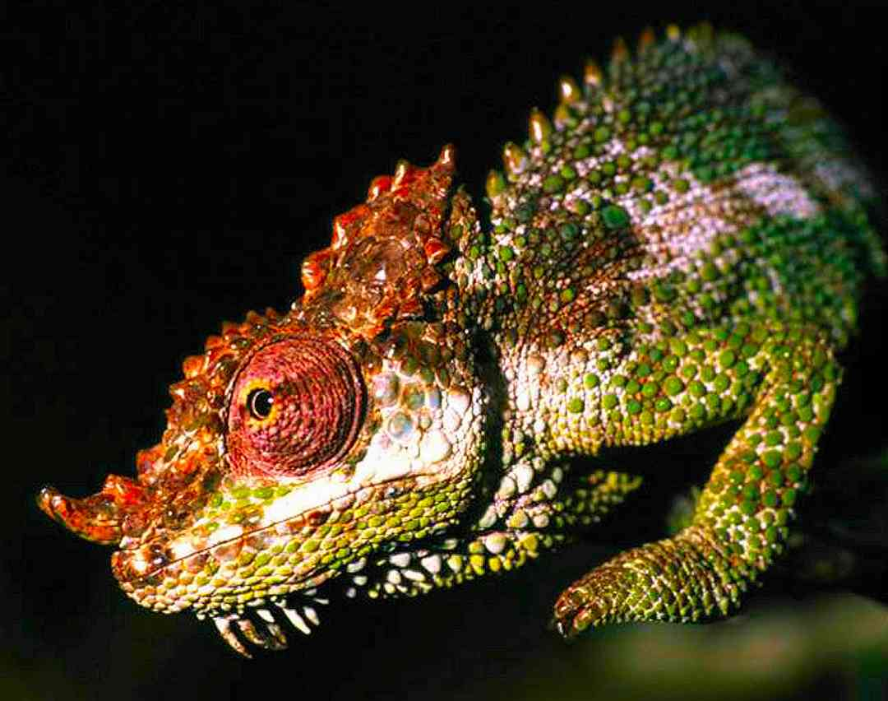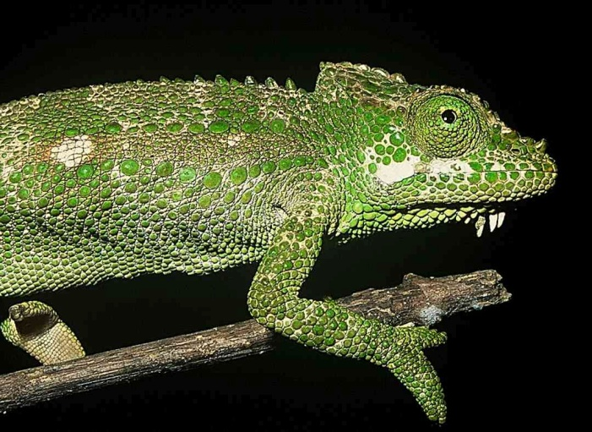
Pictures: Male left ( © Roberto Sindaco), female right ( © Tomas Mazuch)
Identification: A small slender chameleon, the male has a pair of soft horns, and both sexes have a beard of elongate gular scales. The tail is long, around 60% of total length. Largest known specimen was about 22 cm. The species was named for James and Sanda Ashe, Watamu-based herpetologists, who helped snakebite victims for 35 years.
Distribution: In the high forest of Mt Nyiro, which is roughly 50 km south of the southern end of Lake Turkana, in northern Kenya. Occurs at an altitude of 2000-2450 m, in bushes and trees.
Natural History: A diurnal, arboreal species. Little is known of its biology; it was first described in 2009. Presumably lays eggs and eats a range of small arthropods.
Conservation Significance: A restricted, vulnerable, endemic species; known only from one mountain. Its habitat, Mt Nyiro, is a gazetted 45 000 hectare forest reserve, but the degree of protection of such reserves in Kenya varies a lot; Mt Nyiro is under pressure from loggers, pastoralists and fires. Another unique species of chameleon, Trioceros ntunte, also lives on Mt Nyiro, in the moorland above the forests over 2 500 m.
Female: Mt Nyiro ( © Tomas Mazuch)
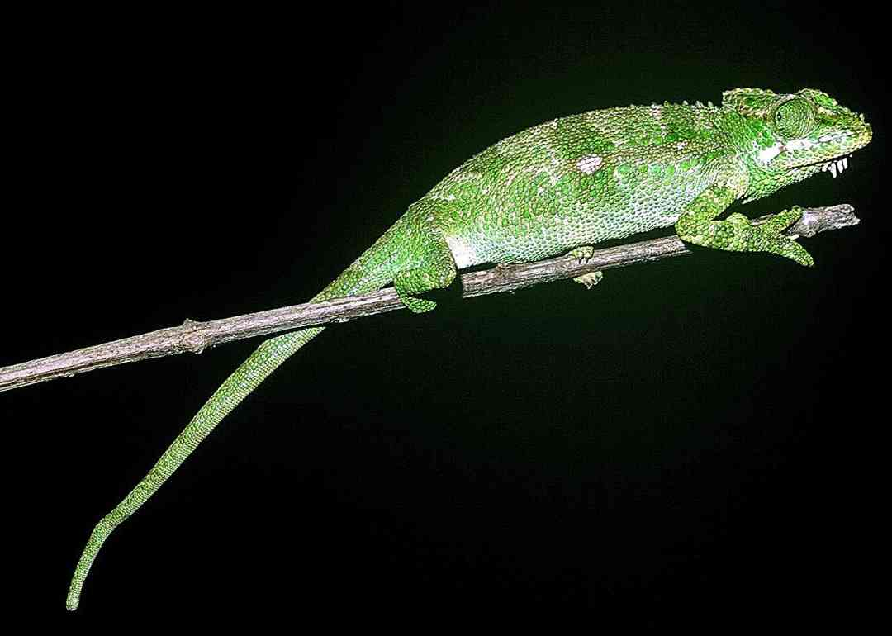

Taita Hills Blade-horned Chameleon Kinyongia boehmei
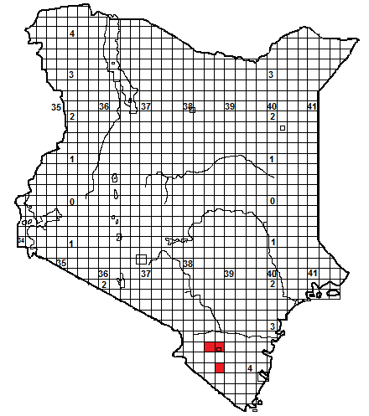
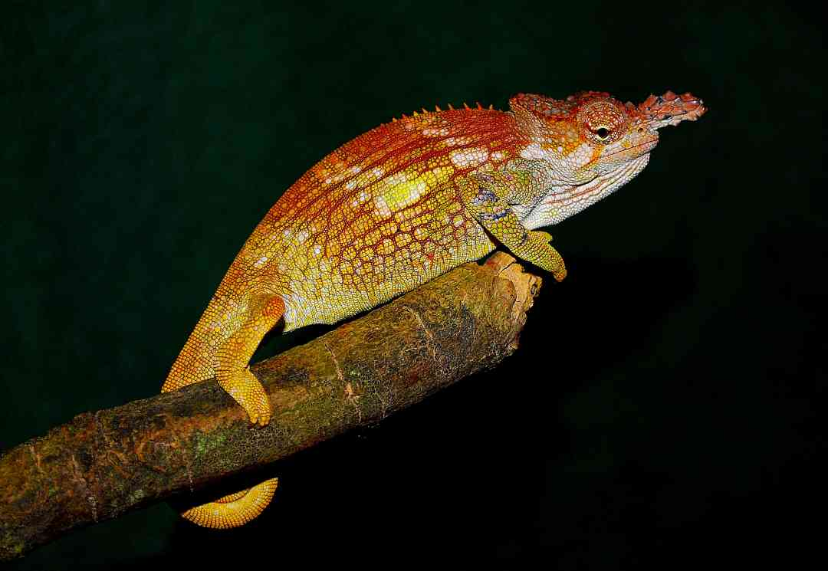
Local Names: Malunge (KiTaita).
Identification: A small chameleon, reaching a total length of about 20 cm. The male has a pair of blade-like horns, covered with small scales forming a serrated profile, and a slightly raised casque; the female has a small double projection on the nose. The males show a range of colours, females are usually green with the top of the head red. It has no gular crest. The tail is slightly over 50% of the total length.
Distribution: Found only in the woodland, forest, farms and gardens of the Dawida and Mt Mbololo blocks of the Taita Hills, Mt Sagalla and Mt Kasigau, in southeastern Kenya, between altitudes of 1 200 to just over 2 000 m.
Natural History: Diurnal, arboreal. They will ascend high in forest trees, but are equally happy in low bushes. Often almost abundant, within the town of Wundanyi they can be found a few metres apart, sheltering on roadside vegetation and in garden hedges. They lay up to 12 eggs. They eat a range of small arthropods.
Conservation Significance: A restricted endemic species. The indigenous forests of the Taita Hills, Mt Sagalla and Kasigau are greatly reduced to a few small patches. However, these patches are fairly well protected. In the actual forest, these chameleons are not very common, but happily, they are abundant in the surrounding agricultural vegetation, so their survival is probably assured. This chameleon has had several scientific names; initially Chamaeleo tavetanus, then Chamaeleo fischeri tavetanus, Bradypodion tavetanum, Bradypodion tavetanum boehmei, Kinyongia tavetanum boehmei, Kinyongia tavetana boehmei and finally Kinyongia boehmei; when it was finally realised that the population on Taita Hills, Sagalla and Kasigau represented a discrete species. 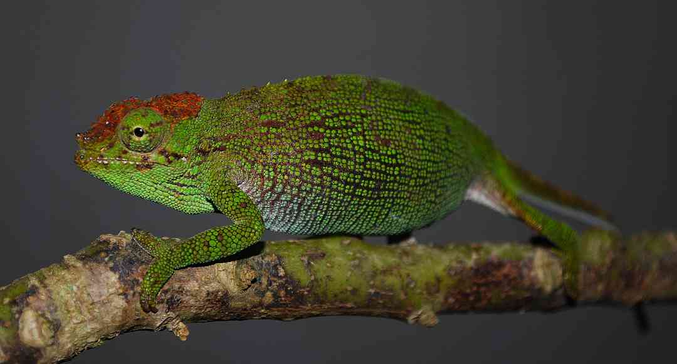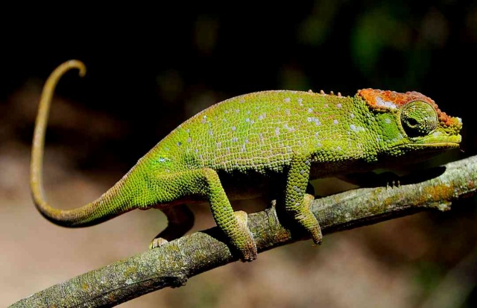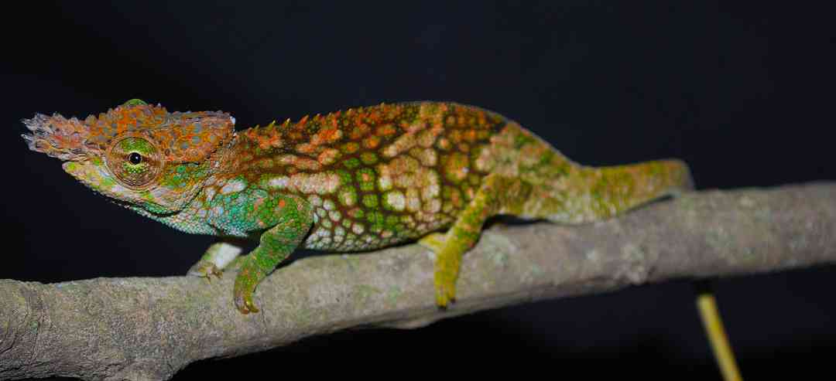
Pictures; all specimens from Taita Hills; male top, females centre, juvenile male bottom.
Mount Kenya Hornless Chameleon Kinyongia excubitor
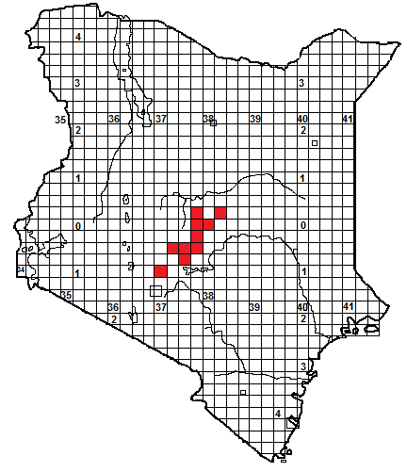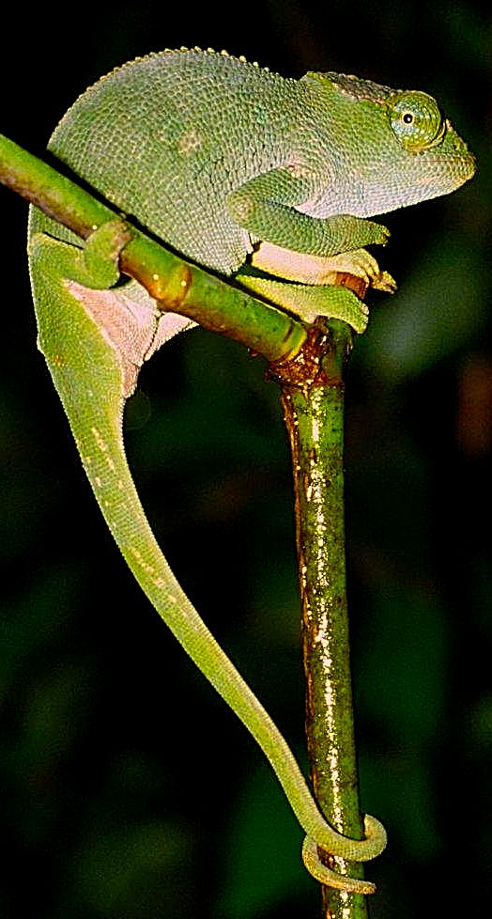
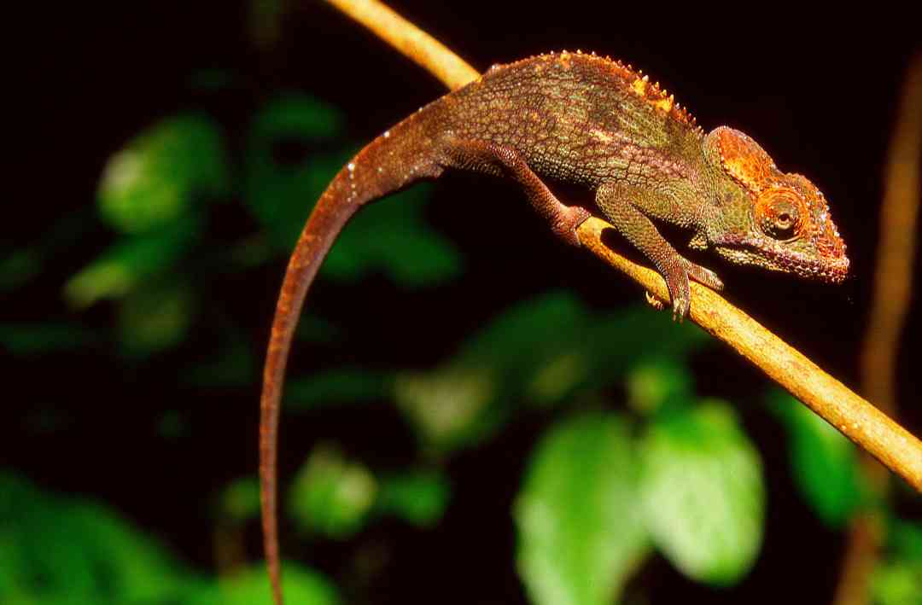
Identification: A small, slender-bodied chameleon, up to 24 cm in length, without horns, or a beard, or ear flaps, but has a broad raised casque. The casque of the female is smaller and her head scales less jagged. Usually greenish, sometimes red-brown. The tail is slightly over 60% of the total length.
Distribution: Mid-altitude forests of central Kenya, east of the rift valley, between 1 100 m and 2 400 m. Originally believed to be confined to the forests of Mt Kenya, from the Kerugoya area anticlockwise round to Meru, it has recently been discovered in the forests at the southern end of the Aberdares, the remaining forest of the Nyambene Hills in the Igembe and Ngaia Forest blocks, (Ngaia is southeast of the Nyambene Hills proper). Might occur in the mid-altitude forests on the lower eastern slopes of the Aberdares.
Natural History: A diurnal and arboreal species, found in shrubs and trees, ascending to 6 or 8 m. Quick moving and reportedly nervous; if pursued it will jump from its perch and curl into a ball in the undergrowth. They lay eggs but no other details known. They eat a range of small arthropods.
Conservation Significance: A restricted endemic species; known only from Kenya. Most of its habitat lies within forest reserves, (where the level of protection varies) but also found in the Mt Kenya National Park. Not apparently exploited for trade.
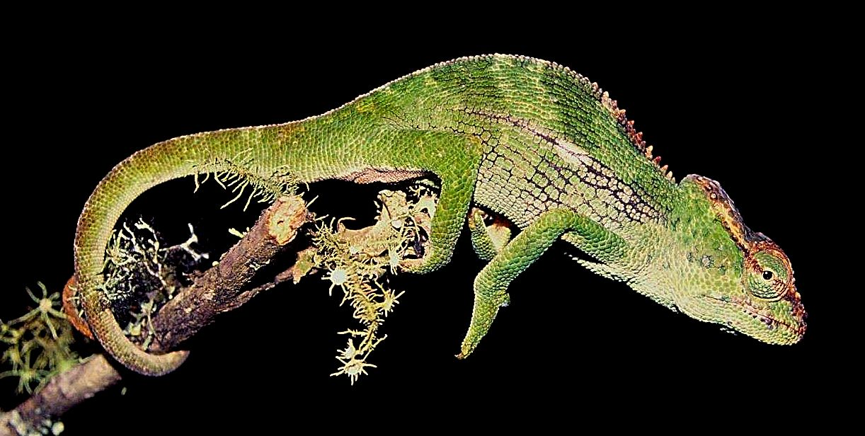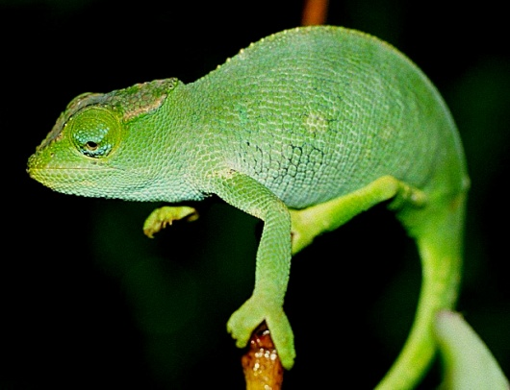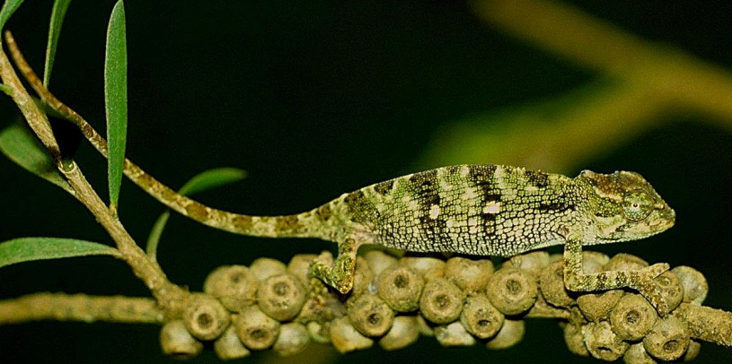
Pictures: Ist page, top right female, Meru, below male, Ngaia Forest, this page above male, below left female, right juvenile female, all Meru. All pictures © Colin Tilbury, except Ngaia Forest specimen, Stephen Spawls.

Mount Kilimanjaro Two-horned Chameleon Kinyongia tavetana
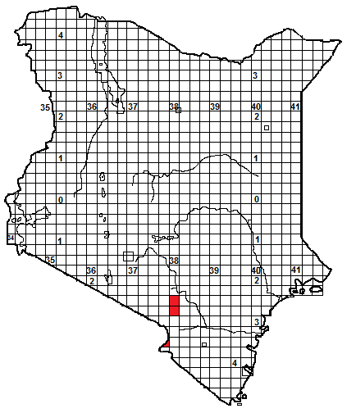
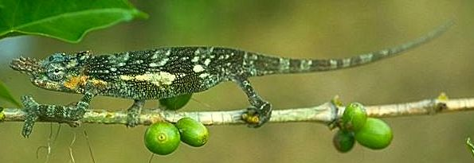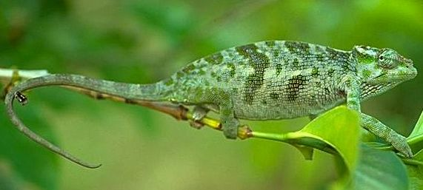
Local Names: Kiafuwe (Chaga; northern Tanzania), no Kenyan names known.
Identification: A small chameleon, up to 23 cm in length, the male has a pair of blade-like horns; the female has two tiny blunt projections on the nose. No gular or dorsal crest. The tail is slightly over 50% of the total length.
Distribution: In Kenya it is known only from the forest around Kibwezi (no museum specimens from this locality), the Chyulu Hills and the forest patches around Taveta, on the Tanzanian border at Mt Kilimanjaro; more widespread in the forests around Kilimanjaro on the Tanzanian side, also Mt Meru and the Pare Mountains. Altitudinal range from 880 m (Kibwezi) to around 2 200 m on the Chyulu Hills. Might occur in the forest blocks around Loitokitok. The isolated Chyulu animals might prove to be a different species.
Natural History: A diurnal and arboreal species, in shrubs and trees, both in primary forest and in altered habitats, including gardens, farmland and coffee plantations. In forest, they prefer the margins and glades, where there is more light. They lay up to 15 eggs, which in captivity hatch in four months. Diet arthropods.
Conservation Significance: Status in Kenya is poorly known. Recent work in the Chyulus and around Kibwezi failed to find specimens. The forest around Taveta has largely disappeared. However, its habitat is protected within the Chyulu Hills National Park (part of the Tsavo National Park system) and some small sections of the Kibwezi Forest are informally protected.
Taxonomic Notes: Originally described as Chamaeleon tavetanus, later Bradypodion tavetanum. It was thought to be the same species as Kinyongia boehmei, of the Taita Hills, but is morphologically and genetically distinct. 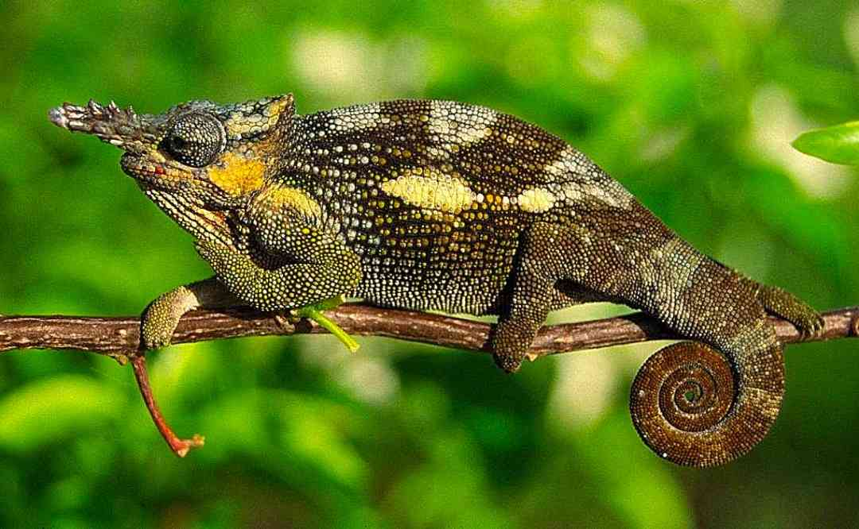Illustrations ;Tanzania (Mt Meru), top © Lorenzo Vinciguerra, lower © Colin Tilbury.
Usambara Soft-horned Chameleon/Usambara Flap-nosed Chameleon Kinyongia tenuis
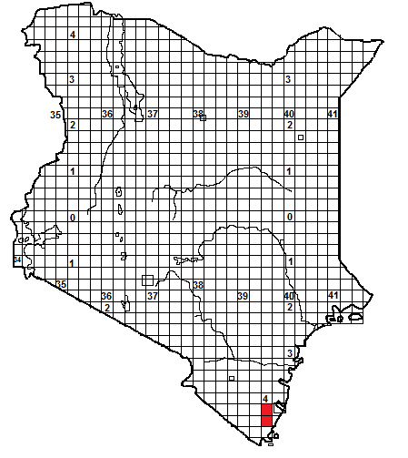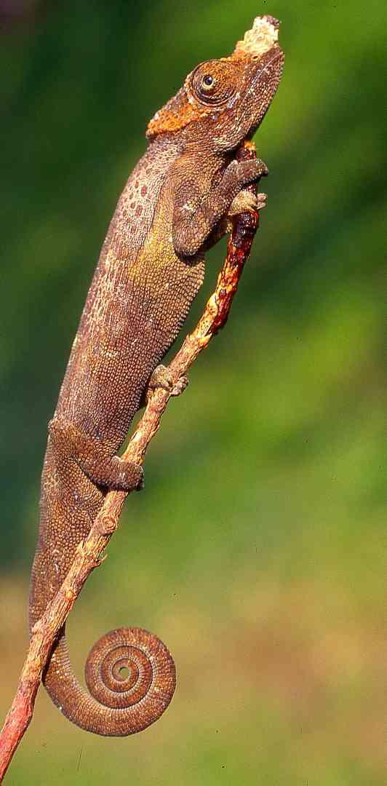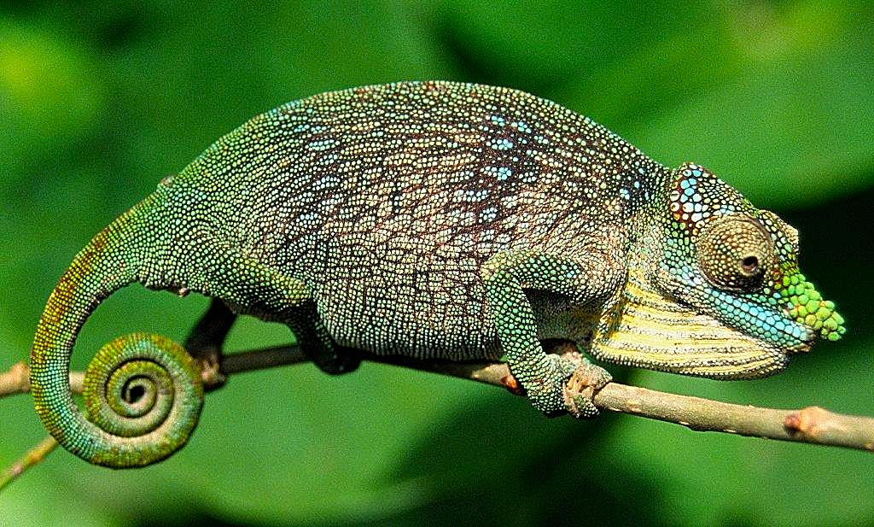
Identification: A small and slender chameleon, up to 15 cm in length with a small flattened horn or rostral process. There is no gular or dorsal crest. The thin tail is slightly over 50% of the total length.
Distribution: Inhabits lowland and sub-montane forest, in Kenya, known only from the Shimba Hills, also on the eastern Usambara Mountains in Tanzania.
Natural History: It is diurnal and arboreal, at the forest edge in shrubs and trees, using perch heights up to 6m above the ground; they have been found in long grass and low bushes. Very secretive, although they can be locally common. When threatened, they will jump from their perch. In forest, they seem to prefer the margins and glades, where there is more light. A Tanzanian specimen contained five eggs.
Conservation Significance: In Kenya, its habitat is protected in the Shimba Hills National Park.
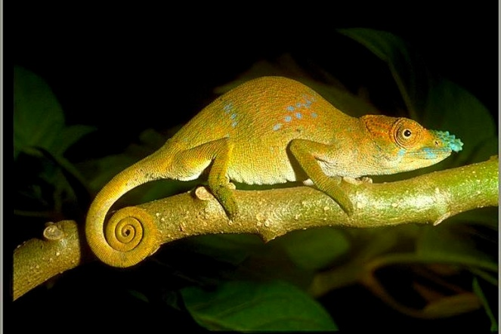Pictures: Top: Stephen Spawls, middle and bottom © Colin Tilbury; all from Usambara Mountains.
Savanna Chameleons: Chamaeleo
A genus of about 19 chameleons, widespread in the savannas and semi-desert of Africa, also in Europe on the northern shores of Mediterranean Sea, the Middle East, the Arabian peninsula, India and Sri Lanka. Three species of Chamaeleo occur in Kenya. All species in the genus are fairly big, some reaching 45 cm or more. They do not have horns or other head ornamentation, although some have occipital lobes and a short gular crest. Most species have large ranges.

Flap-necked Chameleon Chamaeleo dilepis.
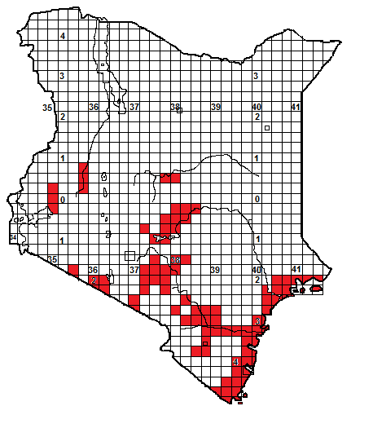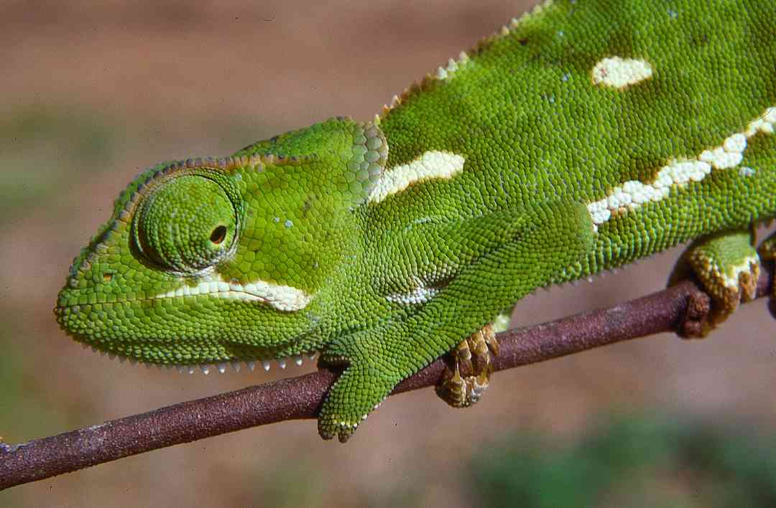

Local Names: Lumbwe (Mijikenda), Lumvivi (KiPokomo), Garrara (Boran), Aygea (Turkana), Kembu (Kikuyu/Kamba), Ong’ongruok (Dholuo), Ekhaniafu (Luhya), Nkototanki (Maasai).
Identification: A big chameleon, up to 43 cm in length, no horn but has small to large ear flaps, the body scales are largely homogeneous, but separated by tiny interstitial scales. Scales on the ear flaps are enlarged. The casque is slightly raised. Usually green, with darker bars when aroused, and a broad white stripe on the lower flank, but occasional brown, yellow and orange individuals are known.
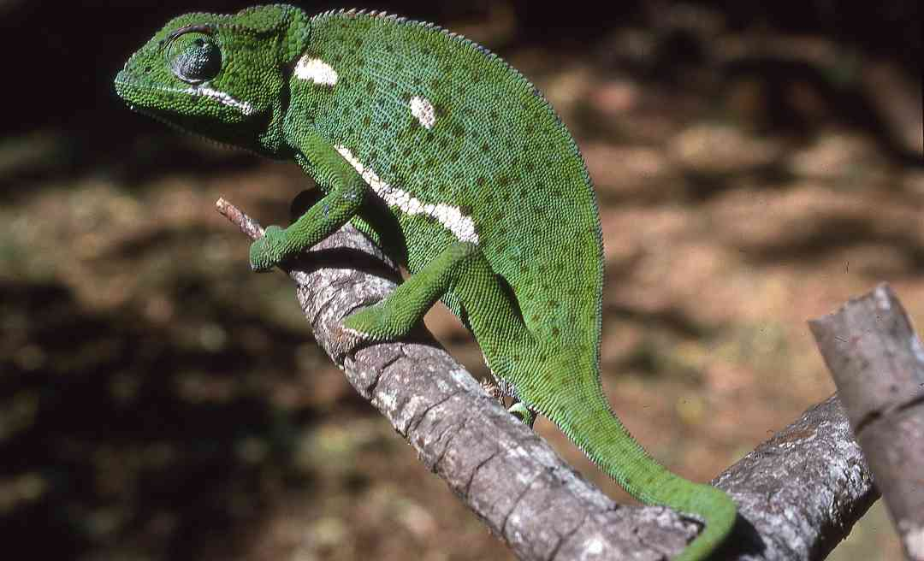
Distribution: In Kenya, widespread in coastal thicket and forest, wet and dry savanna, from sea level to about 1 500 m altitude, occasionally higher, for example, known from Sultan Hamud but not Nairobi, but is found at 2 200 m altitude in the Maasai Mara. Apparently absent from much of the dry north. In Tsavo, where it occurs with Chamaeleo gracilis, the slender chameleon, C. gracilis seems to be on the plains and the flap-necked chameleon on the hills.
Natural History: A diurnal and arboreal species, found in bushes and trees, will readily descend to the ground and often seen crossing roads and paths during the rainy season. Quite fast moving. If threatened and unable to escape, they will hiss, inflate the body, elevate the ear flaps and bite. In the mating season, the orange skin on the male’s gular grooves goes pale and the female will permit him to approach for mating. They lay up to 65 eggs, although 20-40 is more usual, in a tunnel dug by the female. Diet arthropods.
Conservation Significance: Widespread and found in a number of national parks, including the Tsavo system and the Shimba Hills.
Taxonomic Notes: Several subspecies have been named, some are thought by some taxonomists to be full species, for example Chamaeleo dilepis roperi, from Kilifi, and C. d. ruspolii, from Somalia, but these may simply represent local variation in a single species.
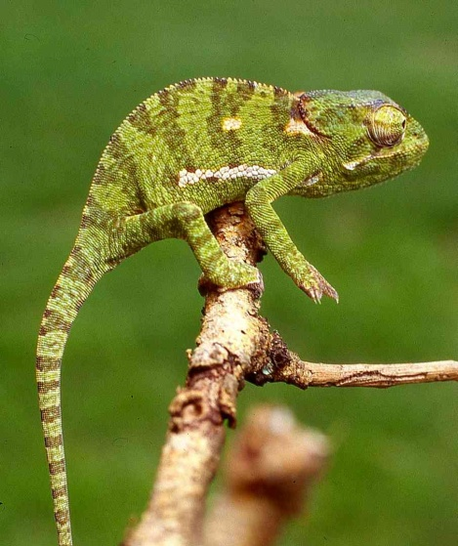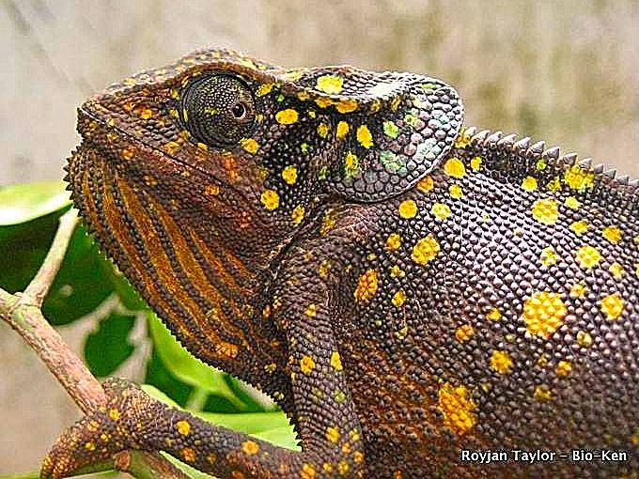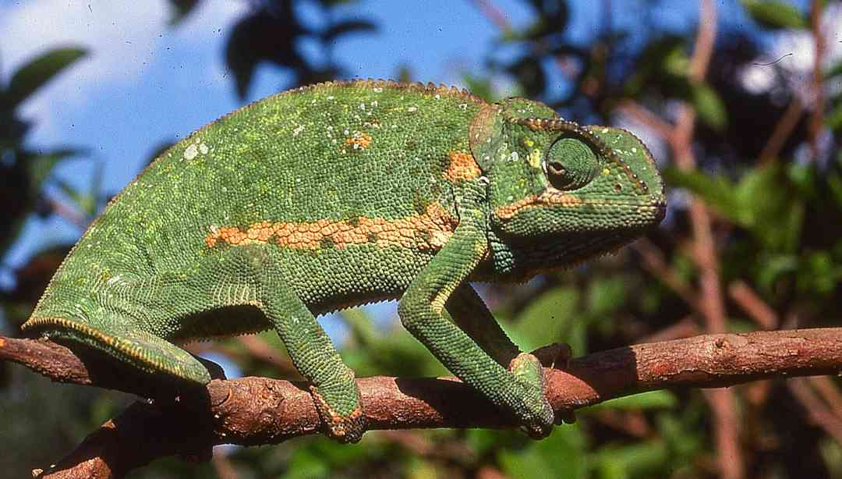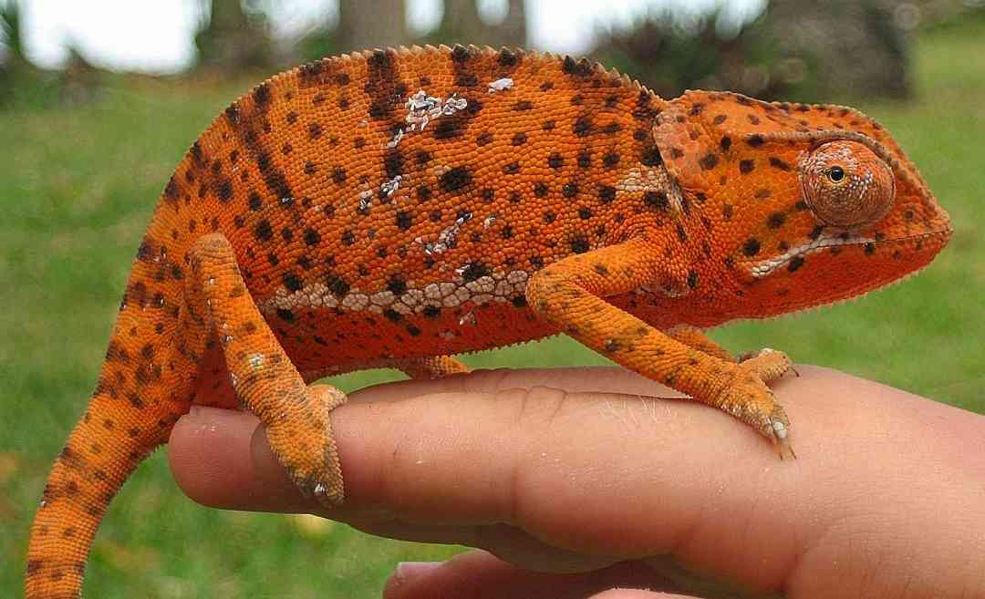
Pictures: Vipingo top, Ngulia lodge middle, above Maasai Mara(L) Watamu(R), Shimo-La-Tewa bottom left, Tiwi bottom right (both BR © Royjan Taylor/Bio-Ken)
Slender or Graceful Chameleon Chamaeleo gracilis
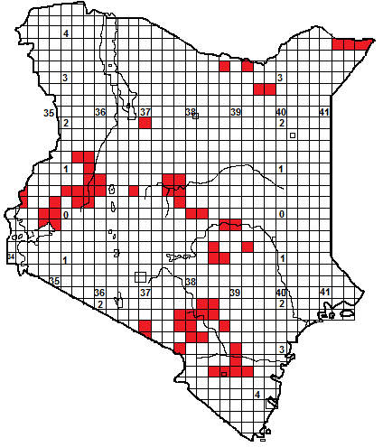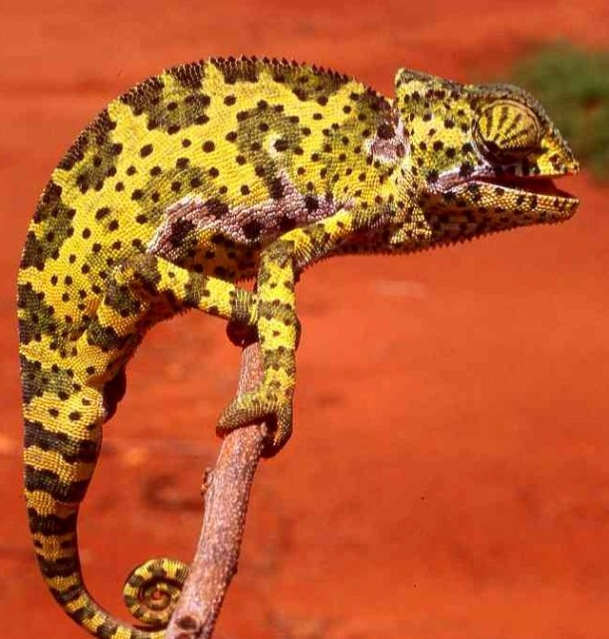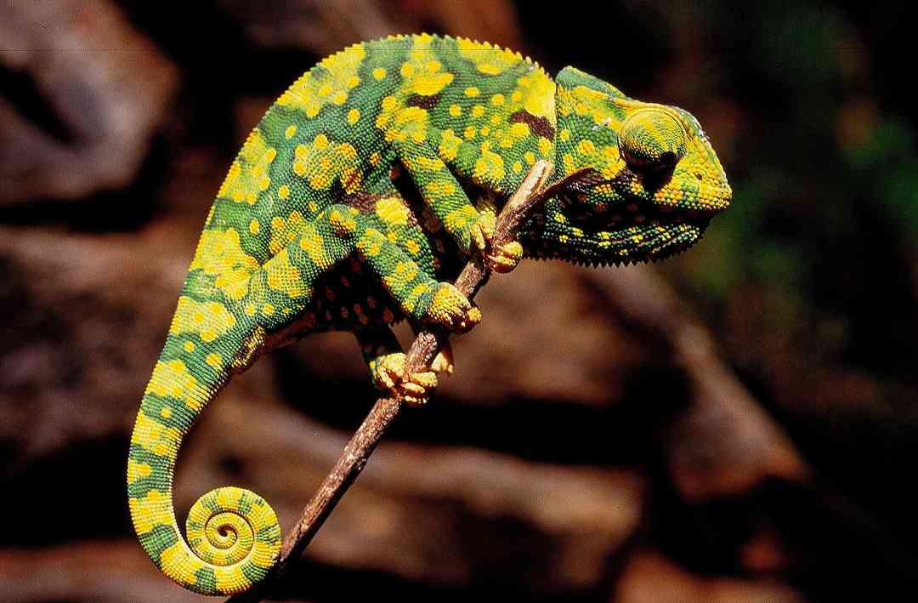

Local Names: Garrara (Borana), Jirjiroolaha (Somali)
Identification: A big chameleon, up to 35 cm in length, without head ornamentation. Very similar to the flap-necked chameleon ((and sympatric with it in eastern Kenya) but has no ear flaps (occasionally very tiny immoveable flaps may be present). The body scales are homogeneous, but with tiny interstitial scales. The casque is slightly raised. Colour: usually some version of green, yellow or brown, with semi-circular blotches along the spine. The males have tarsal spurs on their hind legs.

Distribution: In Kenya, widespread in moist and dry savanna. Sporadic records from the northeast, and in a crescent of country from Kakamega and the lakeshore eastwards, round Mt Kenya and south into Tsavo. In Tsavo, where it occurs with the flap-necked chameleon, it seems to be on the plains and the flap-necked chameleon on the hills, and absent from the coast, where C. dilepis is common..
Natural History: A diurnal and arboreal species, found in bushes and trees, will readily descend to the ground and often seen crossing roads and paths during the rainy season. Quite fast moving. If threatened and unable to escape, they will hiss, inflate the body and bite, it will also jump from its perch. Rival males fight, at least in captivity. The females lay up to 45 eggs, although 20-30 is more usual, in a tunnel dug by the female. Diet arthropods.
Conservation Significance: Widespread and found in a number of national parks, including the Tsavo system and the parks on the northern Uaso Nyiro..
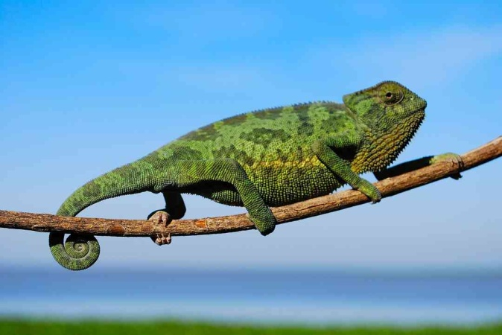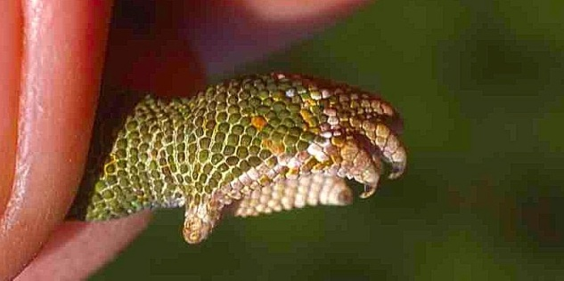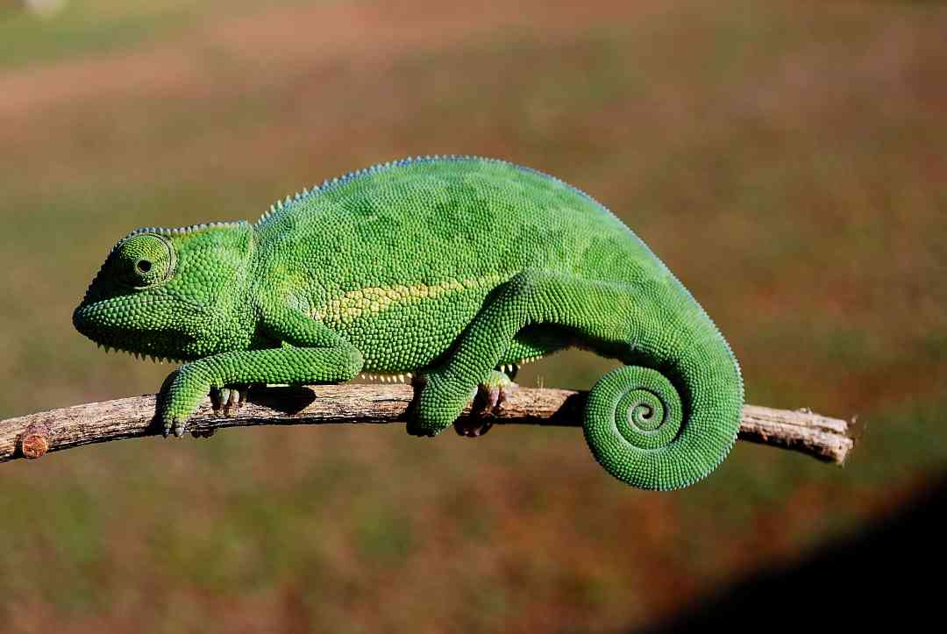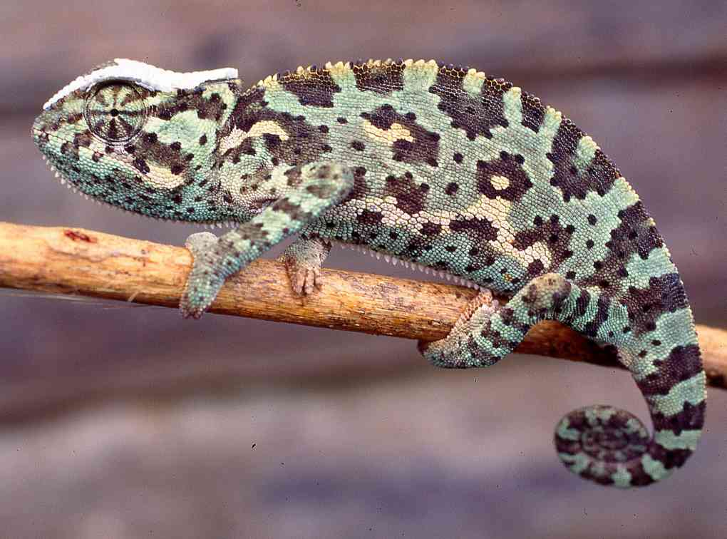
Pictures: Tsavo East, top, Kisumu middle left and bottom left, Moyale middle right (showing tarsal spur), Namanga bottom right.

Smooth Chamaeleon Chamaeleo laevigatus
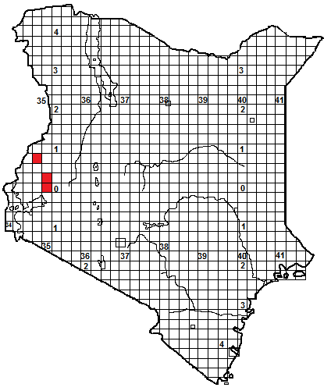
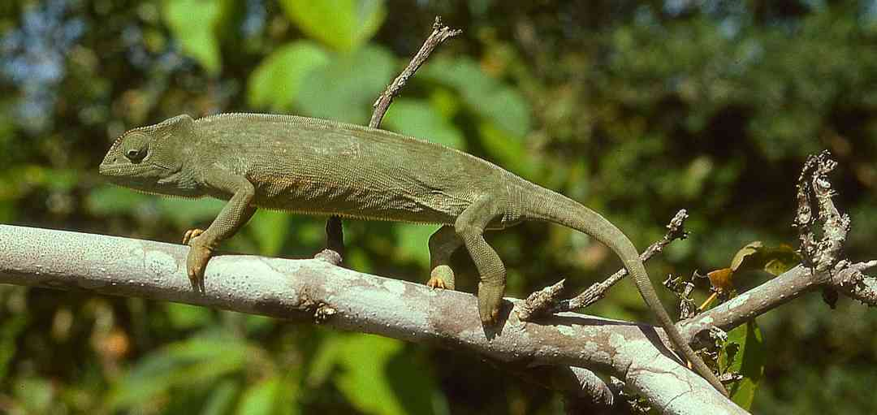
Identification: A medium-sized chameleon, up to 25 cm in length, without head ornamentation, the casque very slightly raised. Very similar to the slender chameleon, but has quite a short tail. The dorsal crest is minute or non-existent. The body scales are homogeneous, but with tiny interstitial scales. The casque is slightly raised. Colour: usually some version of green or whitish/brown.
Distribution: In Kenya, known only from a few records in the woodland and moist savanna of the west; from the Kakamega area and south of Mt Elgon. Also in Uganda, South Sudan, northeast Congo.
Natural History: Similar to the slender chameleon; a diurnal and arboreal species, found in bushes and trees, will readily descend to the ground and may be seen crossing roads and paths during the rainy season, sometimes found moving in quite treeless areas. Arthur Loveridge recorded a female with 60 eggs, although 20-30 is more usual, they are laid in a tunnel dug by the female. Diet arthropods.
Conservation Significance: In Kenya, protected in the Kakamega Forest. 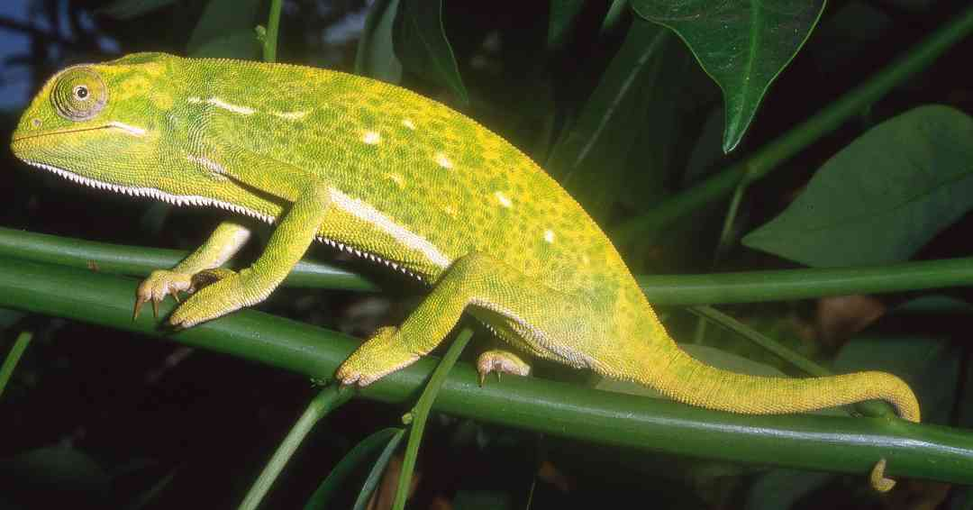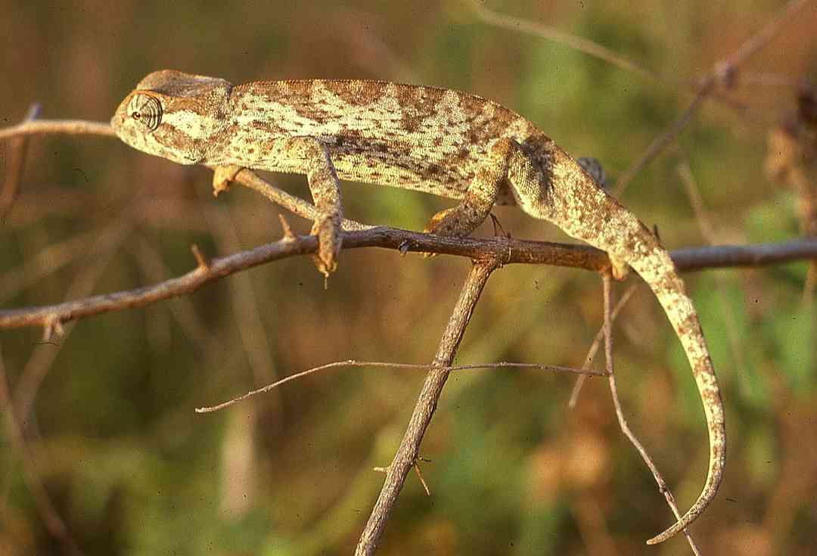
Pictures: South Sudan, except middle, from Bukoba, Tanzania (Middle picture © Lorenzo Vinciguerra).

