The Kenya Reptile Atlas
A free, downloadable atlas of Kenya’s reptiles. This is a free source of regularly updated information on Kenya’s Reptiles. Authors: Stephen Spawls, Beryl Bwong, Patrick Malonza, Vincent Muchai, Victor Wasonga
Obtainable under ‘downloads’ at Kenyareptileatlas.com
This project is funded by the Rufford Foundation under the auspices of the National Museums of Kenya; Department of Herpetology.
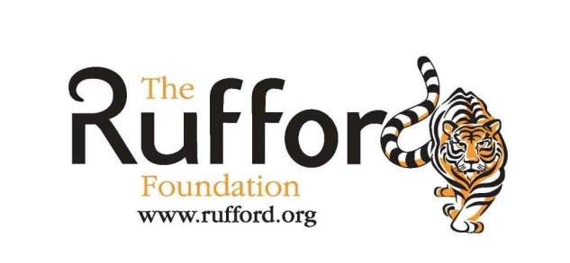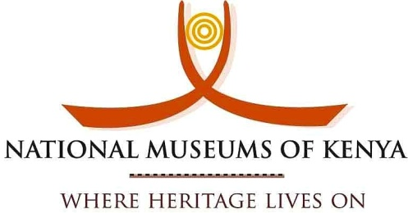

The Kenya Reptile Atlas offers you:
Pictures of Kenya’s reptiles
Distribution maps by quarter-degree-square
A description of the species

Click on any of the titles listed under the downloads tab to download for free. The various families will be added as the accounts are completed.

If you have any observations of Kenya’s reptiles, any distribution records, or any other data, or any digital pictures, we would like to receive them! Send them to Kenyareptileatlas@gmail.com
And if you live or travel in Kenya, and find any dead reptiles, please preserve them and take them to the Department of Herpetology, at the National Museum, Museum Hill, Nairobi.
The team thanks those who kindly commented upon the text or loaned us pictures; this includes Sanda Ashe of Bio-Ken at Watamu, Caspian Johnson and Barry Hughes.

Elapids 2 – Cobras and Gold’s Tree Cobra. All dangerous elapids.
James Ashe’s Spitting Cobra/Large Brown Spitting Cobra Naja ashei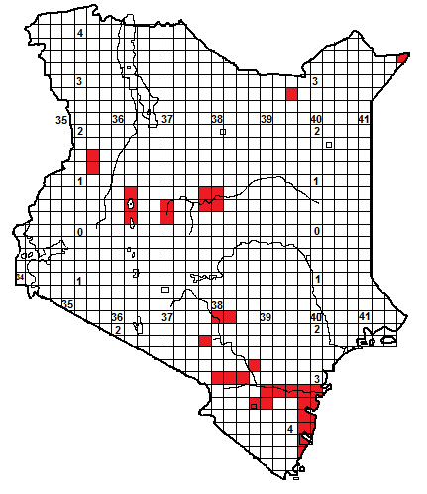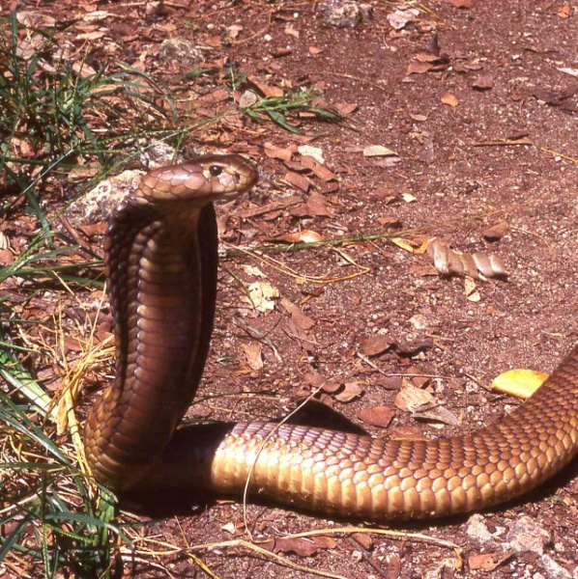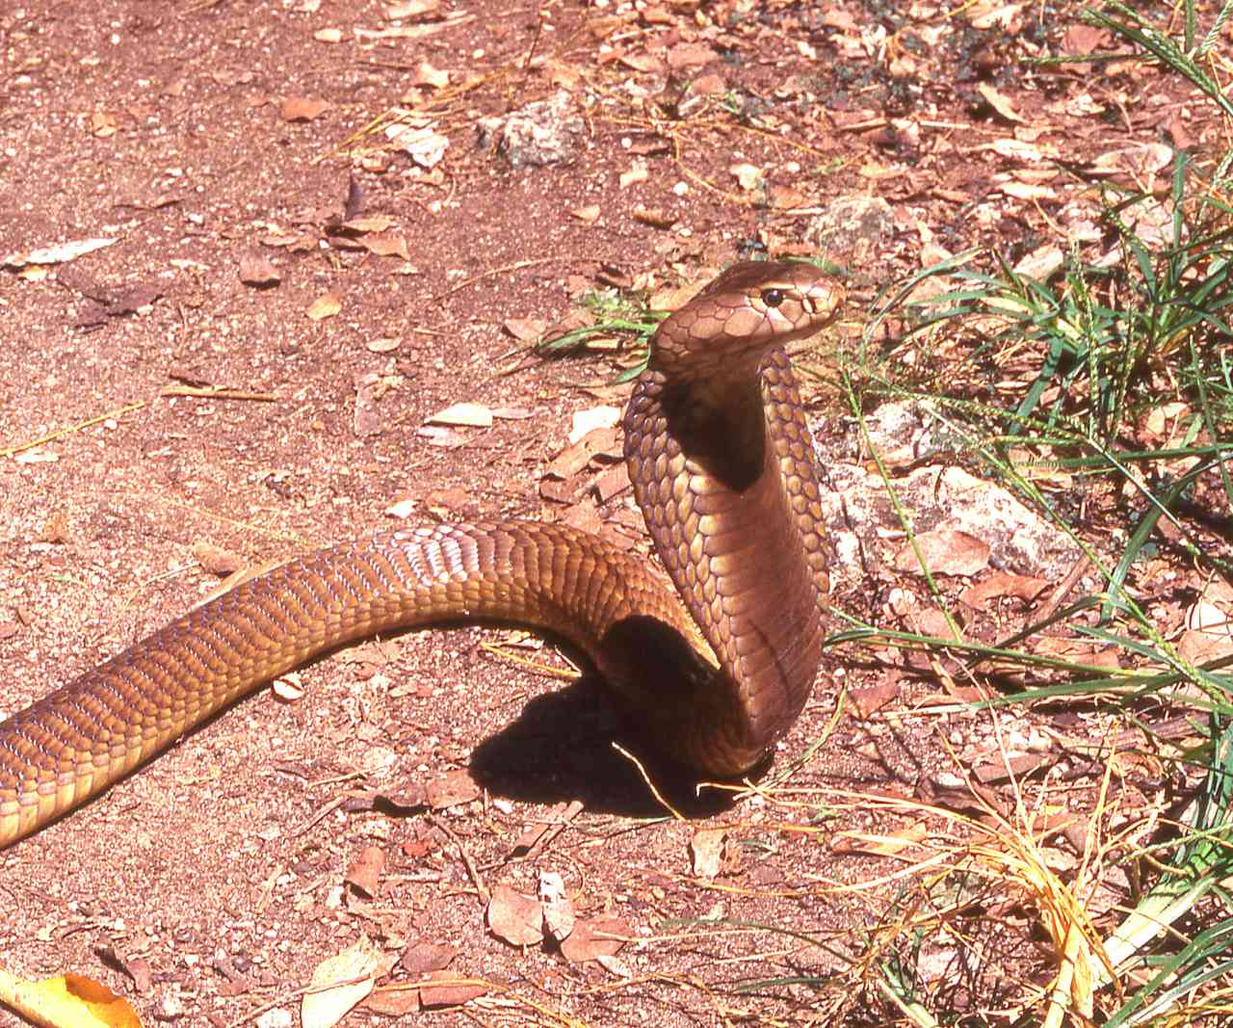
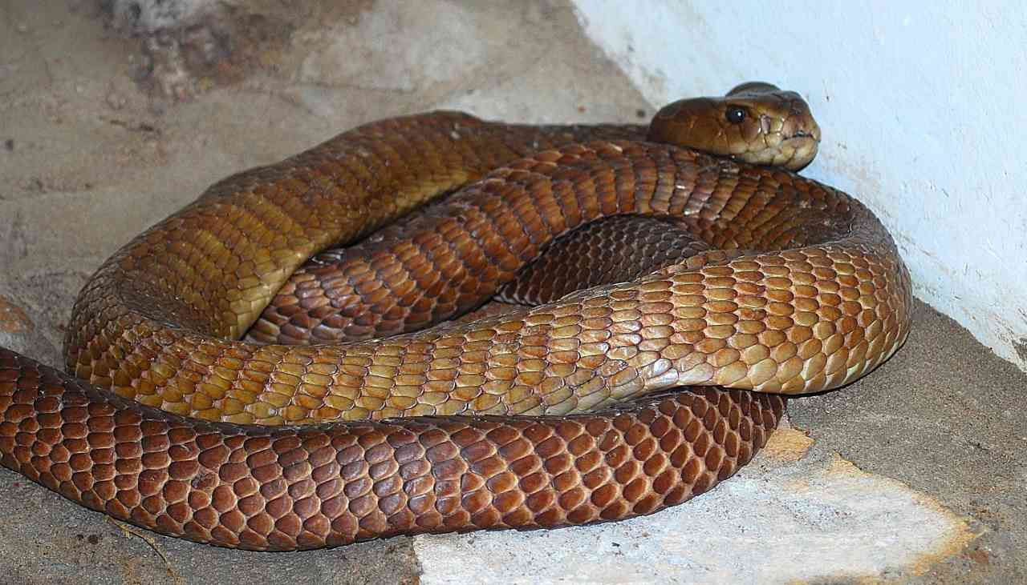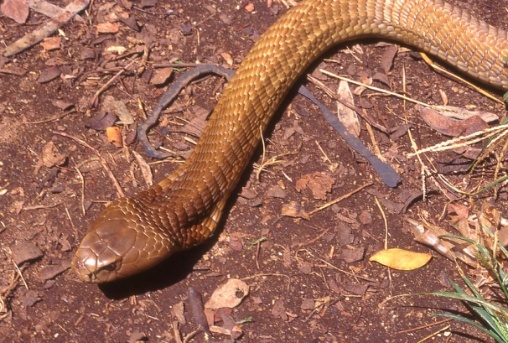
All illustrations coastal adults.
Local Names: Swila, Swila hudhurungi, Fira (Swahili), Kiko kiu, Kiko Kya nzaana (Kikamba), Fira, (Mijikenda), Giko (Kikuyu), Ilimajighu (Kitaita).
Identification: A large snake, reported to reach 2.7 m, average 1.2 – 2.2 m, usually some shade of brown, grey or yellowy-brown, the throat and underside darker brown in places, lighter in others, often with cream or yellowish crossbars. Juveniles may be grey or brown, often with a shiny black head.
Distribution: Occurs sporadically on the coast and in the dry country of eastern and northern Kenya, up to altitudes of 1 500 m in the Mt Kenya foothills. Due to earlier confusion with the black-necked spitting cobra, Naja nigricollis, many early records from low altitude attributed to that snake may prove to be Naja ashei, and thus it probably occurs widely in low country Kenya, particularly in rocky areas. Found near the following towns; Mombasa, Watamu, Malindi, Voi, Kibwezi, Isiolo.
Natural History: Active by night. Shelters in termitaria, holes, deep rock crevices, under ground cover. Fairly quick moving. Mostly terrestrial but will climb small trees. Eats mammals, birds and reptiles, including monitor lizards and other snakes, will raid chicken runs. Lays eggs.
Conservation Significance: Does not co-exist well with humans due to its size, but its secretive nature nocturnal habits means it often persists in coastal farms. Found in the following conservation areas; Gede, Arabuko-Sokoke, Tsavo, Shimba Hills and the conservation areas on the Uaso Nyiro River.
Medical Significance: Spits venom in large quantities. Eyes should be gently and thoroughly washed out with large quantities of water. Bites tend to cause swelling and necrosis, treat bite as medical emergency and transport to hospital. 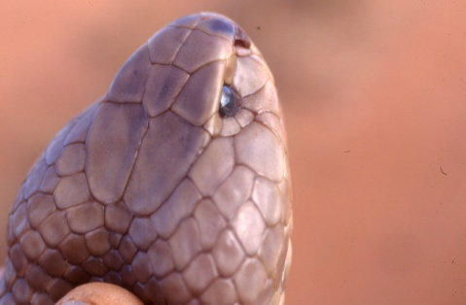
Black-necked Spitting Cobra Swila Naja nigricollis
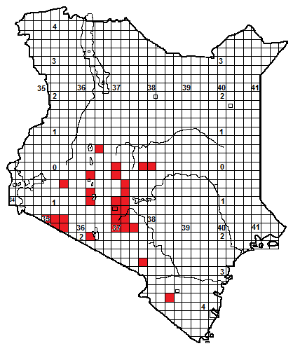

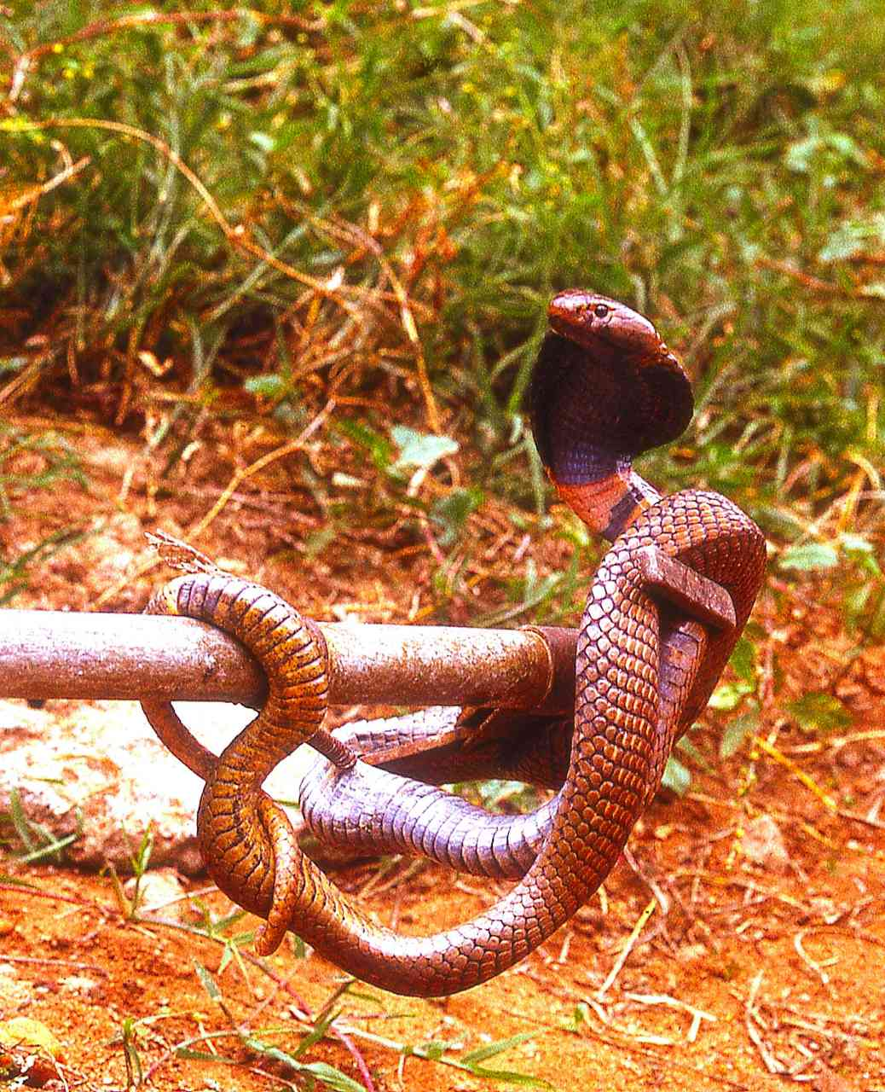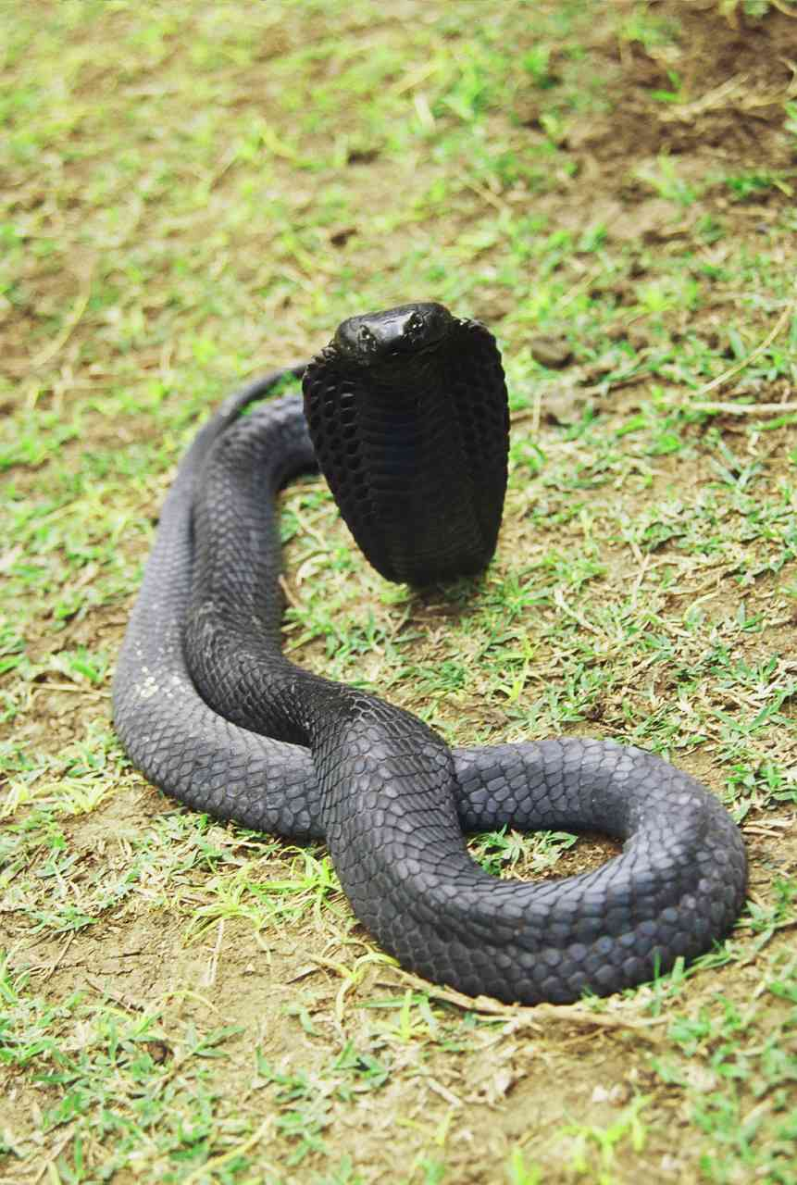

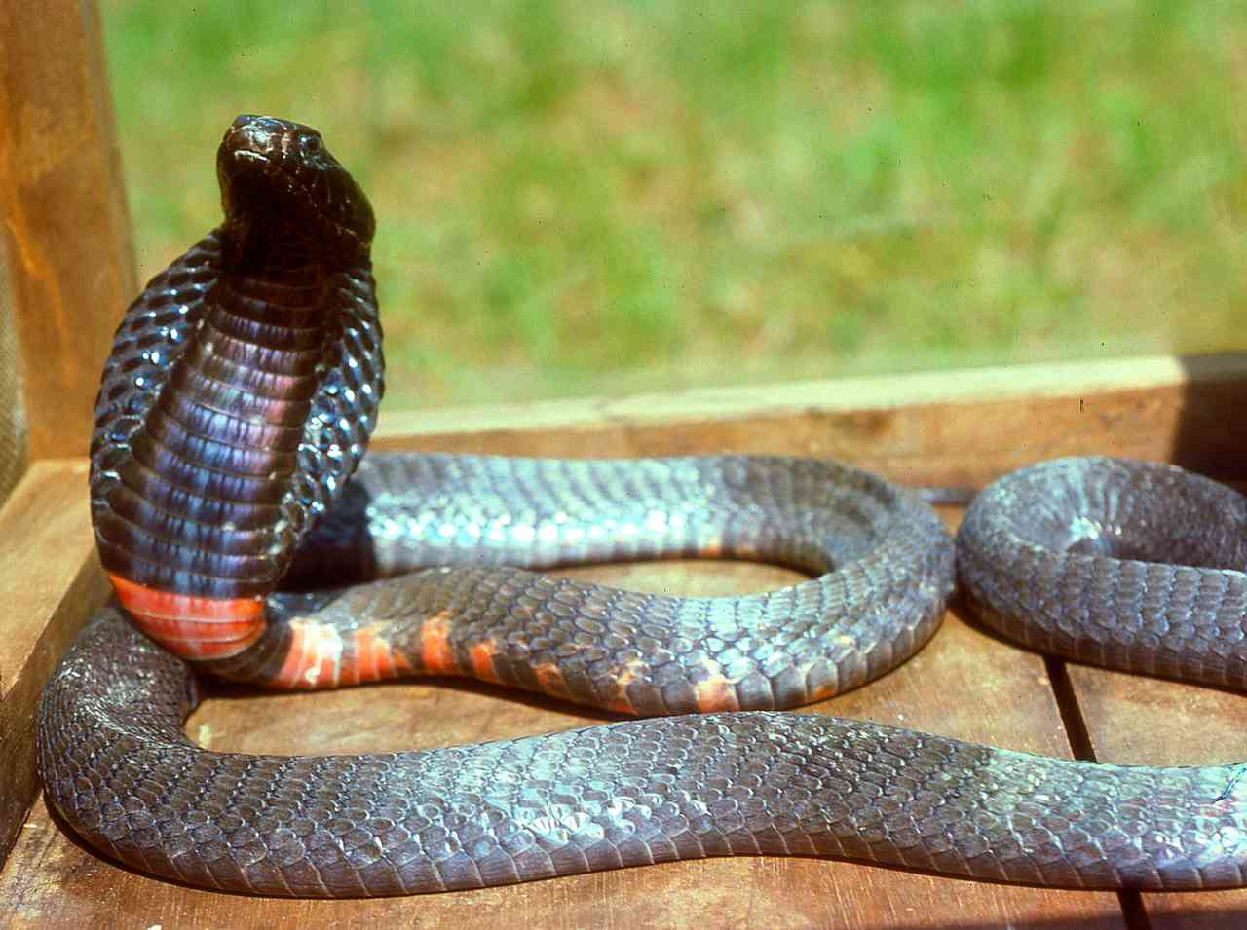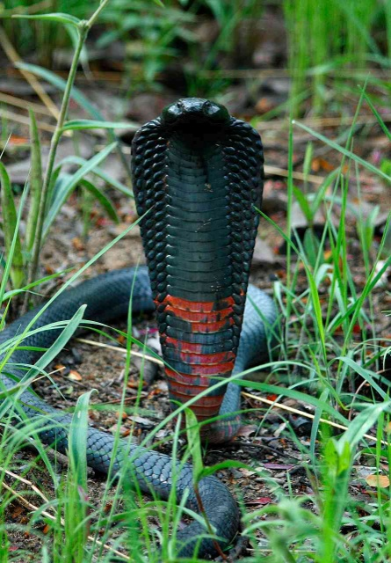
Photographs: © Barry Hughes (left) Caspian Johnson (right)
Local Names: Swila, Fira (Swahili), Kiko kiu, (Kikamba), Giko (Kikuyu), Thu’ond rachire (DhoLuo), Kipgineroi (Kalenjin), Emun-Lokimol (Turkana), Ekhilakhima (Luhya).
Identification: A fairly large snake, maximum about 1.8 m, average 1.0-1.5 m, black, grey, or coppery red, often with black and red bars on the throat. Juveniles often grey, with black head and neck; juvenile throat bars sometimes pale, not red.
Distribution: In Kenya, mostly in the south-west, in well-watered savannah in medium altitude areas, but also known from the Chyulu Hills and Mwatate, Taita Hills. Probably widespread throughout the mid-attitude southwest, but few records. Found in or near the following towns; Nairobi, Thika, Ruiru, Kiambu, Athi River, Machakos, Embu, Meru, Nakuru, Narok, Naivasha.
Natural History: Adults active by night, juveniles often by day. Shelters in termitaria, holes, deep rock crevices, under ground cover. Largely terrestrial but will climb trees. Fairly quick moving. Eats mammals, birds, amphibians and reptiles, will raid chicken runs. Lays 8-20 eggs.
Conservation Significance: Does not co-exist well with humans due to its size, but its secretive nature and nocturnal habits means it often persists in agricultural areas. Found in the following conservation areas; Nairobi National Park, Maasai Mara National Reserve, Hell’s Gate National Park, Ol Doinyo Sabuk..
Medical Significance: Spits venom, and it can produce large quantities. Eyes should be gently and thoroughly washed out with large quantities of water. Bites tend to cause swelling and necrosis, treat bite as medical emergency and transport to hospital.
Red Spitting Cobra Swila Nyekundu Naja pallida
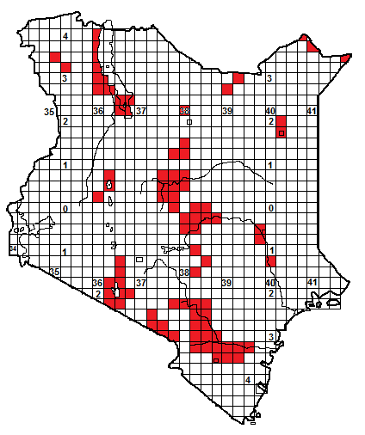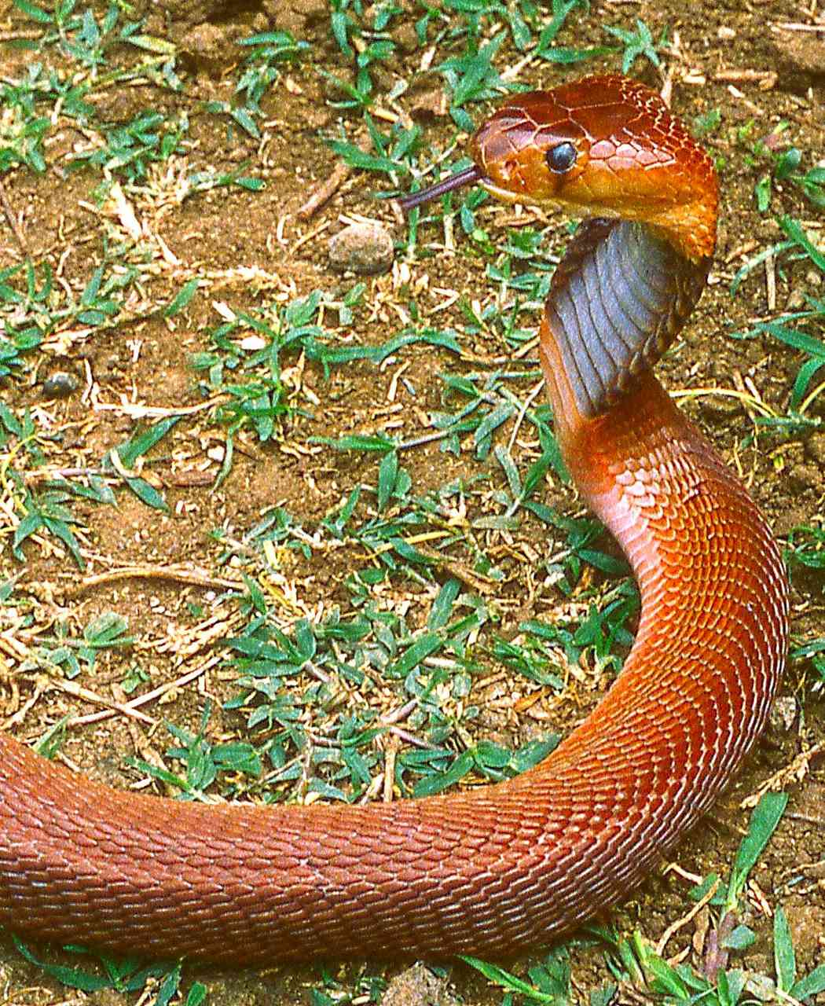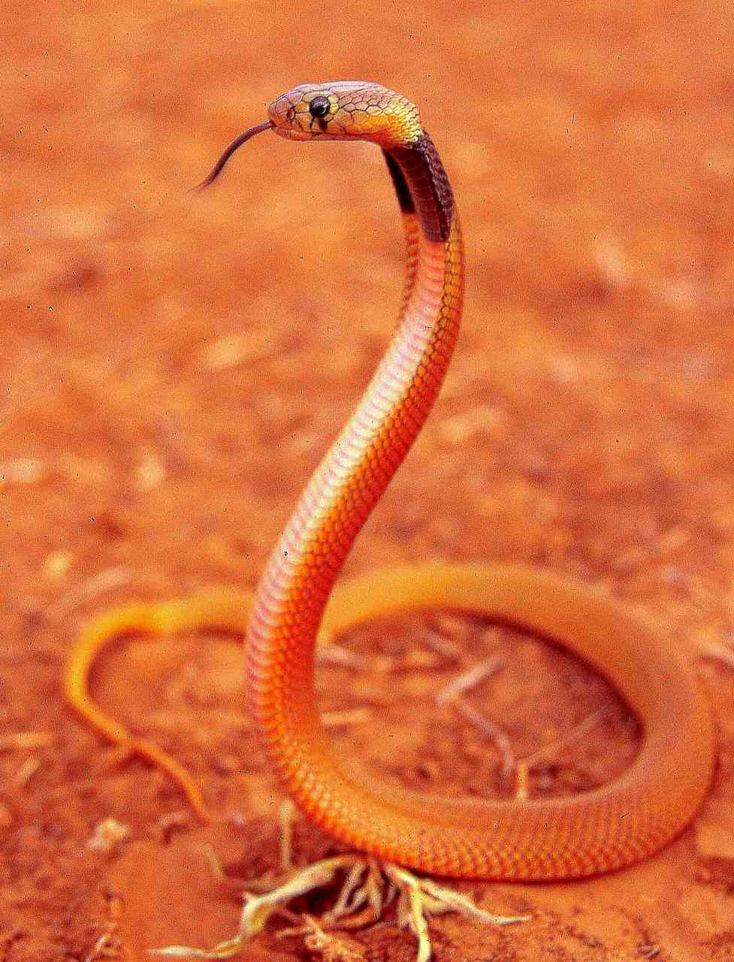
Adult above and below left, Longido, juvenile above right, Olorgesaille, below right Voi.
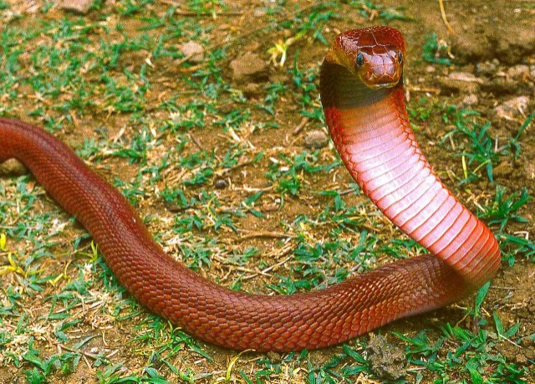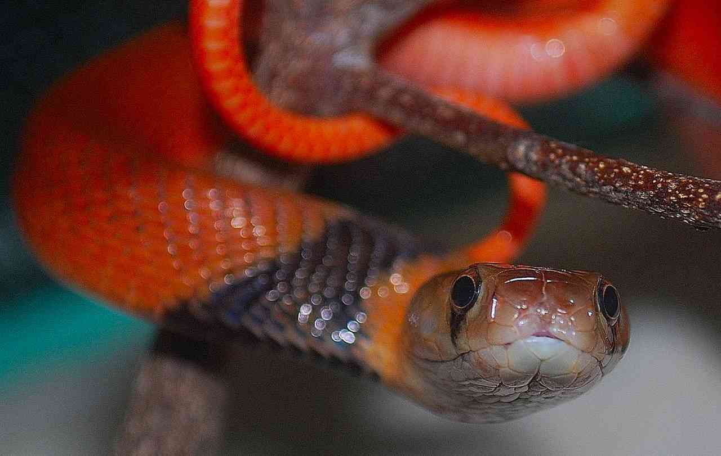
Local Names: Kiko kitune, Kiko kya nguku (Kikamba), Kirugwa (Tharaka), Mas Gadut (Somali)
Identification: A fairly large, slim snake, maximum size about 1.5 m, hatchlings 20 cm, adults usually 70 cm to about 1.2 m.
Distribution: Dry savanna and semi-desert, from sea level to about 1 300 m altitude. Probably occurs virtually through northern and eastern Kenya, but few records from the far eastern side near the Somali border. Recorded from a number of Kenyan towns, including Garissa, Isiolo, Kakuma, Kibwezi, Lodwar, Mandera, Mtito Andei, Mwingi, Voi, Wajir, Wamba. Not found at altitude, so absent from most of southwest Kenya.
Natural History: Adults nocturnal, juveniles sometimes diurnal. Hides in termite hills, in holes, under ground cover. Largely terrestrial but sometimes climbs small trees. Eats a range of vertebrates, particularly frogs. Lays 6-15 eggs.
Conservation Significance: Not evaluated, but its huge distribution within dry and agriculturally unusable land in Kenya, Somalia and Ethiopia means it is unlikely to be threatened in conservation terms. Occurs within the following Kenyan sanctuaries: Amboseli National Park, Buffalo Springs National Reserve, Losai National Reserve, Malka Murri National Park, Rahole National Reserve, Tsavo National Park (East and West), Samburu National Reserve, Shaba National Reserve, Kora National Park.
Medical Significance: Highly venomous, front-fanged elapid snake. Not aggressive, but can spit venom, which causes intense pain if it lands in the eyes; first aid treatment consists of prolonged gentle irrigation of the affected eye(s) with large quantities of water or any bland fluid (milk has been used), followed by treatment with antibiotic eye ointment.
Symptoms following a bite include immediate pain, vomiting, swelling and occasionally necrosis of the skin and subcutaneous tissues. The venom may be produced in large quantities; neurotoxicity is usually absent. Fatalities are rare, but bites should be treated as emergencies and victims should be seen by a doctor. A polyvalent serum is obtainable.
Forest Cobra Naja melanoleuca
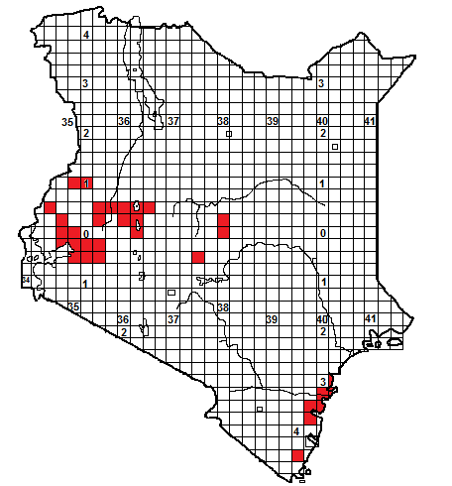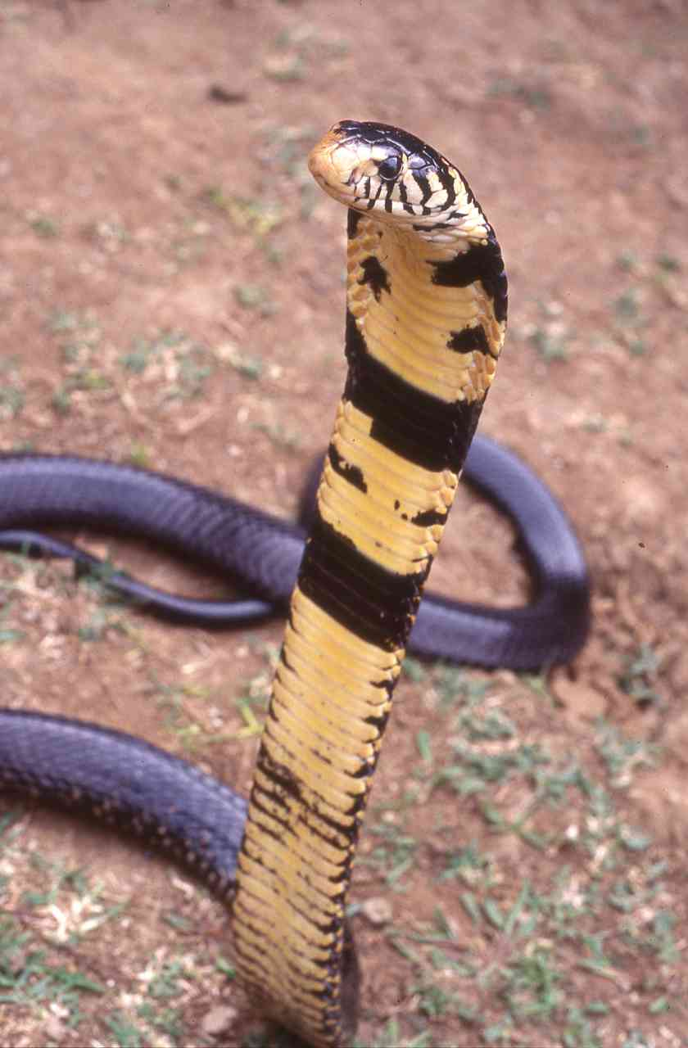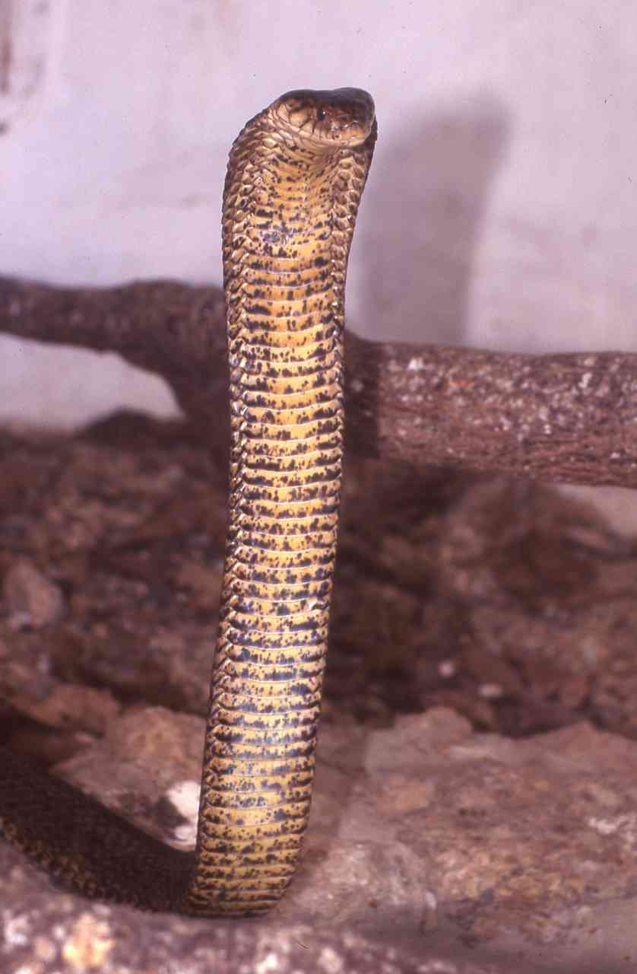
Illustrations: above left forest form, above right coastal adult, below coastal juvenile.
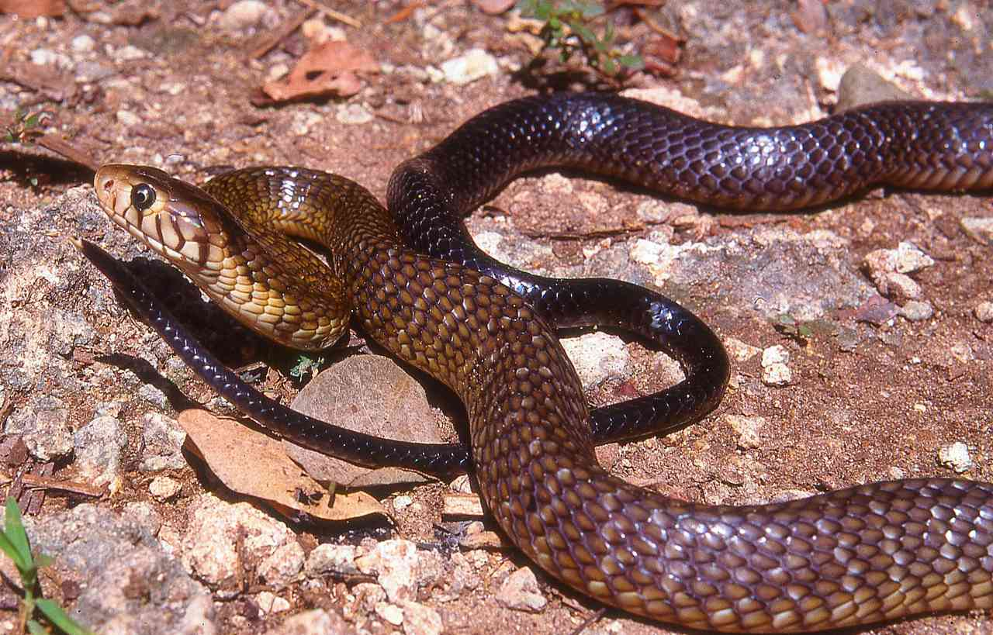
Local Names: Swila, (Swahili), Kiko kiu, (Kikamba), Fira, (Mijikenda), Ekhilakhima (Luhya), Kipsyono (Kalenjin).
Identification: A large snake, grows to 2.7 m, average 1.2 – 2.2 m. Two main colour forms in Kenya; those from the west are black, the chin, throat and anterior belly are white, yellow or cream, with broad black crossbars and blotches, the sides of the head are strongly barred in black and white. Coastal specimens are brown or blackish brown, darkening towards the tail, which may be black. The belly is yellow or cream, but heavily speckled with brown or black.
Distribution: Usually in forest or woodland; occasionally in moist savanna and grassland (e.g. around Rongai). Occurs in three discrete areas of Kenya. The brown form occurs along the coast from Diani north to Malindi, (lower picture), the black form from Nakuru westwards; another population exists in the forests of southeast Mt Kenya and the Nyambene Hills. Found near the following towns; Eldoret, Kitale, Bungoma, Njoro, Kisumu, Kakamega, Nakuru, Kericho, Embu, Mombasa, Kilifi, Malindi.
Natural History: Active by day and night, usually by day in uninhabited areas. Climbs well, often in trees, and also swims well. Shelters in termitaria, holes, root tangles, rock crevices, under ground cover. Quick moving and alert. When angered rears up and spreads a long narrow hood. Eats a range of food, including mammals, birds, reptiles and amphibians. Lays up to 25 eggs.
Conservation Significance: Does not co-exist well with humans due to its size, but its secretive nature and nocturnal habits means it often persists in inhabited areas. Found in the following conservation areas; Gede, Arabuko-Sokoke, Shimba Hills, Kakamega Forest, Mt Kenya forest.
Medical Significance: Bites are rare; this alert snake usually avoids confrontation. However, the venom is a powerful neurotoxin fatalities have occurred in western Kenya in tea/coffee plantations. Bites should be treated as a medical emergency.
Egyptian Cobra Naja haje
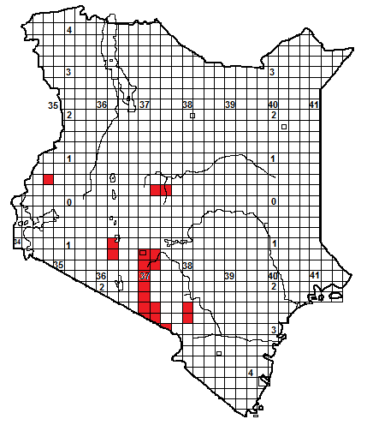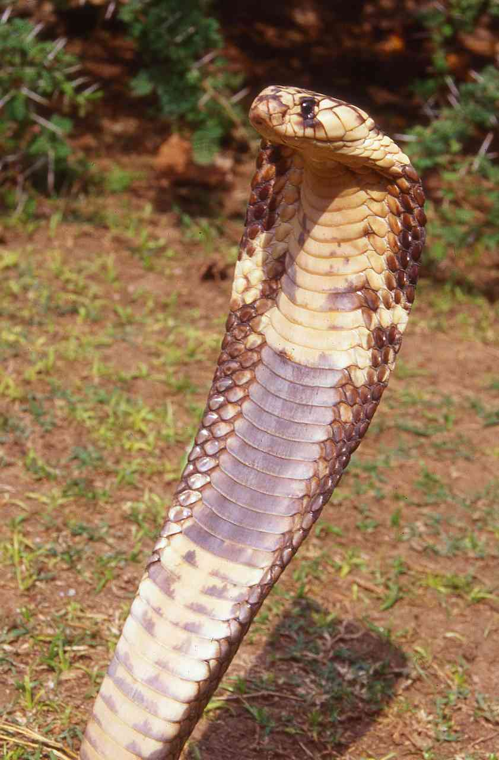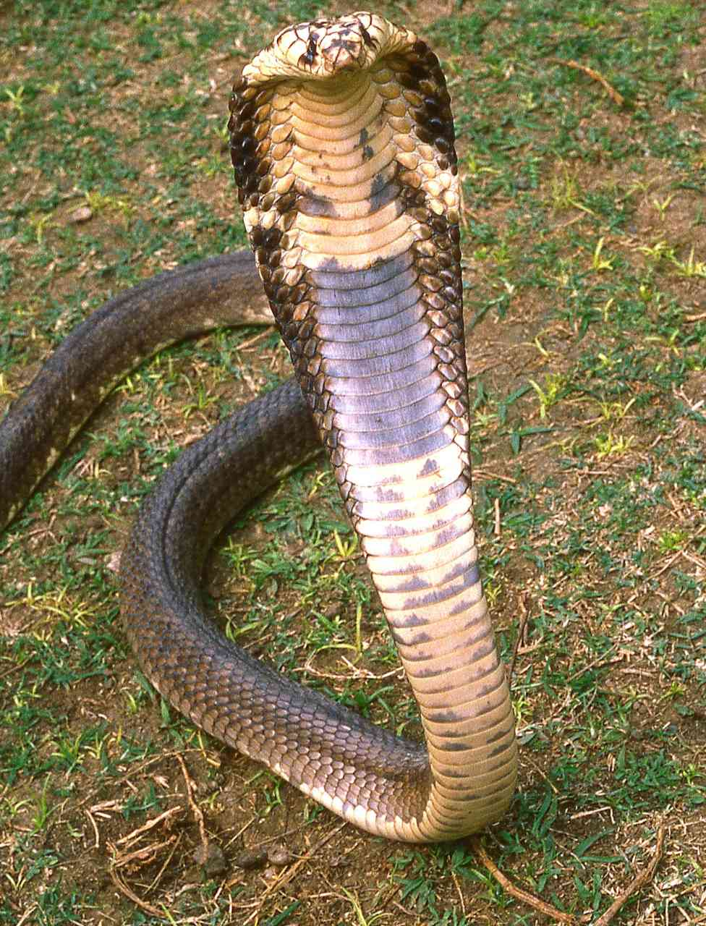

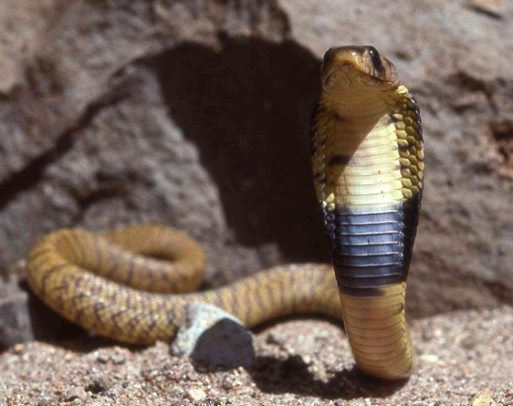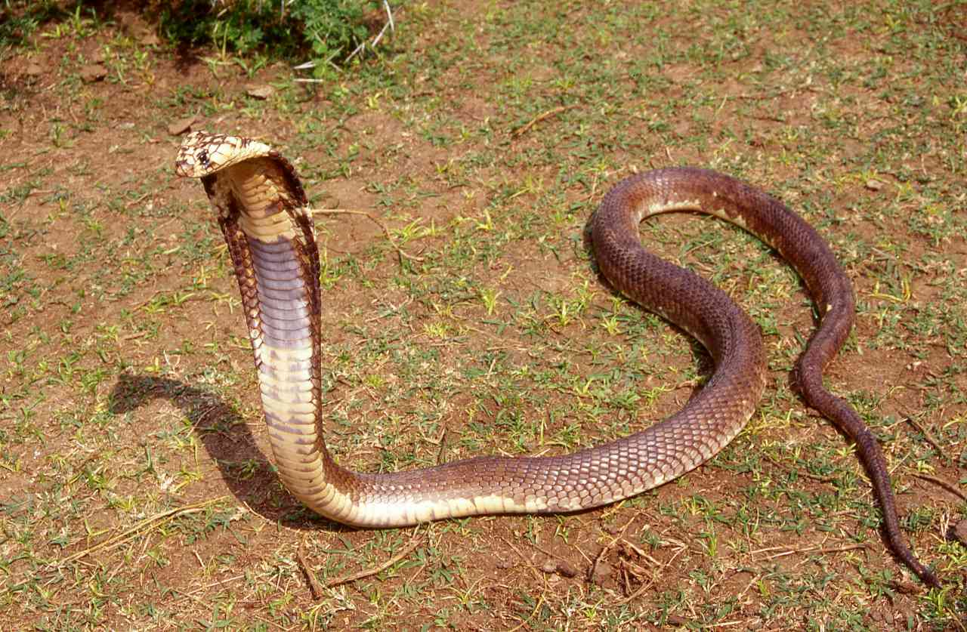

Illustrations: all adults, Amboseli, except bottom left, juvenile, Ethiopia.
Local Names: Swila, (Swahili)
Identification: A large snake, grows to 2.5 m, average 1.2 – 2 m. Usually brown, grey-brown or reddish brown above, cream or yellow below, with a broad brown or black throat band. Often there are splotches of the ventral colour on the flanks, and juveniles may be reddish, with some barring.
Distribution: Usually in moist and dry savanna. A discrete population occurs from the southern suburbs of Nairobi east to Thika, south to Amboseli. Also known from Mtito Andei, the Chyulu Hills, and from Lake Naivasha through the Kedong Valley and Mt Suswa, this population might be connected with the Nairobi/Amboseli population through the southern Ngong Hills. A population also occurs west and northwest of Isiolo, and around Bungoma. Found near the following towns; Nairobi, Thika, Athi River, Mtito Andei, Namanga, Naivasha, Bungoma.
Natural History: Active by day and night, usually by day in uninhabited areas. Shelters in termitaria, holes, rock crevices and under ground cover. Rather clumsy but quick moving and alert. When angered rears up and spreads a broad hood and if cornered will lunge forward and try to bite. Eats a range of food, including mammals, toads and snakes, will raid chicken runs. Lays up to 20 eggs.
Conservation Significance: Does not co-exist well with humans due to its size, but its secretive nature nocturnal habits means it often persists in inhabited areas. Known from the following conservation areas; Nairobi National Park, Amboseli National Park, Tsavo West.
Medical Significance: A front-fanged elapid, the venom is a powerful neurotoxin and bites should be treated as a medical emergency.
Gold’s Tree Cobra Pseudohaje goldii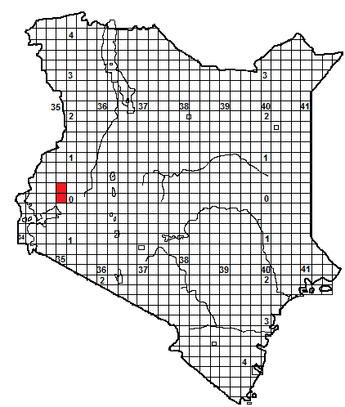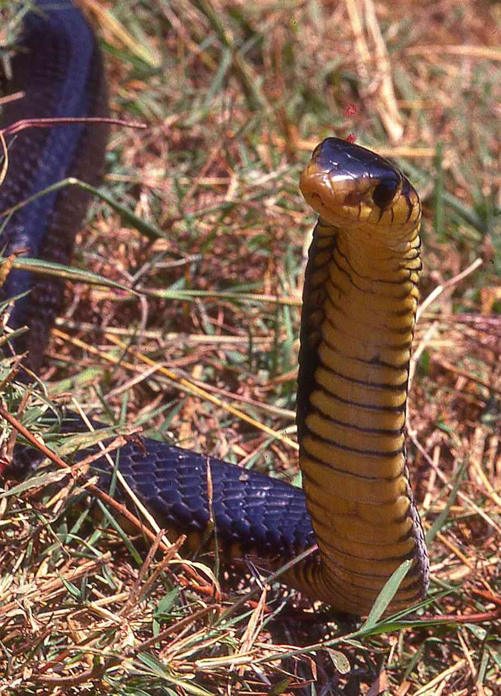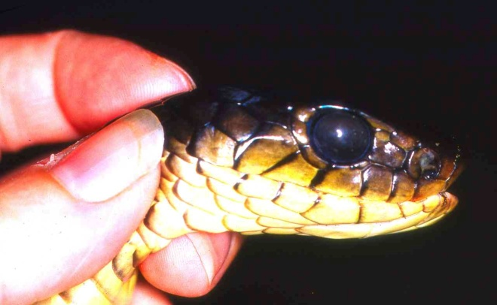
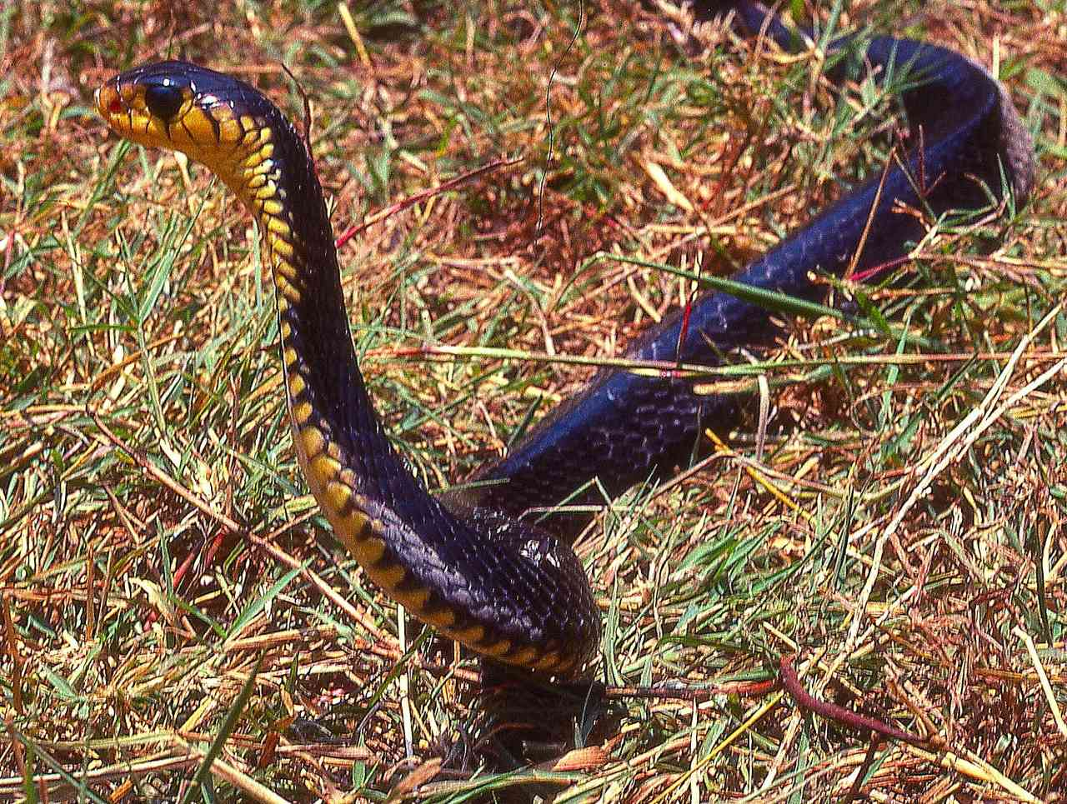
Illustrations; all adults, Kakamega Forest
Local Names: None known.
Identification: A big, shiny, thin-bodied tree cobra, head short, eye large. Tail long and thin and ends in a spike. Glossy black above, chin, throat and belly yellow, with black encroaching onto the belly scales.
Distribution: In forest in western Kenya; known only from Kakamega Forest, South Nandi Forest and other associated forests.
Natural History: Little known. May be diurnal or nocturnal. Arboreal, but will descend to the ground. If disturbed, will pause with head up, moving it from side to side. Eats mammals and amphibians; reported to eat fish. Lays eggs.
Conservation Significance: A secretive arboreal snake of the central African forest; unlikely to be threatened in its huge range; in Kenya only known from the Kakamega area, the forest there is protected.
Medical Significance: A front-fanged elapid, the venom is a powerful neurotoxin. Bites are unknown, but should be treated as a medical emergency.

