The Kenya Reptile Atlas
A free, downloadable atlas of Kenya’s reptiles. This is a free source of regularly updated information on Kenya’s Reptiles. Authors: Stephen Spawls, Beryl Bwong, Patrick Malonza, Vincent Muchai, Victor Wasonga
Obtainable under ‘downloads’ at Kenyareptileatlas.com
This project is funded by the Rufford Foundation under the auspices of the National Museums of Kenya; Department of Herpetology.

The Kenya Reptile Atlas offers you:
Pictures of Kenya’s reptiles
Distribution maps by quarter-degree-square
A description of the species

Click on any of the titles listed under the downloads tab to download for free. The various families will be added as the accounts are completed.

If you have any observations of Kenya’s reptiles, any distribution records, or any other data, or any digital pictures, we would like to receive them! Send them to Kenyareptileatlas@gmail.com
And if you live or travel in Kenya, and find any dead reptiles, please preserve them and take them to the Department of Herpetology, at the National Museum, Museum Hill, Nairobi.
The team thanks those who kindly commented upon the text or loaned us pictures; including Sanda Ashe, Bill Branch, Brian Copeland, Steve Russell, John Tashjian, Alan Channing.
Vipers 2: Night adders and bush vipers
Rhombic night adder Causus rhombeatus
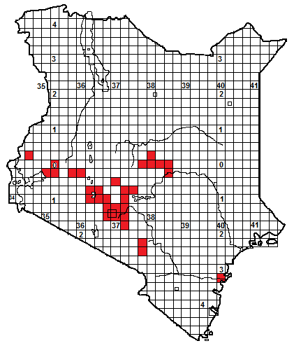
Nairobi (TL), Nyambene Hills (TR, BR), Ethiopia (BL)
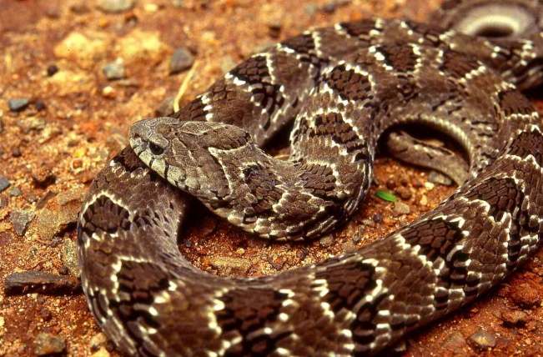 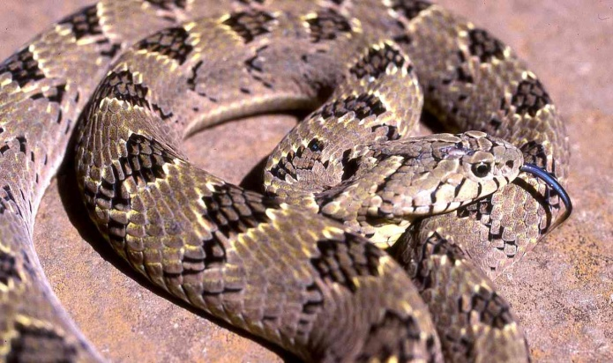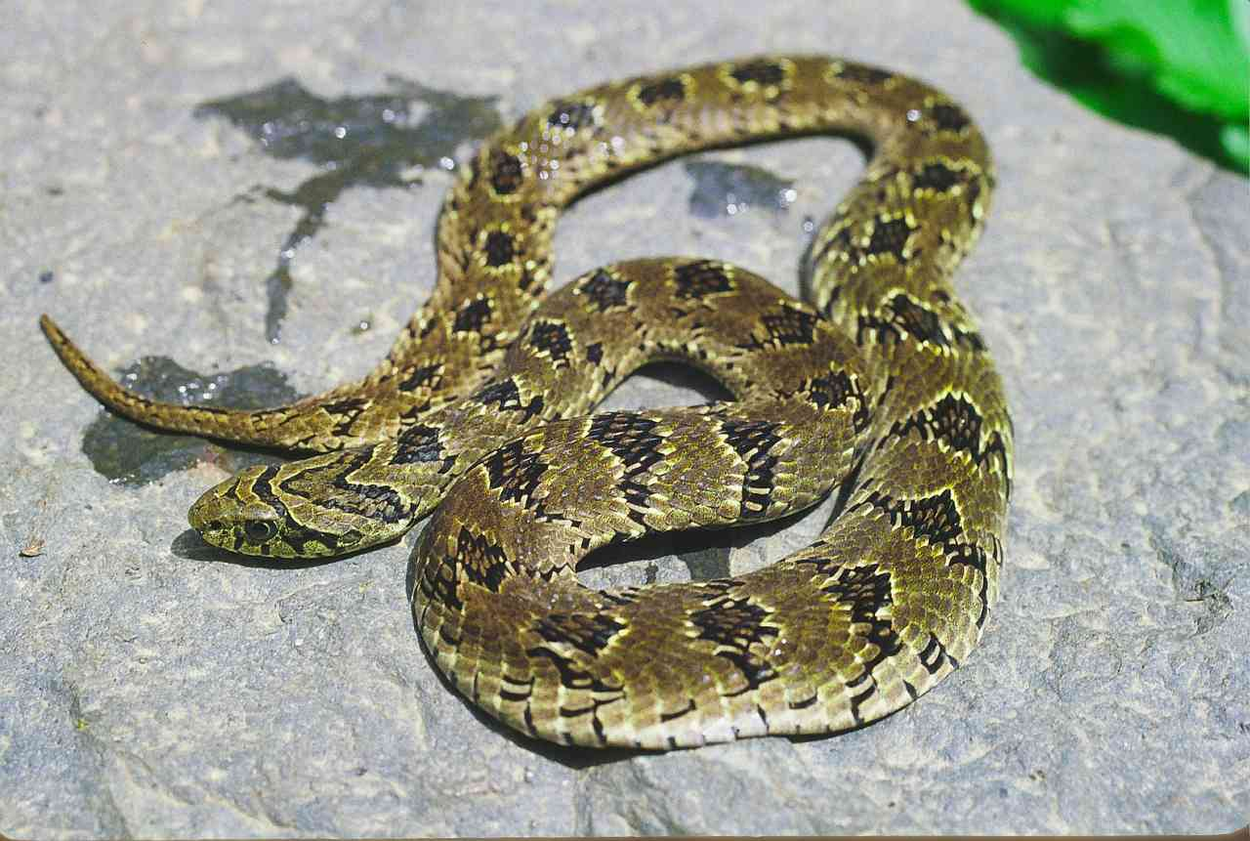 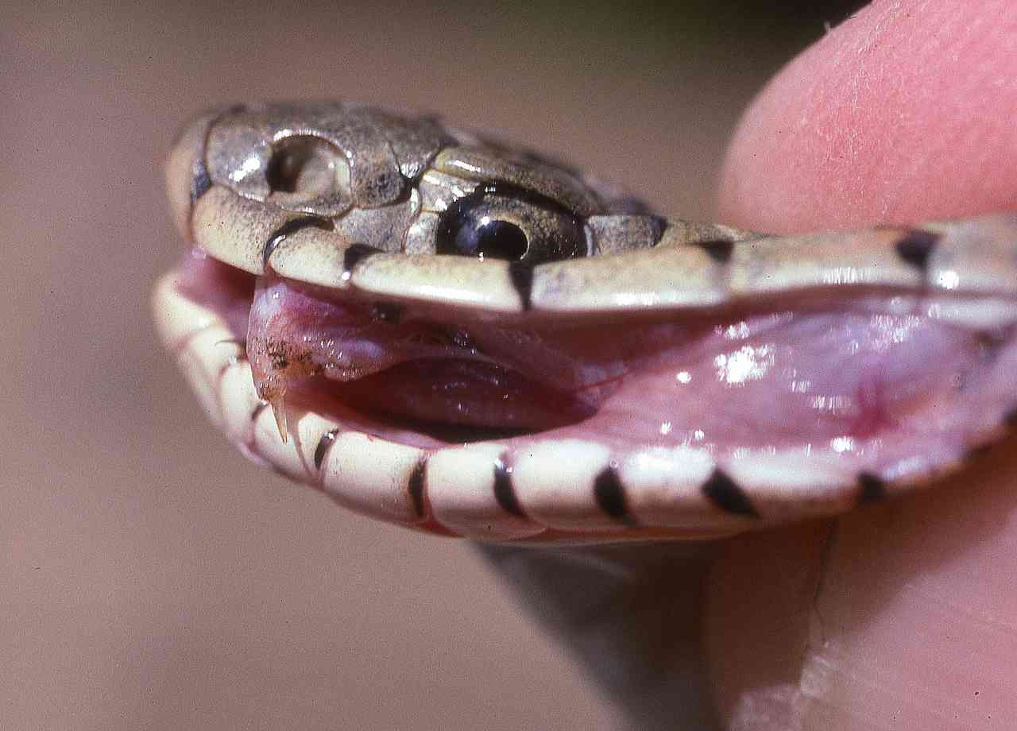Identification: A small, stocky viper, head just distinct from the neck. Average size 40-70 cm maximum 90 cm. Usually brown above (may be pinky-brown or greyish), with 20-30 dark, white-edged rhomboidal saddles down the back and a sprinkling of black scales or oblique bars on the flanks. There is a characteristic forward-pointing V-shape on top of the head. The belly is pale, but each ventral scale may gradually darken towards the long edge, giving the belly a barred appearance.
Distribution: Sporadically known from moist savanna, grassland and light woodland of high central and western Kenya, nearly always in the vicinity of water sources. Known localities include most of the land between 1000 and 2000 m on the eastern and southern slopes of Mt Kenya, the Nyambene Hills and around Nairobi, also the Chyulu Hills and one enigmatic record from the Jilore Forest. Found around the following towns: Nairobi, Thika, Muranga, Nyeri, Naivasha, Meru and Kisumu.
Natural History: Usually terrestrial but it may climb bushes in pursuit of frogs. Fairly slow moving. Despite the name, active by day and night. Shelters in holes, under ground cover, in vegetation tangles. Hisses and puffs when angry and will make swiping strikes if molested. It may lift the front portion of the body off the ground and flatten the neck, looking like a little cobra. Eats frogs and toads. Lays 7 to 26 eggs.
Conservation Significance: Widespread in the African savannas, and found in several national parks including Meru and Nairobi.
Medical Significance: The toxicity of the venom is low; bite cases usually involve pain (sometimes extreme) and minor swelling. No existing antivenom is specific against the venom, but puff adder antivenom in extreme cases has been seen to give some relief.
Illustrations: Sudan (UL; © Alan Channing), Nairobi (UR), Kidepo (below, © Steve Russell)
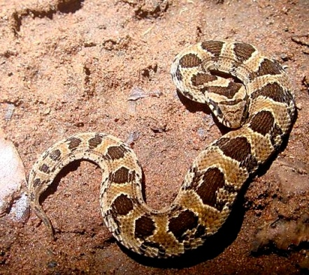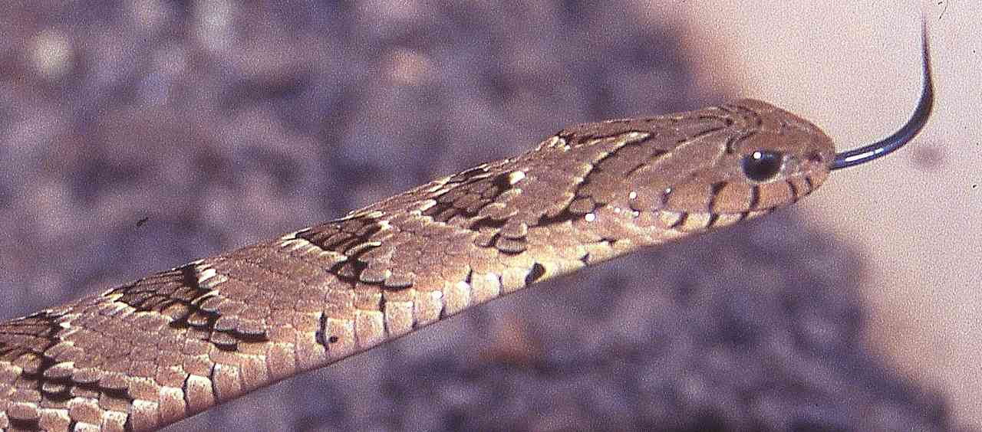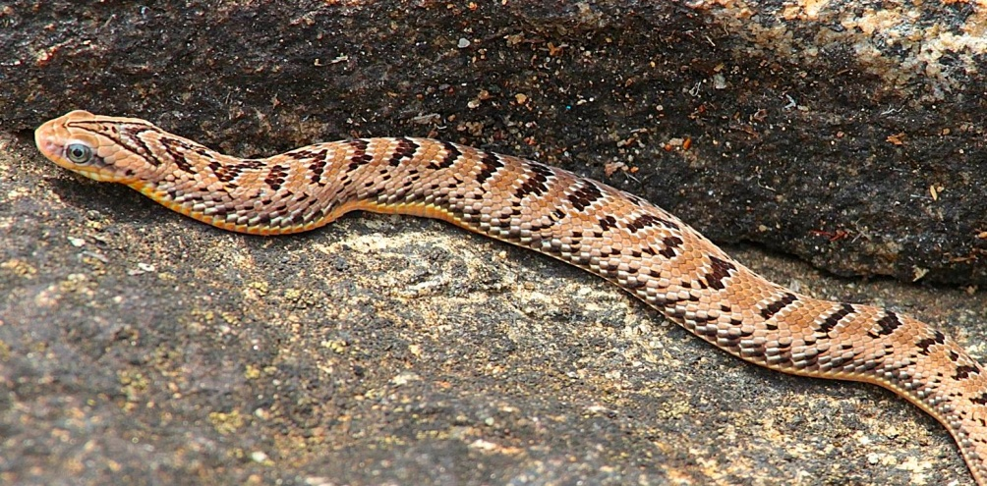
Snouted night adder Causus defilippii
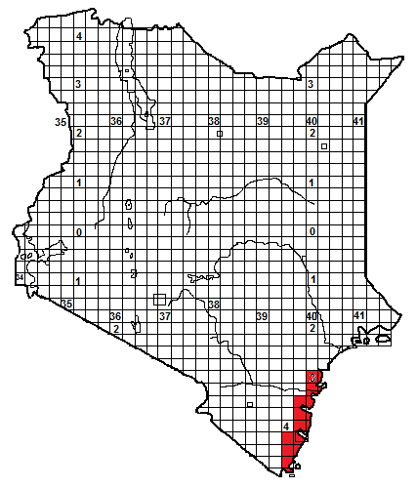
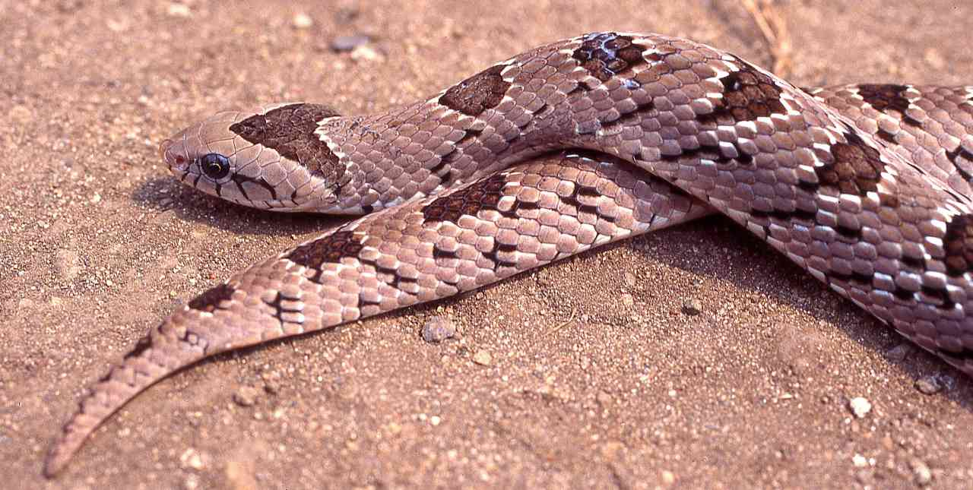
Local Names: Kivuva (Giriama)
Identification: A small, stocky viper, head just distinct from the neck. Average size 20-35 cm but may reach 40 cm. Usually velvety-brown above, often with a pinkish sheen, with 20-30 dark, white-edged rhomboidal saddles down the back and a sprinkling of black scales or oblique bars on the flanks. There is a characteristic forward-pointing V-shape on top of the head. The belly is cream, pearly white or grey.
Distribution: The Kenya coast, from the Malindi area southwards to the border, in moist savanna, grasslands, thicket and forest; often near water sources and wetlands. Occurs in or near the following towns; Malindi, Watamu, Kilifi, Mombasa (although not recorded on the island for some years).
Natural History: Usually terrestrial but it may climb bushes in pursuit of frogs. Fairly slow moving. Despite the name, active by day and night. Shelters in holes, under ground cover, in vegetation tangles. Hisses and puffs when angry and will make swiping strikes if molested. It may lift the front portion of the body off the ground and flatten the neck, looking like a little cobra. Eats frogs and toads. Lays from 3 to 9 eggs.
Conservation Significance: Widespread in the savannas of southeastern Africa, and found in Arabuko-Sokoke Forest and Shimba Hills National Park.
Medical Significance: The toxicity of the venom is low; bite cases usually involve pain (sometimes severe) and minor swelling.
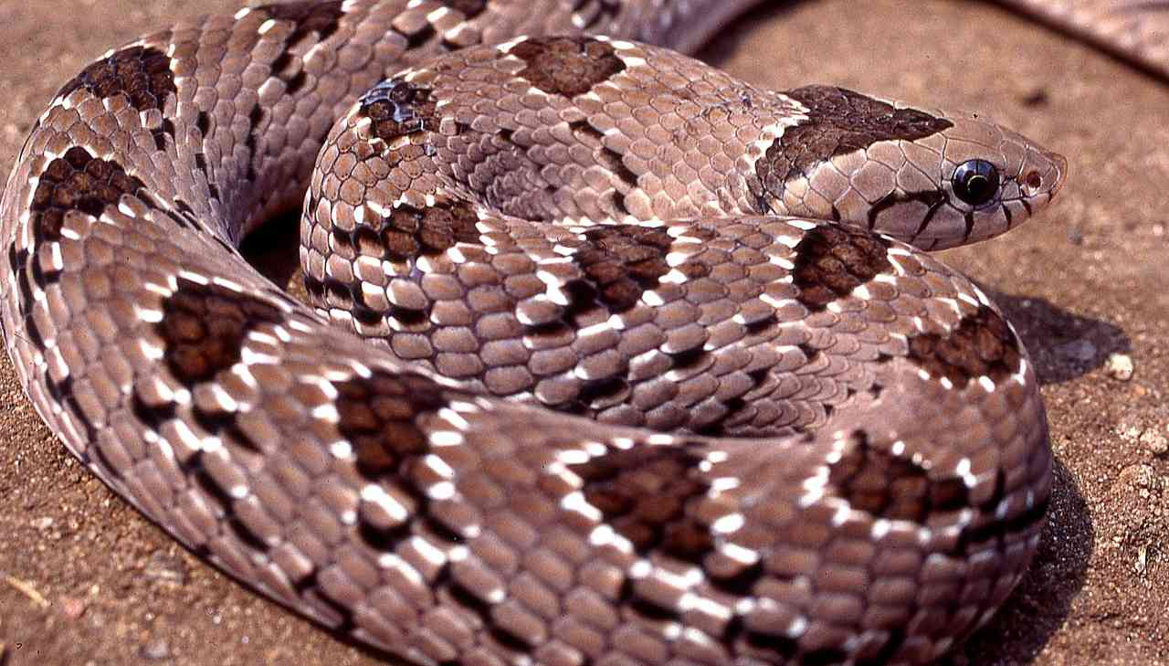
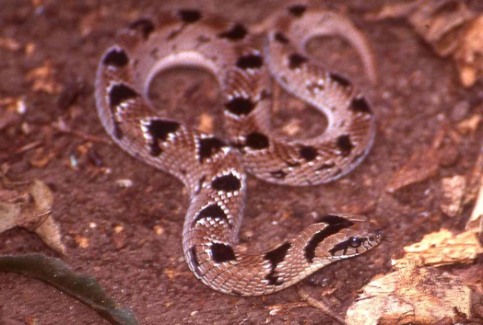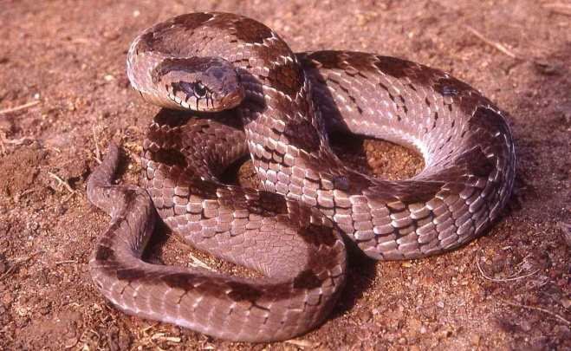
Left hand photo © Sanda Ashe, Watamu.

Velvety-green night adder Causus resimus

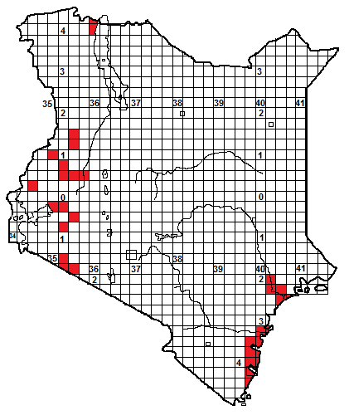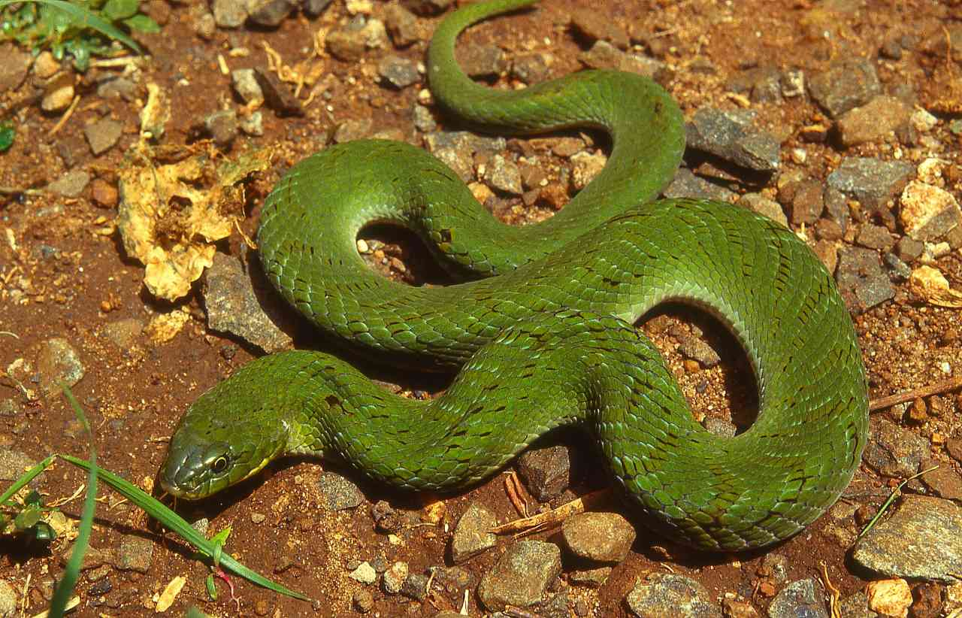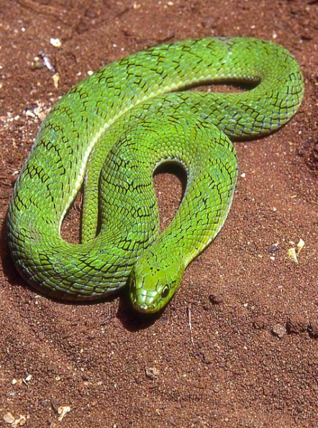
Local Names: Kivuva (Giriama)
Identification: A small, stout viper, head just distinct from the neck. Average size 30-60 cm but may reach 75 cm. Usually vivid green above, of various shades. On the head, especially in juveniles, black scales may form a V-shape outline. Scattered black scales may form indistinct rhomboid shapes on the back and oblique bars on the flanks. When angered, this snake inflates its body, exposing the hidden vivid blue scale margins. The chin and throat may be tinged with yellow, and some belly scales black-edged.
Distribution: In moist savanna, grassland and woodland, often in the vicinity of water sources. In Kenya, two widely separated populations exist. The eastern population occurs from the Tana River Primate Reserve south along the river to the coast and thence south to Shimoni, although records lacking from the Ungwana Bay and Watamu area; they seem not to have penetrated into the lee of Mida Creek. In western Kenya, it extends from the Maasai Mara north through the lakeshore to Mt Elgon, eastwards to the Kerio Valley. Also known from Lokitaung and thence into southern Ethiopia. There is an anecdotal report from Makindu.
Natural History: Usually terrestrial but it may climb bushes in pursuit of frogs. Fairly slow moving. Despite the name, active by day, at twilight and at night. Shelters in holes, under ground cover, in vegetation tangles. Hisses and puffs when angry and will make swiping strikes if molested. Eats frogs and toads. Lays from 4 to 12 eggs, which females may brood.
Conservation Significance: Widespread in several curiously disjunct areas of Africa (Angola, Chad, southern Somalia, South Sudan) so unlikely to be under threat. In Kenya found in Arabuko-Sokoke Forest , Shimba Hills National Park, Maasai Mara National Reserve and Mt Elgon National Park
Medical Significance: The toxicity of the venom is low; bite cases usually involve pain (sometimes severe) and swelling, which can be severe (but without necrosis).No serum has any effect on the bite.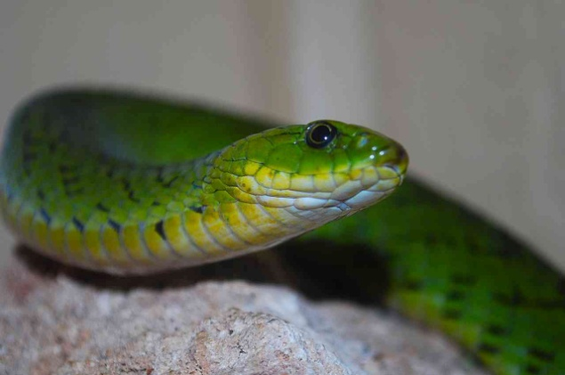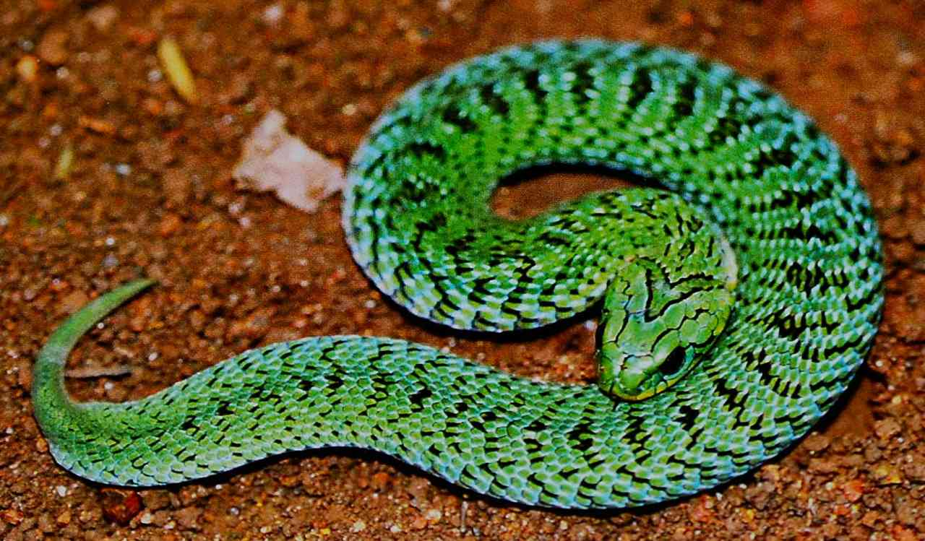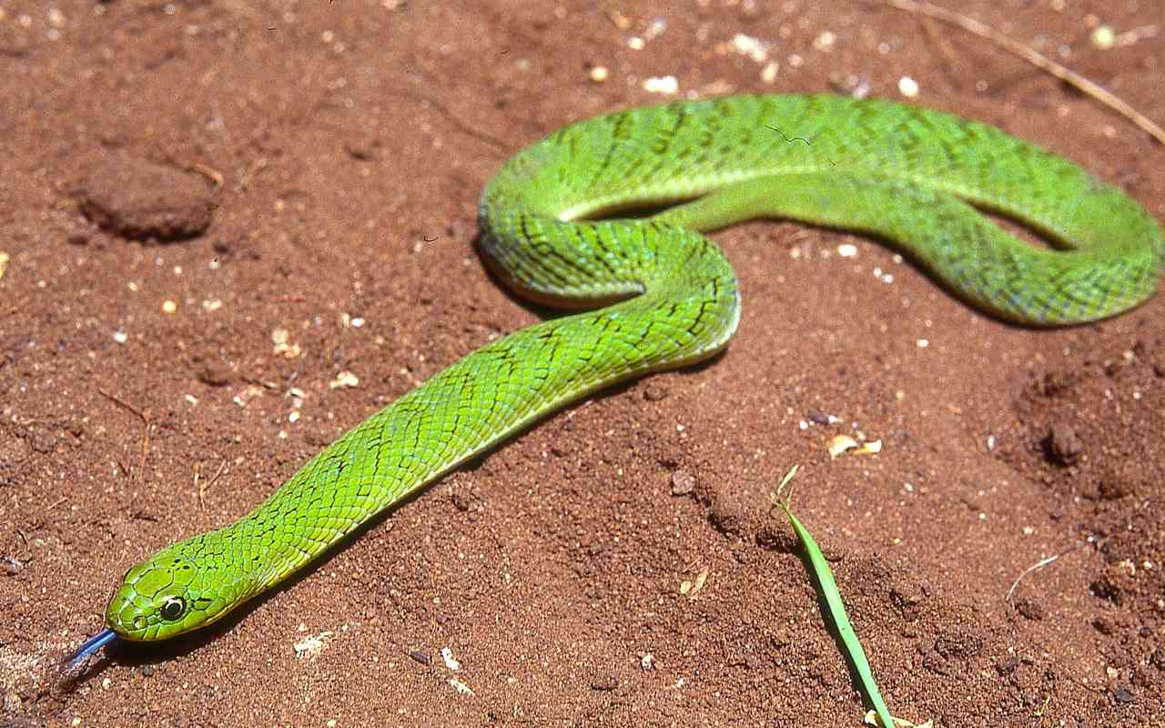
Illustrations: Kericho (TL), Omo (TR,bottom), Watamu (ML), Mt Elgon (MR; © Brian Copeland)
Forest night adder Causus lichtensteini
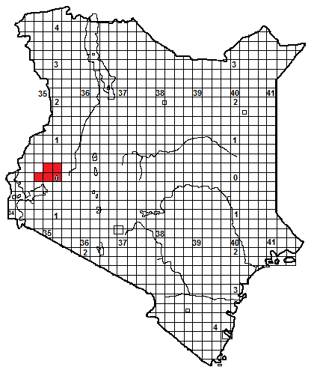
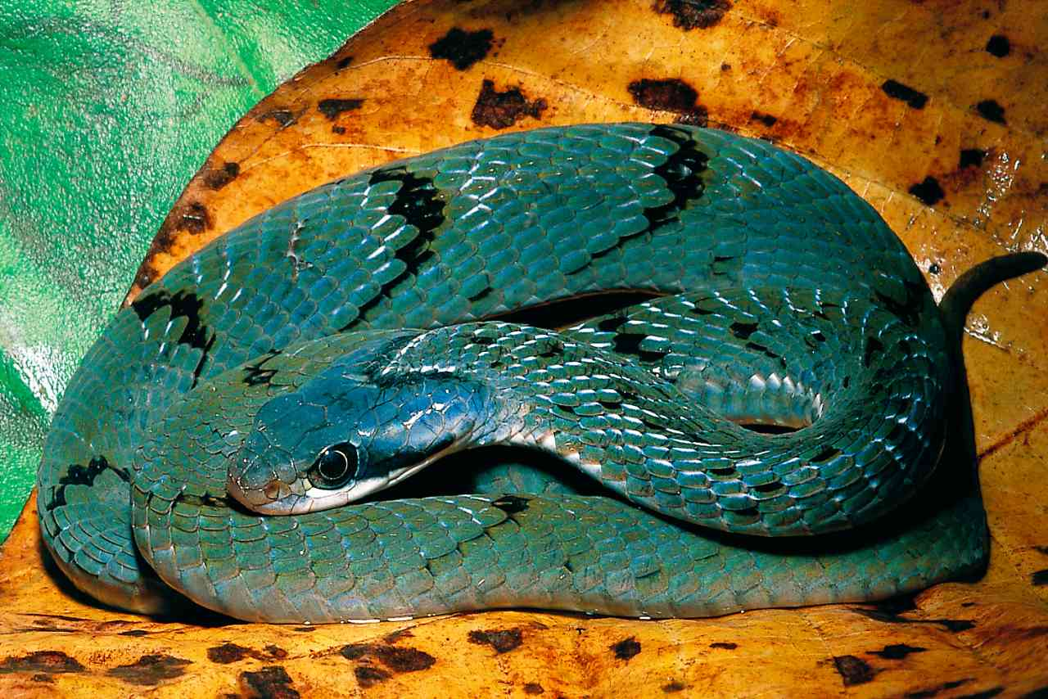
(Photo © Bill Branch; Gabon)
Local Names: None known
Identification: A rather unusual night adder, with big eyes and relatively slim body. The head is just distinct from the neck. Average size 30-55 cm but may reach 70 cm. Various shades of green above, from pale to emerald or even turquoise (especially on the head); may have orange bars on the tail. The back is speckled with black, which may form vague black cross bars or V-shapes, many anterior dorsal scales are white-edged and there is usually a white V on the neck. The lips are white or yellow. Belly yellowish or cream. Juveniles may be brown or black, with a distinct white V-shape and stripes on the head.
Distribution: In Kenya, this species is confined to forest and woodland in the west, it is recorded from Kakamega Forest, Kaimosi, the Yala River and the North and South Nandi Forest.
Natural History: Terrestrial and secretive. Despite its name it seems to be most active by day, in the shade and leaf litter of the forest floor. Swims well, it has colonised islands in the Ugandan waters of Lake Victoria. Hides in leaf litter, under ground cover, down holes etc. When upset, it inflates the body and hisses and puffs and will strike if molested. Eats frogs and toads, lays from 4-8 eggs.
Conservation Significance: Widespread in the big forests of central Africa, in Kenya its habitat is protected in Kakamega Forest.
Medical Significance: The toxicity of the venom is low; bite cases usually involve pain (sometimes severe) and minor swelling. No serum has any effect on the bite.

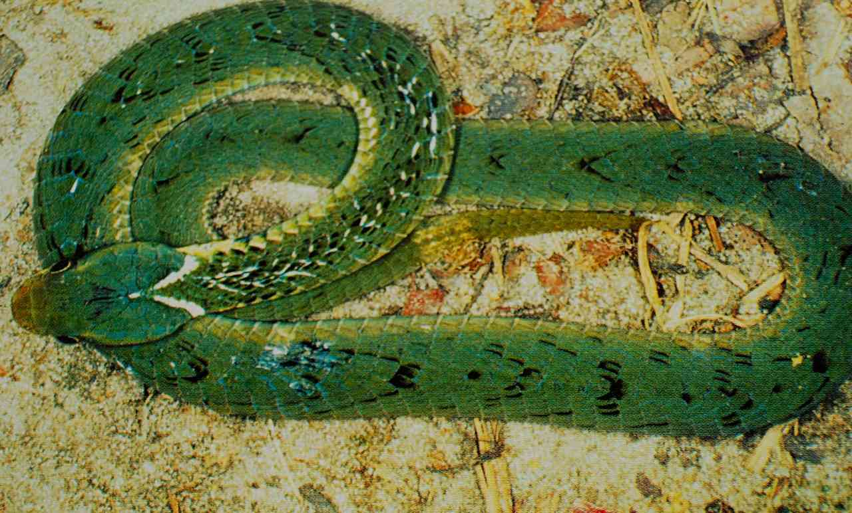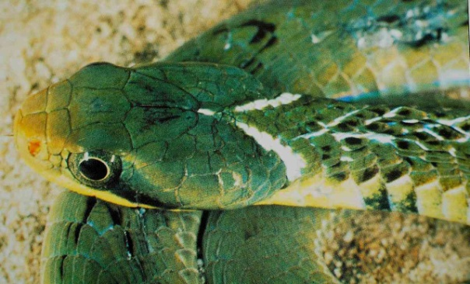
Photographs © FPD ‘Woody’ Cotterill; Zambia.

Mt Kenya Bush Viper Atheris desaixi
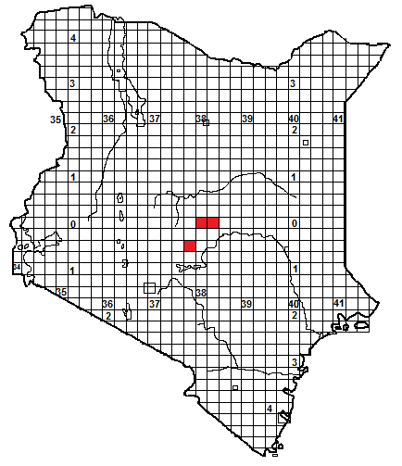
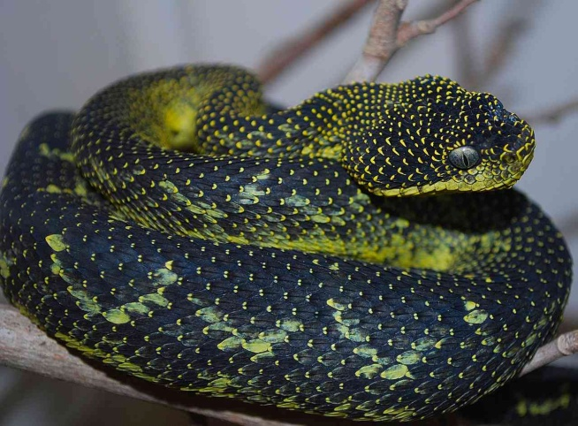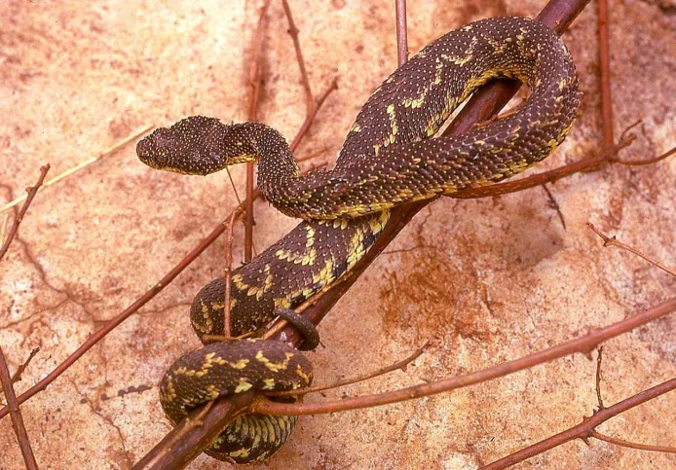
Identification: A thickset bush viper, with a broad triangular head covered with strongly keeled scales. Average size 40 to 60 cm, maximum about 70 cm. The body is greeny-black to charcoal black, most dorsal scales are edged with yellow to some extent, creating a speckled effect or a series of yellow half-loops. The belly is yellow, becoming progressively suffused with purplish black towards the tail. Occasional mono-coloured individuals – green or dull yellow occur (illustrated below).
Distribution: Endemic to Kenya, and known from three forests alone; the Mt Kenya forest west of Chuka town, the forests around Igembe in the Nyambene Range and the Ngaya (Ngaia) forest, north of the road connecting Kangeta with Meru National Park. Might be more widespread in similar mid-altitude forests in Kenya, for example those around Meru, or the eastern Aberdares.
Natural History: Arboreal and slow-moving. Activity patterns unknown, probably nocturnal but will opportunistically strike passing prey at any time. Usually found in low vegetation, but will ascent to 15 m or more in trees. Mating has been observed during the day. When molested, these snakes will form c-shaped coils and hiss and strike vigorously. They feed on small mammals. Up to 15 young are born alive.
Conservation Significance: Under threat; from habitat destruction and collection for the pet trade. Their exact range is not known, recent studies suggest that they occur in a relatively small area of the Chuka Forest, and commercial collectors there state that their numbers are declining. Research also failed to find the species in the Nyambene Hill forest. No part of their range is within a National Park.
Medical Significance: The toxicity of the venom is unknown, one bite victim suffered considerable swelling and pain; there is an anecdotal report of a death. Accidental bites are unlikely, although foresters might be at risk.
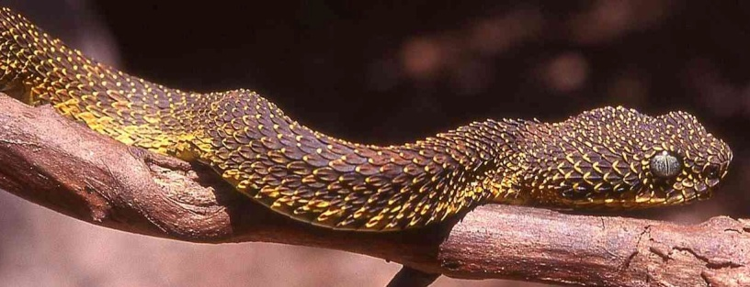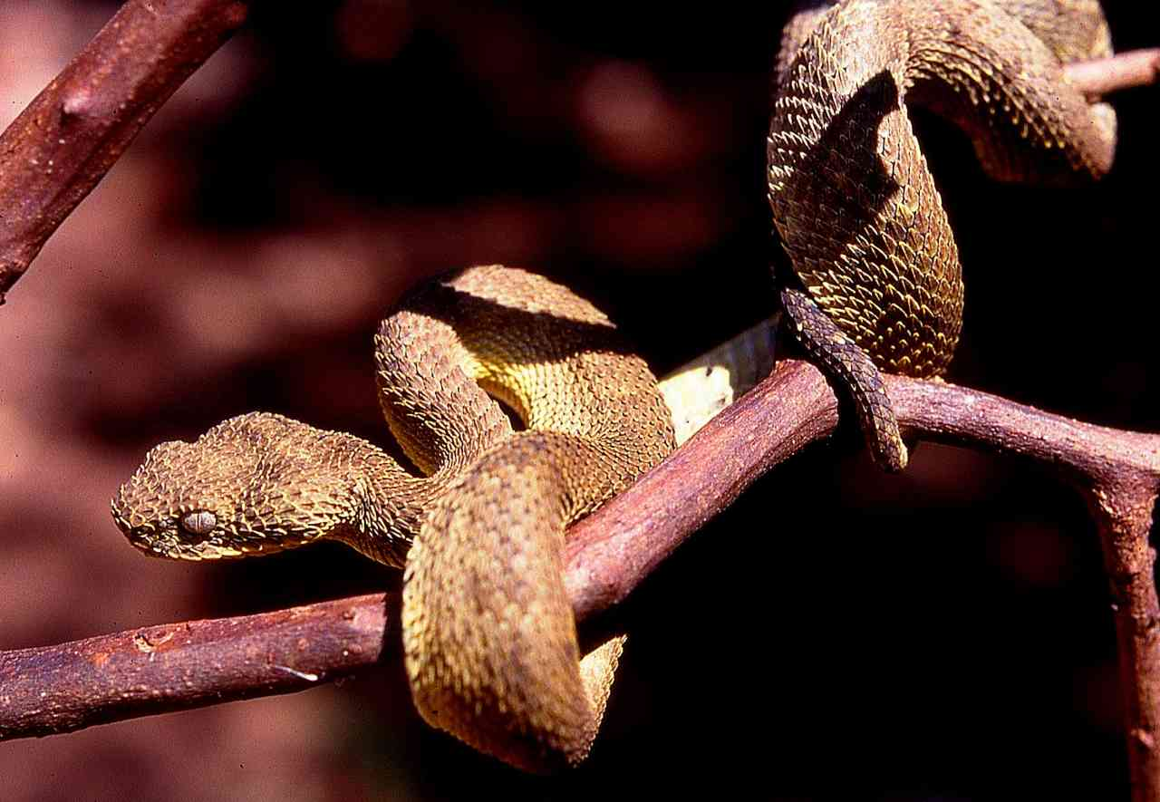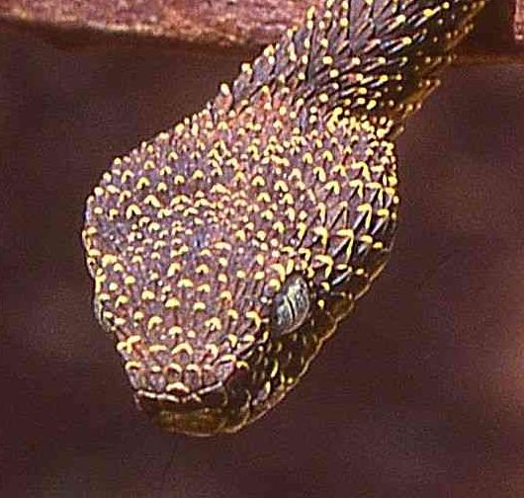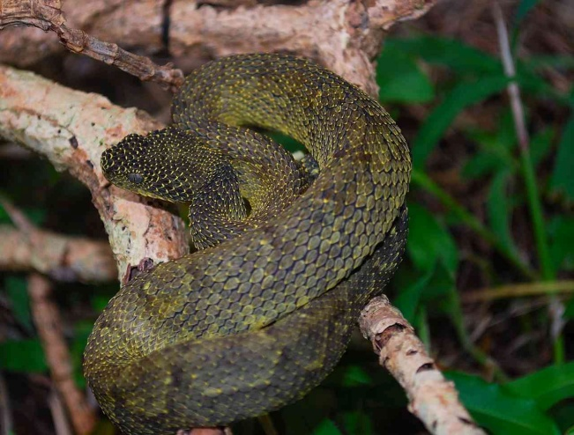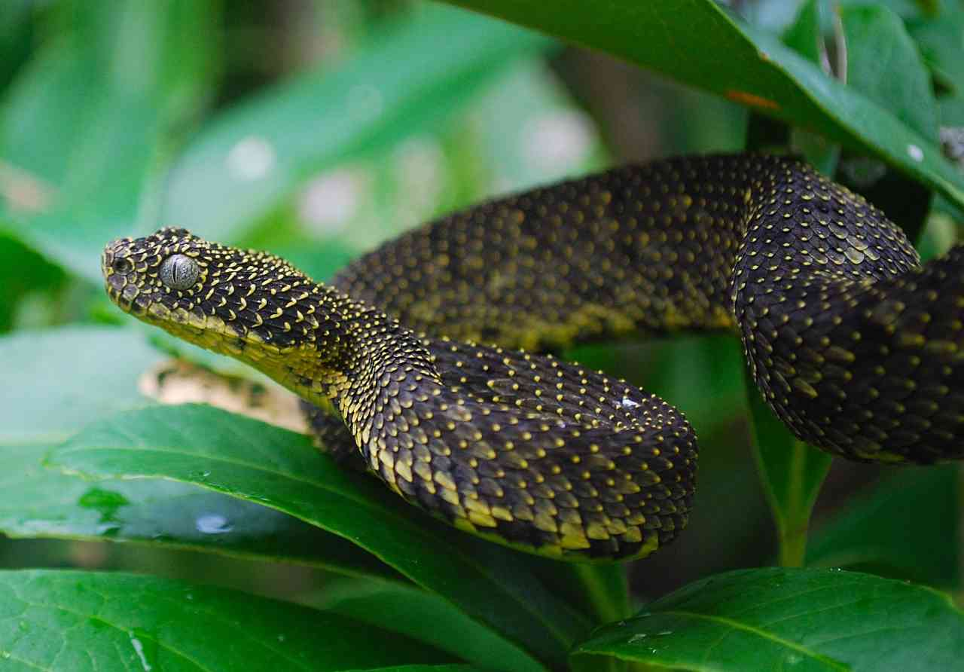
Green Bush Viper Atheris squamiger
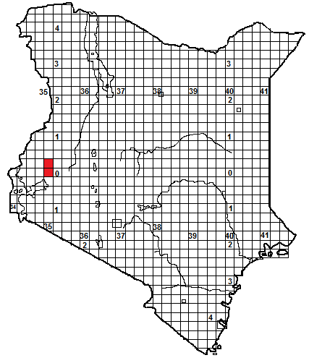
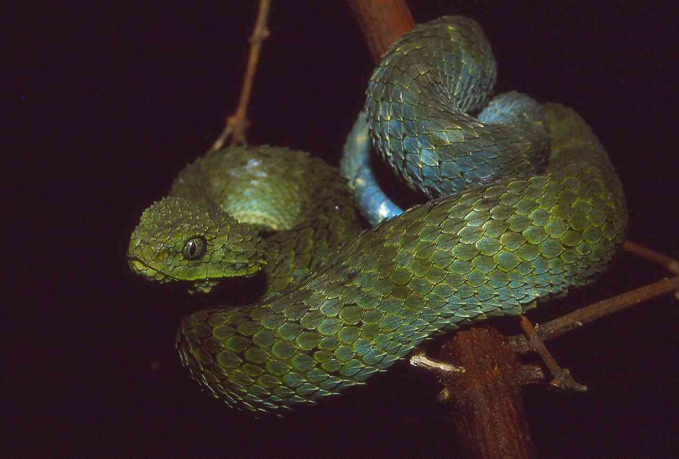
Identification: A thickset bush viper, with a broad triangular head covered with strongly keeled scales. Average size 40 to 65 cm, maximum about 75 cm. In Kenya usually green or yellow-green, becoming turquoise towards the tail, sometimes yellow-tipped scales form a series of fine yellow crossbars. Greenish-blue below, sometimes with yellow speckling, juveniles may show dark V-shapes on the back.

Distribution: In Kenya found in Kakamega forest, in the west. There is an enigmatic record from Chemelil and a sight record from the forest above the Soit Ololol escarpment above the Mara. Might occur in other western forests (Nandi, Mau Escarpment) but not yet recorded there.
Natural History: Arboreal and slow-moving. Largely nocturnal but will bask on top of vegetation and opportunistically strike passing prey at any time. Usually found in low vegetation, and small trees. When molested, these snakes will form c-shaped coils and hiss and strike vigorously. They feed on small mammals and lizards, amphibians and small snakes also recorded. Seven to nine young are born alive.
Conservation Significance: Entire range within Kenya protected in the Kakamega Forest. Widespread in the central African forest, so unlikely to be under any threat.
Medical Significance: The toxicity of the venom is poorly known but the bite has caused fatalities, the victim showed massive swelling and incoagulable blood. No existing serum gives protection against the bite of this snake. 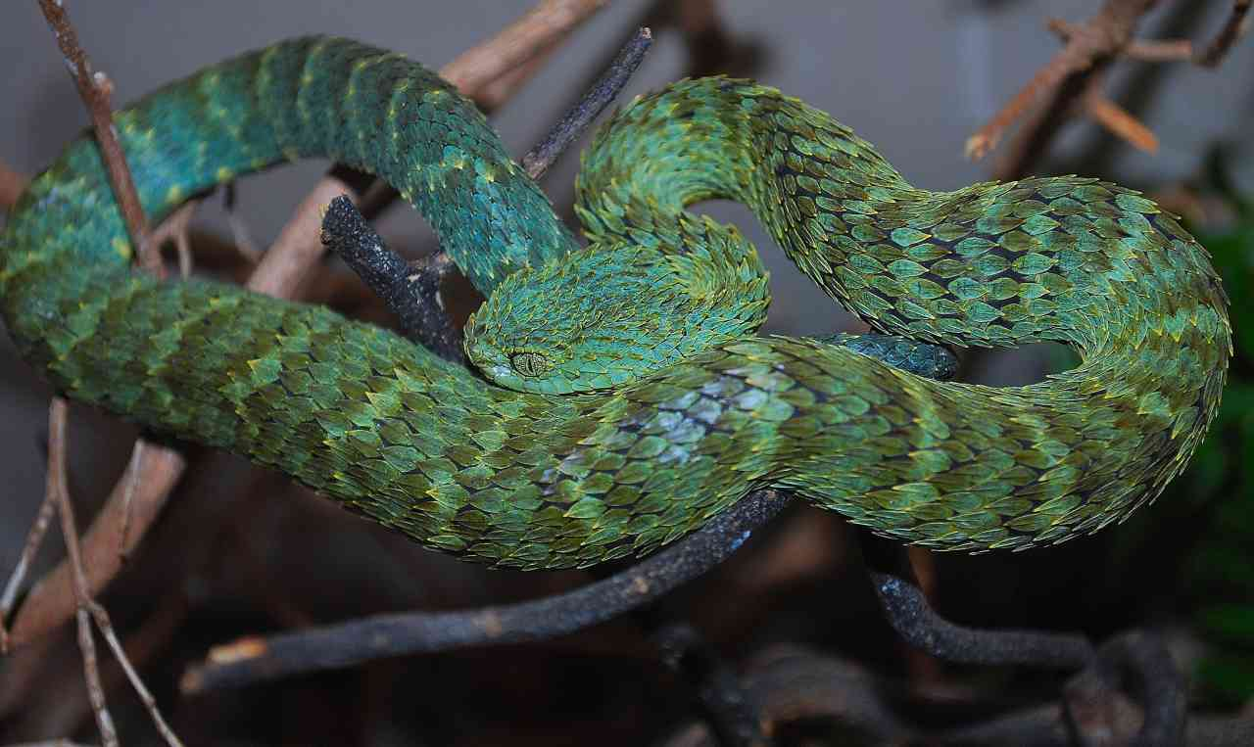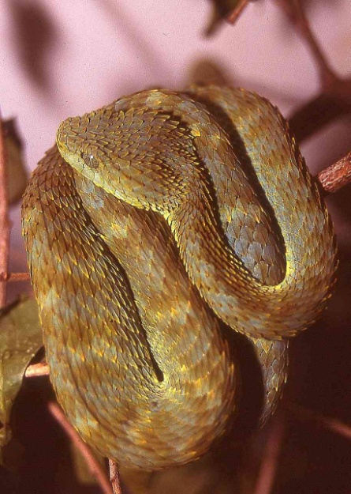 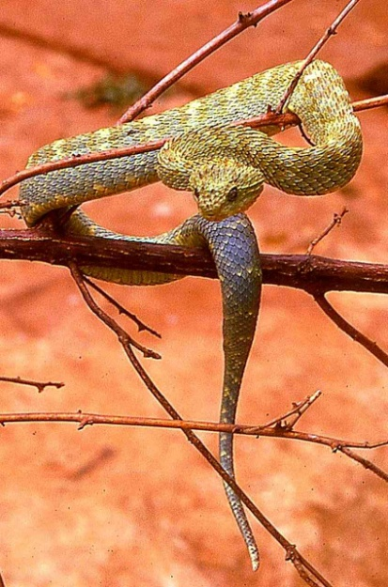 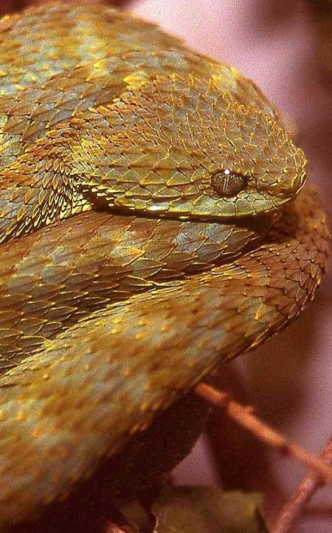
Rough-scaled Bush Viper/Prickly bush viper Atheris hispida
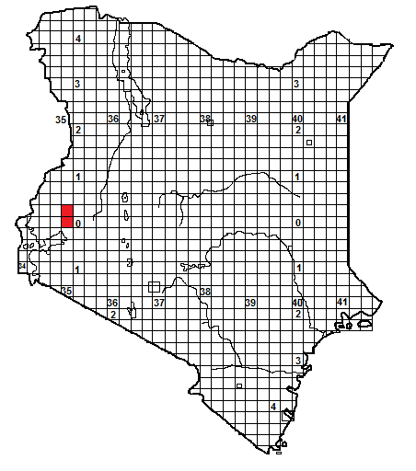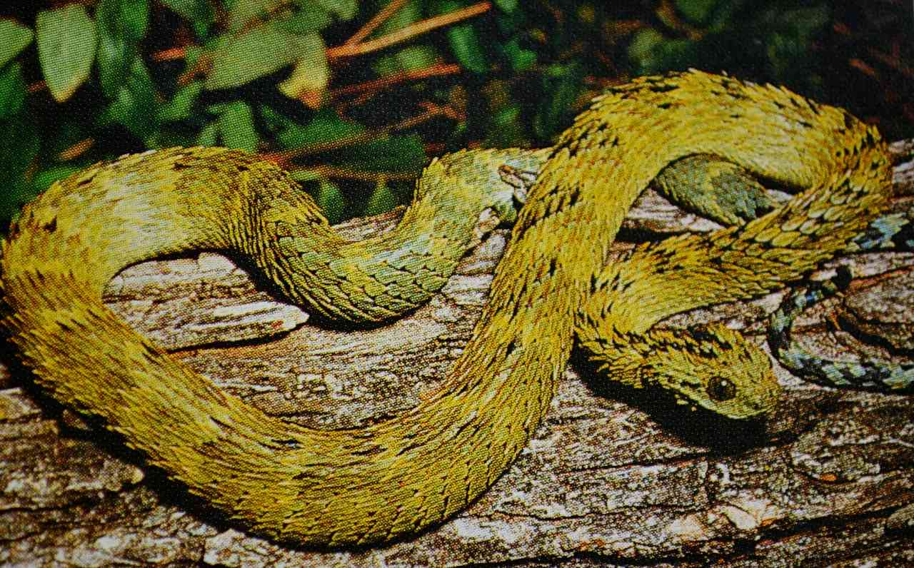
Photograph © John H Tashjian; Kakamega.
Identification: A slender bush viper, with a fairly broad triangular head, the head and body scales are curiously long, giving the impression of hairs (see head photo below). Average size 40 to 60 cm, maximum about 70 cm. In Kenya usually green or brownish, with a dark marking (often H, W, or V-shaped, sometimes just a dark blotch) on top of the head. Underside greenish, darkening towards the tail.
Distribution: In Kenya, so far found only in the Kakamega forest, in the west.
Natural History: Poorly known. Arboreal and slow-moving, climbs well, in Kakamega usually found in taller bushes than the green bush viper. Largely nocturnal but will bask on top of vegetation and opportunistically strike passing prey at any time. Usually in low vegetation, and small trees. When molested, these snakes form c-shaped coils and hiss and strike vigorously. Their mouths are often full of tiny black mites. Diet: small mammals and amphibians. Two to twelve young are born alive; in Kakamega born in April at the height of the rainy season. The numbers of this snake in the Kakamega Forest seem to vary in a curious way; sometimes they are present in numbers, at other times they appear to be absent.
Conservation Significance: Entire range within Kenya protected in the Kakamega Forest. Sporadically recorded from Uganda and the country around the Albertine Rift. Their status and distribution are poorly understood.
Medical Significance: The toxicity of the venom is unknown, presumably similar to oher bush vipers, but no bite cases are known. No existing serum gives protection against the bite of this snake.
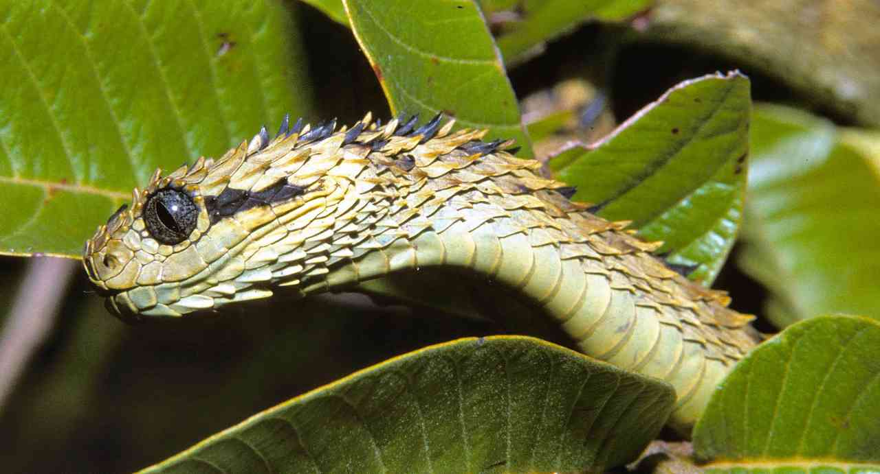
Photograph © Philipp Wagner; Kakamega
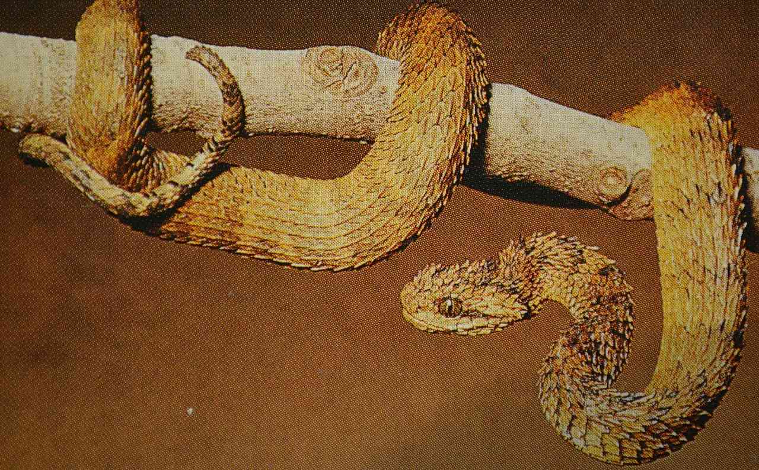
Photograph © John H Tashjian. Kakamega.

