The Kenya Reptile Atlas
A free, downloadable atlas of Kenya’s reptiles. This is a free source of regularly updated information on Kenya’s Reptiles. Authors: Stephen Spawls, Beryl Bwong, Patrick Malonza, Vincent Muchai, Victor Wasonga
Obtainable under ‘downloads’ at Kenyareptileatlas.com
This project is funded by the Rufford Foundation under the auspices of the National Museums of Kenya; Department of Herpetology.

The Kenya Reptile Atlas offers you:
Pictures of Kenya’s reptiles
Distribution maps by quarter-degree-square
A description of the species
Click on any of the titles listed under the downloads tab to download for free. The various families will be added as the accounts are completed.
If you have any observations of Kenya’s reptiles, any distribution records, or any other data, or any digital pictures, we would like to receive them! Send them to Kenyareptileatlas@gmail.com
And if you live or travel in Kenya, and find any dead reptiles, please preserve them and take them to the Herpetology Section at the National Museum, Museum Hill, Nairobi.
The team thanks those who kindly commented upon the text of this section or generously loaned us pictures; including Christopher V Anderson, Bill Branch, Jackie Hendrix, Tomas Mazuch, Konrad Mebert, Eduardo Razzetti, Lorenzo Vinciguerra, and the herpetological team at Bio-Ken at Watamu (Sanda Ashe, Anthony Childs and Royjan Taylor), All uncredited photos by Stephen Spawls.
Large rear-fanged Snakes
The Kenyan snakes in this account do not form a natural group. We describe here six species, of which four belong in the family Colubridae, sub-family Colubrinae, (boomslang, vine snakes, two Boiga) and two belong in the family Lamprophiidae, subfamily Psammophiinae (beaked snakes) . All are distinctive and relatively easy to identify if seen clearly. The reason we have chosen to group them together is all six species are relatively large, have large fangs set back in the upper jaw and are dangerous or potentially dangerous. It should be mentioned that bites by the snakes described here are extremely rare, and almost never occur to people who are unaware of the snake’s presence. However, at least two of these snakes (boomslang and the vine snake) have deadly venom and have killed people; one species (Blanding’s tree snake) has a very toxic venom but has not caused any fatalities. The powdered tree snake belongs to the same genus, although little appears to be known of its venom. Severe swelling and pain have been recorded following a bite from a rufous beaked snake, Rhamphiophis rostratus.
As always, we make a plea; specimens and data are needed for Kenya’s museums, without museum specimens, we cannot do conservation or taxonomic work. The species listed here are dangerous (some very dangerous) and not easy to catch; we do not advise trying to collect live specimens, if you are not an expert. But if you see one, (or any interesting reptile, for that matter) photograph it and send the picture to the address above. Likewise, if you find a dead specimen and it is not too damaged, take a good photograph of it. If you are certain it is dead and feel like contributing to the nation’s store of knowledge on reptiles, consider preserving it (in methylated spirit, or alcohol such as gin or vodka, if no formalin or ethanol is available), or freezing it, and take it to the Nairobi Museum. If the specimen is large and dead, cut off the head and preserve that, and take or send it to the museum at the address above.
Boomslang Dispholidus typus
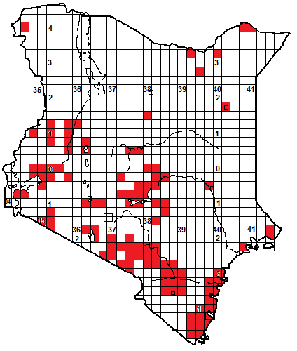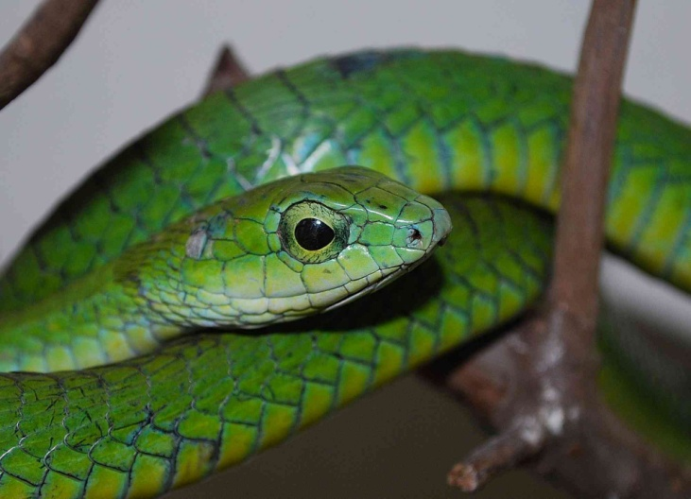
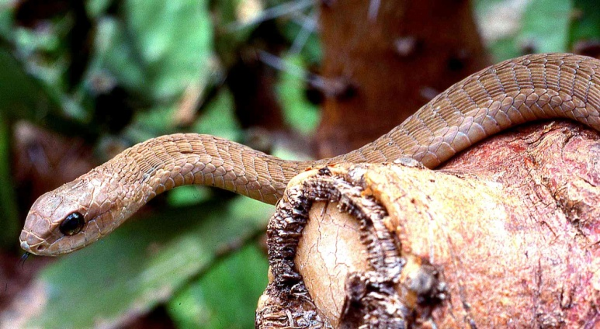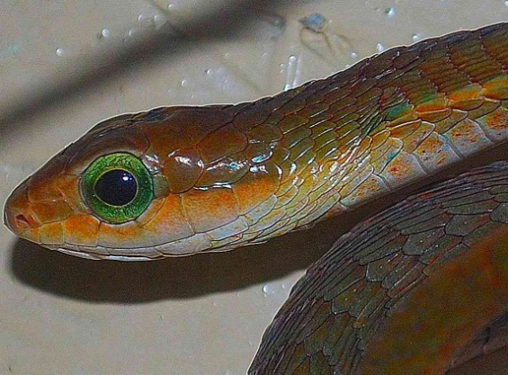
Local Names: Ngole (Swahili), Ndalanga (KiKamba), Ikwakwa (kiTharaka),
Identification: A big, slim, highly venomous tree snake, with a short egg-shaped head, a huge eye with a tear-drop shaped pupil, the body is sub-triangular and the scales are usually strongly and visibly keeled. Maximum size about 1.85 m, average 1.2 – 1.5 m, hatchlings about 30 cm. Adults may show a wide range of colours; males are usually some shade of green, females, grey or brown. Other Kenyan colour forms include olive, yellow-brown with white spots, green with black-edged scales, black, brown with a red head, and striped black and grey-white. Young ones are grey with black speckling below, dark with white speckling above, the chin and throat yellow, with an apple-green eye; often with a distinctive dark throat spot. They change to adult colour around 70-80 cm, and there is some evidence that adults may also change colour late in life; the turquoise individual below was originally green, the black one with a green head was all-green.
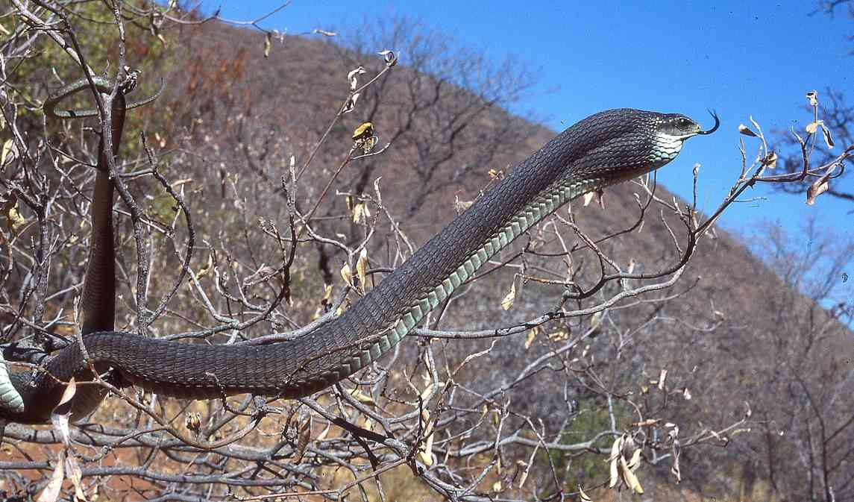
Distribution: Virtually throughout Kenya, in coastal thicket, forest and woodland, moist and dry savanna and semi-desert, around forest edges but not usually within dense mid-altitude forest. Absent from grassland and areas above 2 200m altitude. Few records from northern and northeastern Kenya, (probably occurs widely there but uncollected), oddly there are no records from near Nairobi.
Natural History: A diurnal, fast moving arboreal snake, climbing swiftly and effortlessly; it will descend to cross open areas or seize prey. It is non-aggressive but if threatened will inflate the neck and forepart of the body and flick the tongue in a deliberate fashion. Boomslangs have binocular vision and can spot motionless prey animals. They lay 8-25 eggs. Diet; most small vertebrates, including arboreal lizards (agamas, chameleons, geckoes), birds and eggs, frogs, bats and rodents. 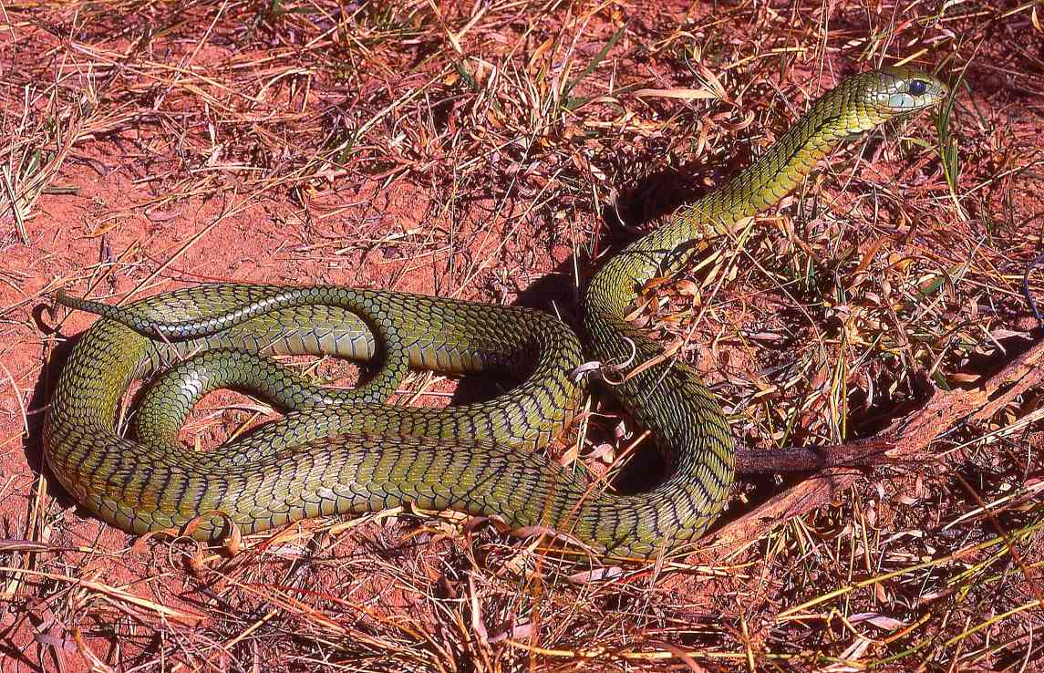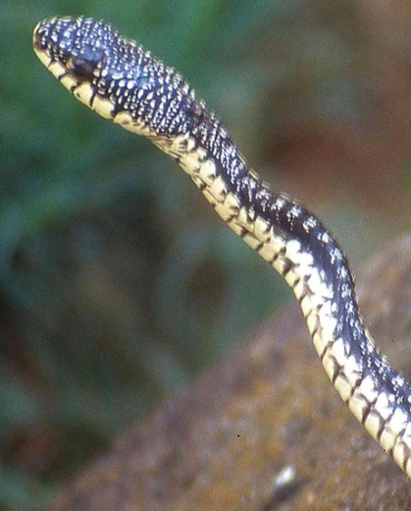
Medical Significance: Bites are very rare, but the venom, although slow-acting, is deadly, unlike that possessed by most rear-fanged snakes. The venom affects clotting factors in blood. Initially few symptoms are seen but after an interval of 1 to 24 hours a general bleeding tendency develops, and may cause death from progressive internal bleeding. An effective specific serum is obtainable from the South African Vaccine Producers. However, bites on victims who were unaware of the snake’s presence are very rare (occasionally people have been bitten after putting their hand into a birds nest), most bites were suffered by snake handlers. 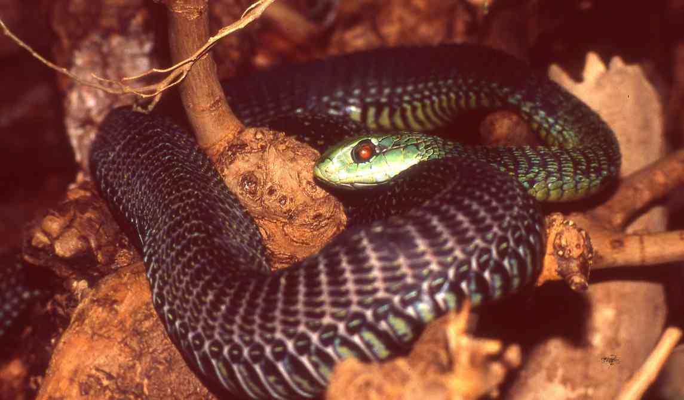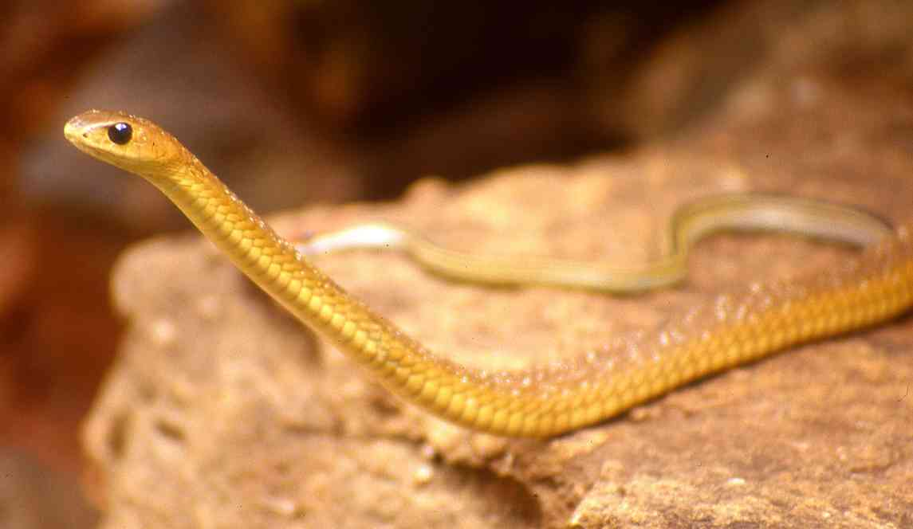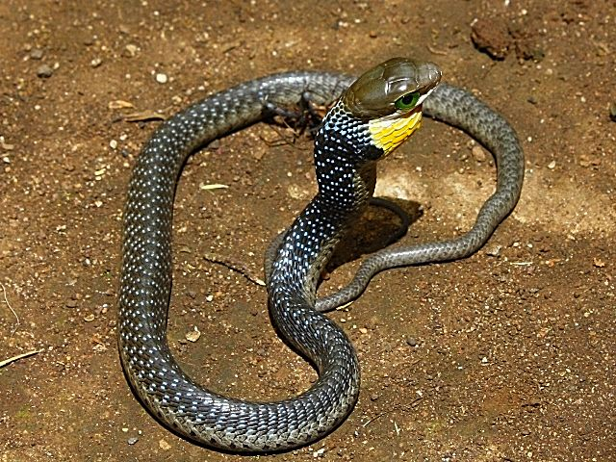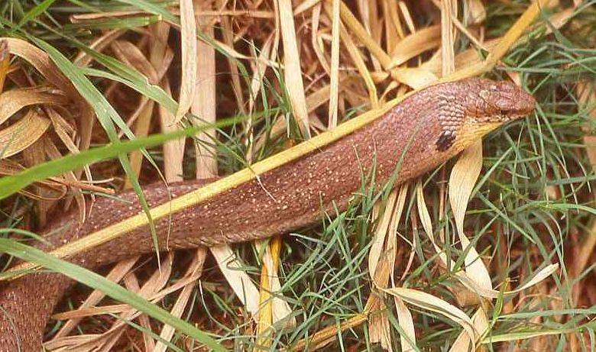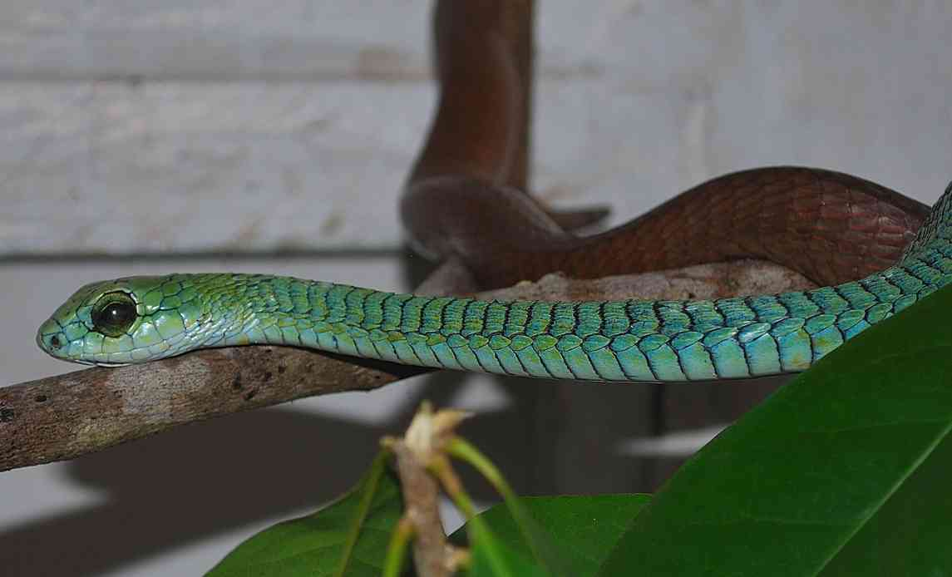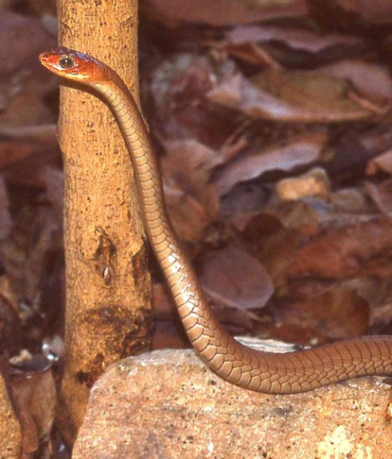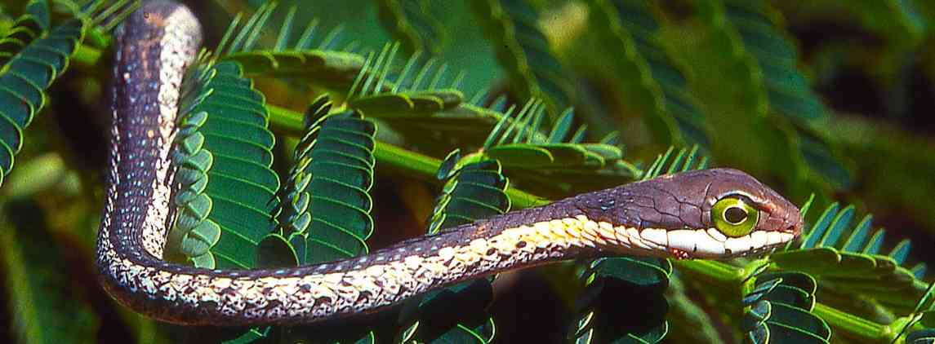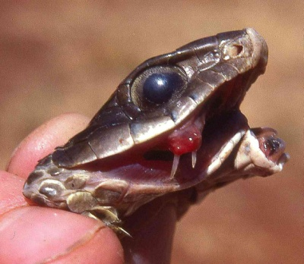
Illustrations: (from top and left to right) green Watamu, left brown Kitui, right with orange labials Watamu, big olive specimen in tree Otse, Botswana, dull green Kibwezi, striped black and white Ngomeni, black with green head captive, yellow with white spots Kitui, juvenile Lake Shalla (© Jackie Hendrix), brown with black neck spot Kajiado, turquoise Watamu, brown with red head northern Tanzania (photo © Lorenzo Vinciguerra), juvenile Otse Botswana, brown with fangs Otse Botswana, black specimen Diani (© Patrick Malonza), green and black specimen Arusha.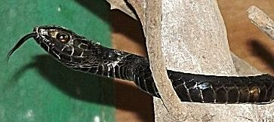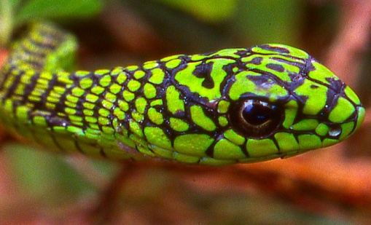
Savanna vine snake/Savanna twig snake, Thelotornis mossambicanus
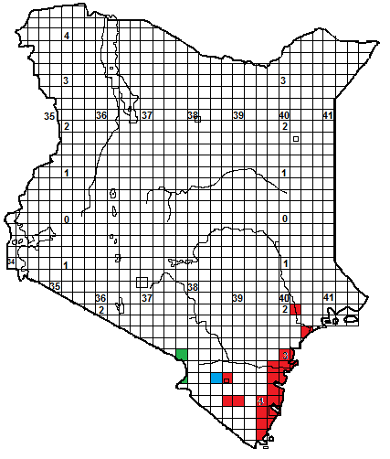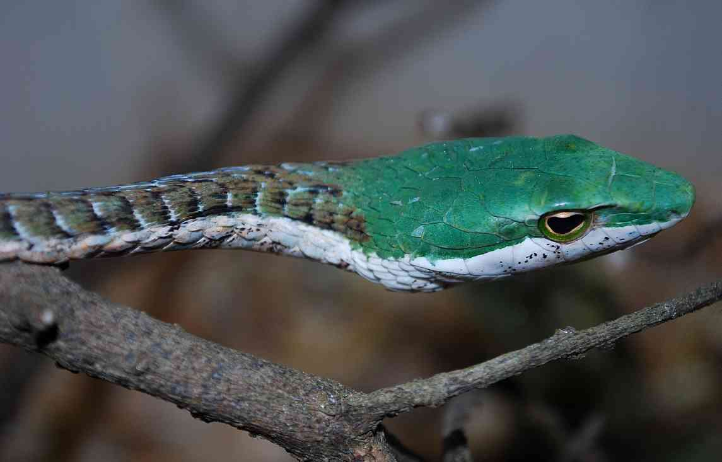

Taxonomic Note: African vine snakes were originally regarded as a single species, Thelotornis kirtlandii. The southern subspecies T. k. capensis was then elevated to a full species, Thelotornis capensis. East African snakes were placed in the subspecies. T. c. mossambicanus. In 2001 the Kenya and Tanzanian coastal forms were split off into a new species. T. usambaricus, by Don Broadley, who stated that in all specimens of T. usambaricus, the top of the head was uniform green. However, in Kenya, some have brown heads. Broadley also said that T. mossambicanus always have brown temporal scales (on the side of the head, just back from the eye). Specimens associated with the forests near Mt Kilimanjaro fit this description, but in the Taita Hills there are both intermediates and ‘typical’ T. mossambicanus, slightly further east are ‘typical’ T. usambaricus. We are not yet convinced of the existence of two species in Kenya. For the time being, we have conservatively chosen to regard all Kenyan vine snakes as a single species, Thelotornis mossambicanus, although the map shows green squares for specimens with brown temporals and green tops to their heads, blue for intermediates and red squares for specimens with the tops of their heads uniformly coloured.
Local Names: None known.
Identification: A very thin, highly venomous tree snake, easily identified by its long pointed head, which is green or brown or a mixture of both, distinctive horizontally elongate pupil, like a sideways keyhole and very thin greyish body. Maximum size about 1.5 m, average 90 cm to 1.3 m, hatchlings 20-30 cm. From a distance looks speckled silvery-grey. In coastal specimens, the head may be green or brown above, and there is often a vague dark triangular blotch or outline on the sixth upper labial scale.
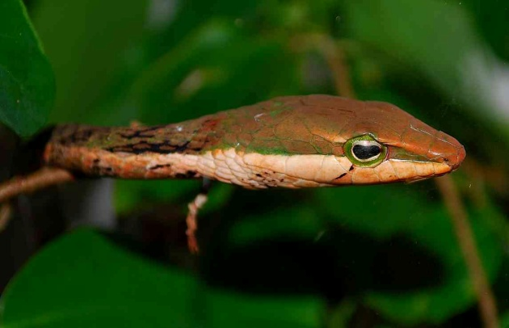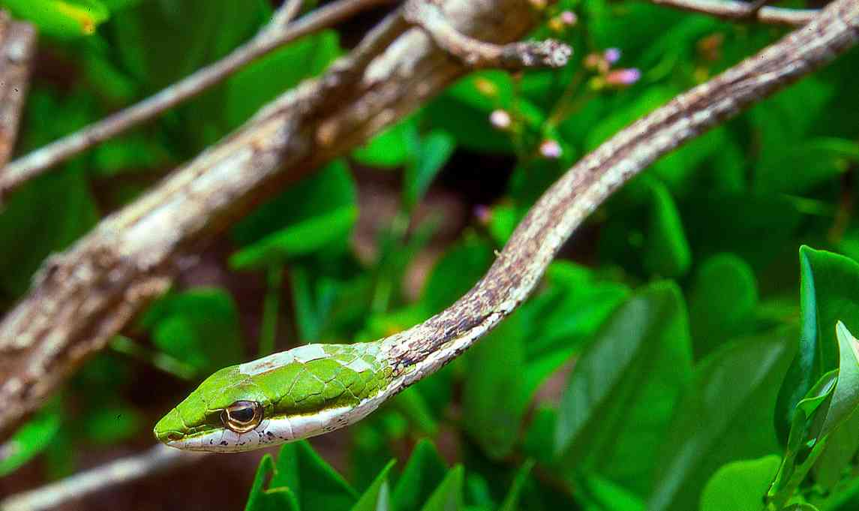
Distribution: South-eastern Kenya. Woodland and thicket of the Kenyan coastal plain, from the lower Tana and the Tana Delta south to the southern Shimba Hills, inland records include Voi, the Taita Hills, Kilibasi, Kasigau and the woodland and forest around Mt Kilimanjaro, between sea level and 2000 m.
Natural History: A diurnal, arboreal and secretive snake. Waits in a tree or bush watching for prey, sometimes with the body extended outwards like a twig, with the head resembling a green or brown leaf. It has binocular vision and can see motionless prey. It will drop down to seize prey on the ground. A gentle snake, unaggressive, but if molested and unable to retreat it may inflate the front half of the body and flick the distinctive red and black tongue up and down. The males fight in the mating season. Four to thirteen eggs are laid. They eat a range of prey, including amphibians, lizards, bats, other snakes and birds. Often mobbed by birds.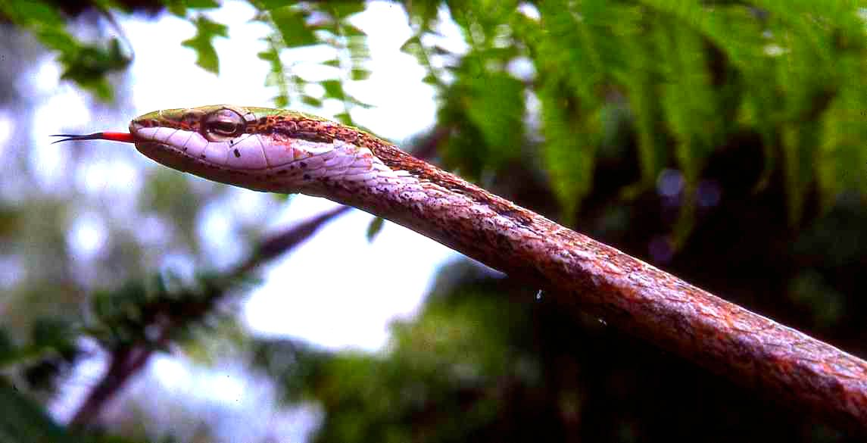 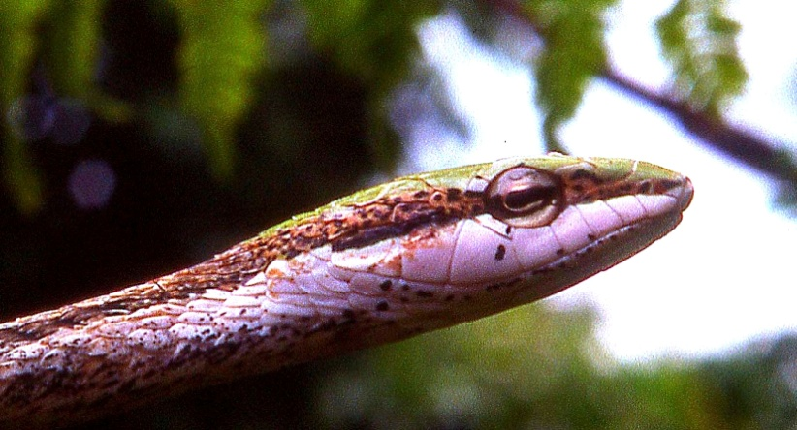
Medical Significance: Venom deadly, unlike most rear-fanged snakes, but slow-acting; affecting clotting factors in blood. Initially few symptoms are seen but after an interval of 1 to 24 hours a general bleeding tendency develops, and may cause death from progressive internal bleeding. No antivenom is produced. However, as with the boomslang, bites on unsuspecting victims are virtually unknown, most recorded bites were suffered by snake handlers.
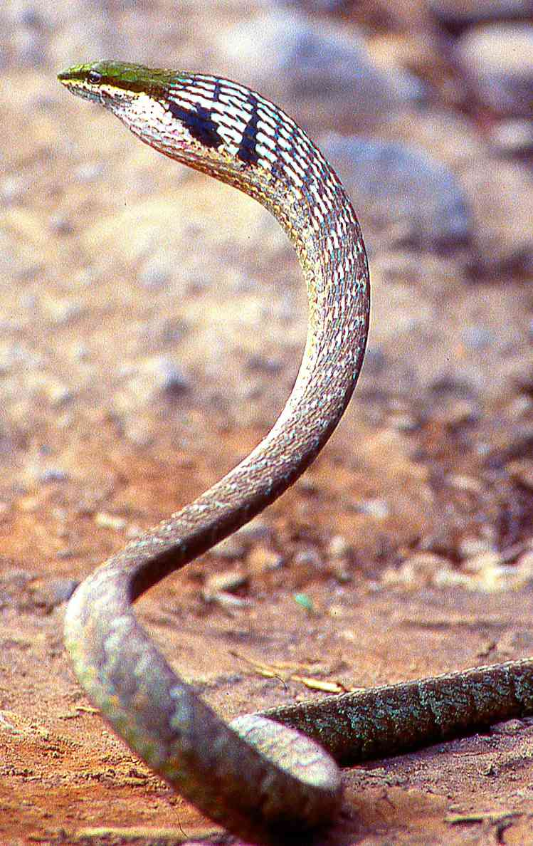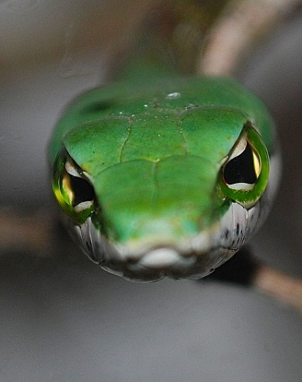
Illustrations: Top three Watamu, middle two Arusha National Park, neck inflated specimen Mt Meru (© Lorenzo Vinciguerra), bottom right Watamu.
Blanding’s Tree snake Boiga (Toxicodryas) blandingii
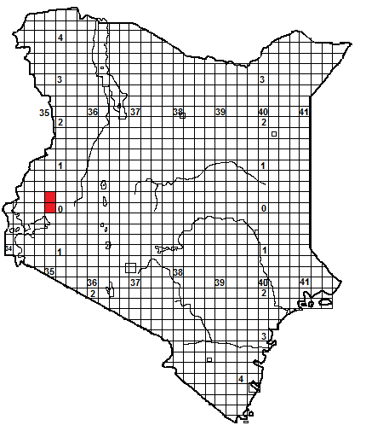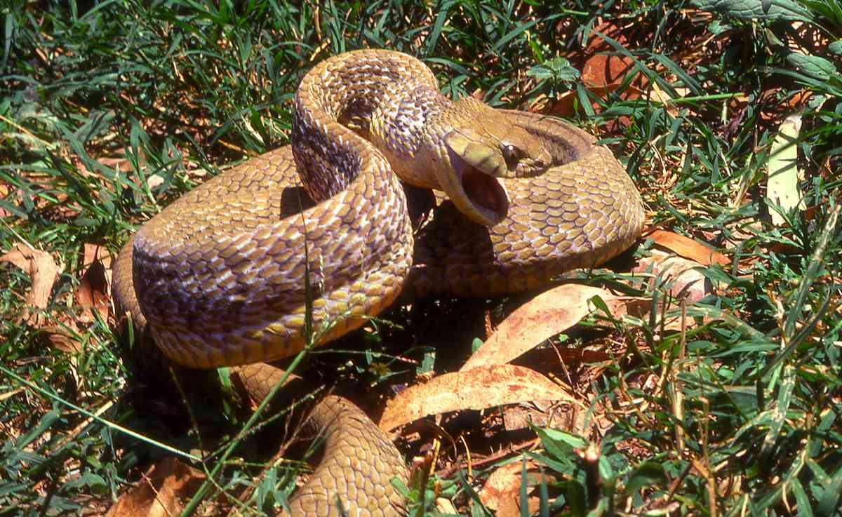
Local Names: None known
Identification: A huge, rear-fanged nocturnal tree snake, with a thin neck and short broad head; big adults can be stocky but this snake usually appears relatively slim, with a triangular body shape. Maximum size about 2.8 m, average 1.4 – 2 m, hatchling size unknown. Adult males usually black above, ventral and lip scales yellow with black edging; females brown, rufous, grey or yellow brown. Juveniles of both sexes are brown or pinkish brown, with clear black diamond flanks bars that often touch to form cross bars; as they grow the darker diamonds may persist to some extent. Readers should be aware that the black males of this species are very similar to Gold’s Tree Cobra, a highly venomous species, although Gold’s tree cobra has very shiny skin, Blanding’s tree snake has more velvety skin, with a remarkable bloom on the scales, and its eye is more prominent and obvious.
Distribution: A snake of the forest and woodland of West and Central Africa, in Uganda it is known from forest-savanna mosaic and riverine woodland. In Kenya recorded only from the western forest at Kakamega, Serem and Kobujoi (South Nandi Forest) at altitudes between 1 500 and 2 000 m.
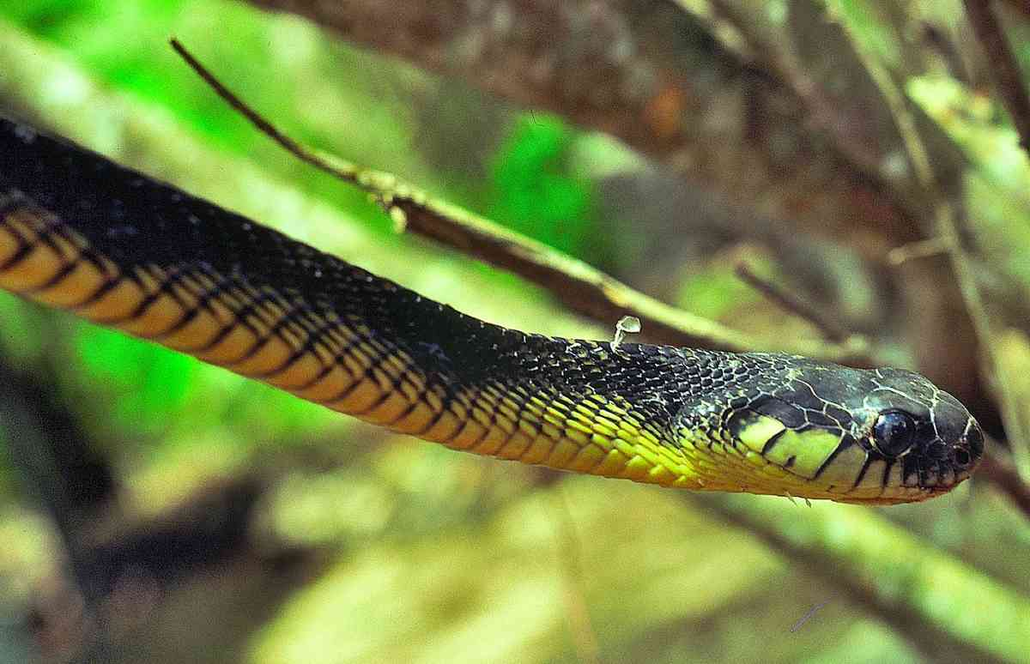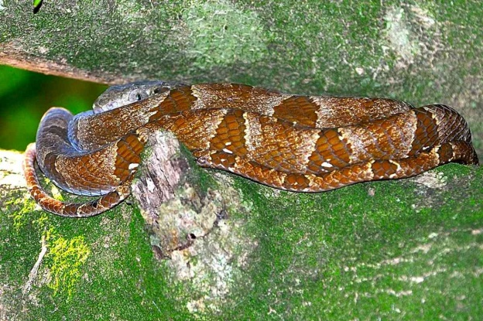
Natural History: Unusually for a tree snake, it is nocturnal; climbing quickly and ponderously to over 30 m in big forest trees, although it will descend to cross roads and open spaces. When inactive hides in leaf clumps, thickets, hollows in trees etc. It has a distinctive threat display; it inflates the body, hisses loudly, flattens the head and opens the mouth. If further molested it will strike, but often aims to miss. They eat a wide range of food, including arboreal rodents, bats, birds and their eggs and lizards; in Kakamega specimens were regularly found in trees outside caves where bats were roosting. They lay from 7-14 eggs.
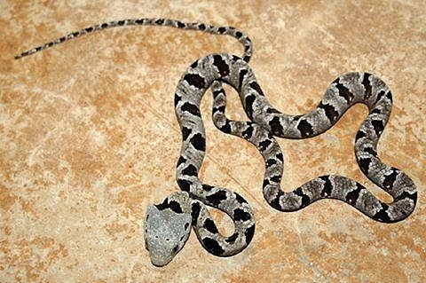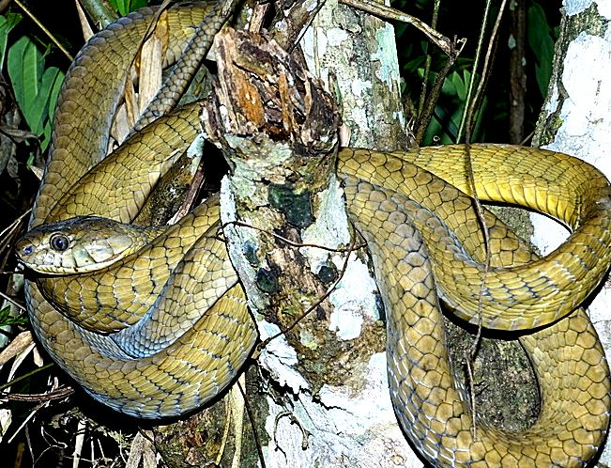
Medical Significance: Bites from this species are very unusual, as might be expected with a secretive tree snake that avoids human contact. It is also rear-fanged, although it has a wide gape. Snake handlers bitten by this species experienced pain and swelling. However, studies indicate that the venom of this snake contains a powerful neurotoxin, as toxic as that possessed by highly venomous Asian Kraits (Bungarus sp).
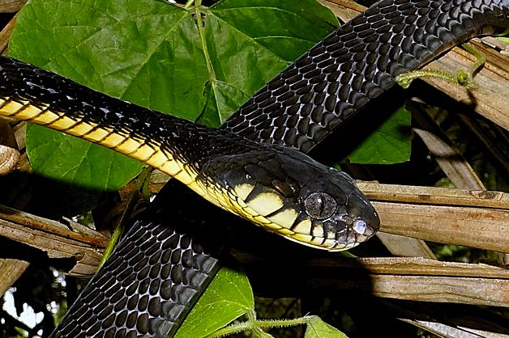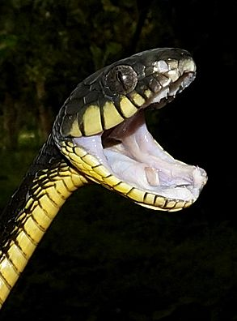
Illustrations: Top female, Kakamega, upper middle left male, Kakamega, right juvenile, Entebbe, Uganda, upper bottom hatchling; Uganda (photo by Mike Ryan), all others Konrad Mebert, near Kisangani, Congo.

Powdered Tree snake Boiga (Toxicodryas) pulverulenta
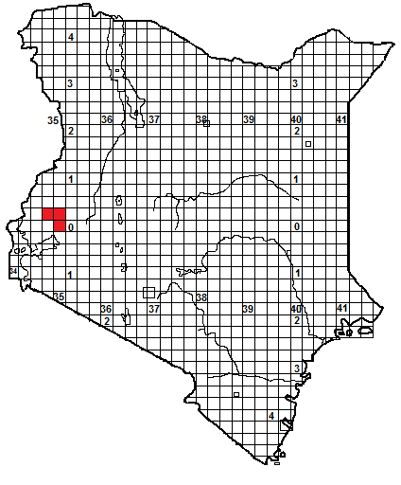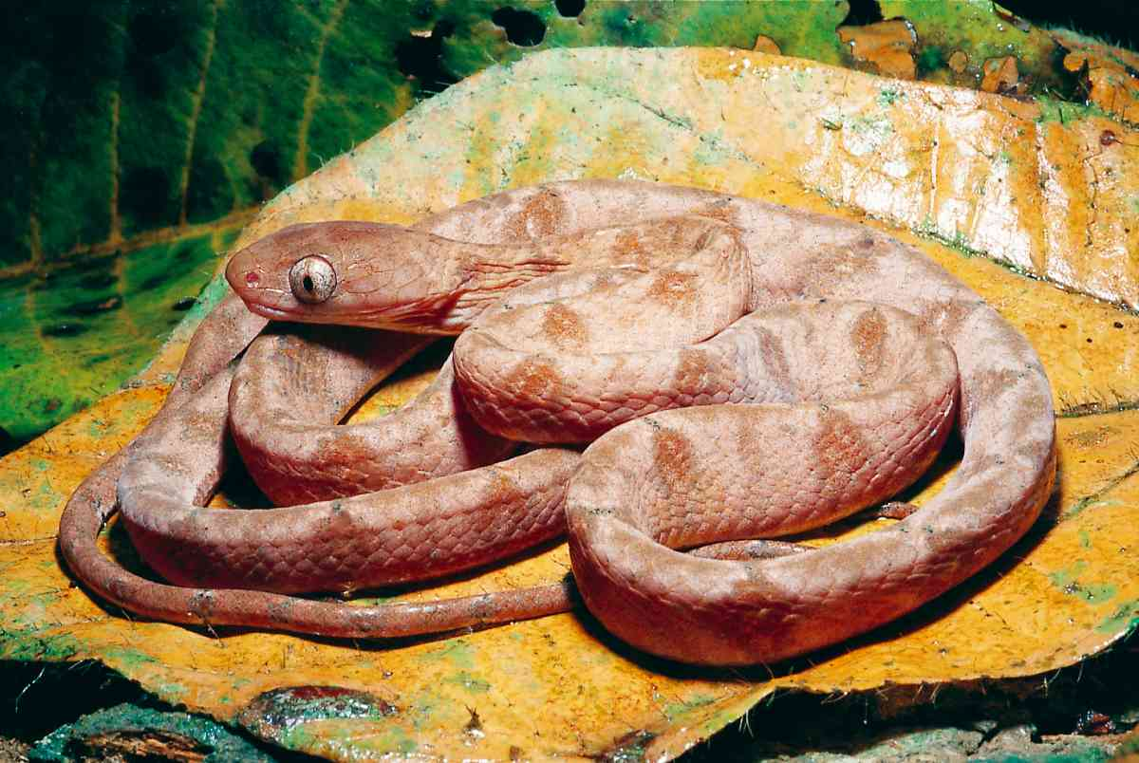
Local Names: None known
Identification: A very slim nocturnal tree snake, with a thin neck, short broad head, prominent eye with a vertical pupil. Maximum size about 1.25 m, average 80 cm to 1.1 m hatchling size unknown. Colour pinkish to red-brown or grey, with darker crossbars consisting of subtriangular flank patches (often with light centres) that may meet on the spine. The back is usually finely or coarsely dusted with white, brown or black speckles and blotches, the belly is pale, often pink, with a darker line on the outer keeled edges of the ventral scales.
Distribution: A snake of the forest and woodland of West and Central Africa, in Kenya recorded only from the west; from forest at Kakamega and Serem and from woodland at Mumias, all at altitudes between 1 500 and 2 000 m.
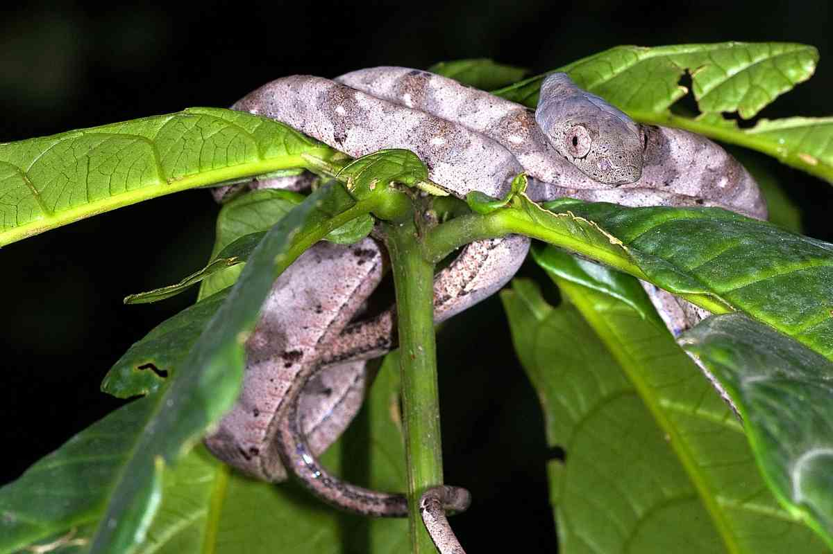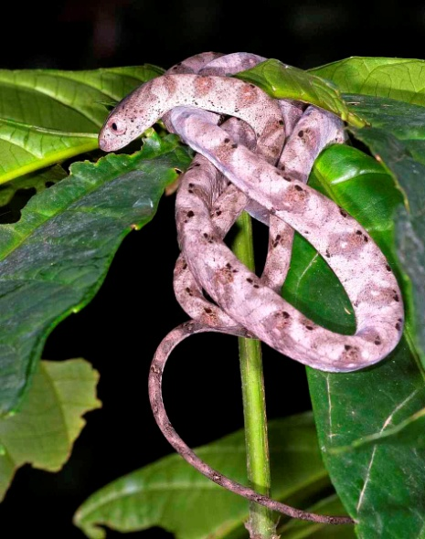
Natural History: Little is known of this snake’s behaviour. It is arboreal and nocturnal, a careful and elegant climber. During the day it shelters in vegetation and crack and holes in trees. When threatened, it inflates itself and raises the forepart of the body in a pile of elevated coils, as shown below, if further molested it will strike. It lays eggs. Diet; rodents and arboreal lizards.
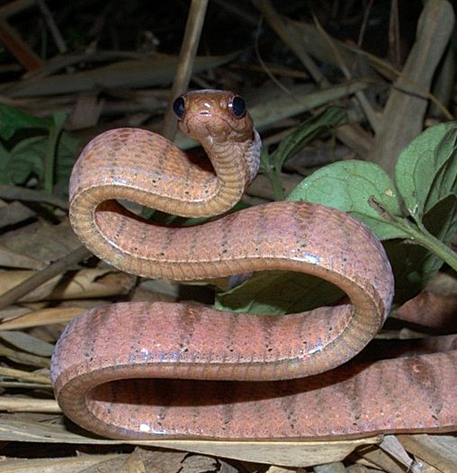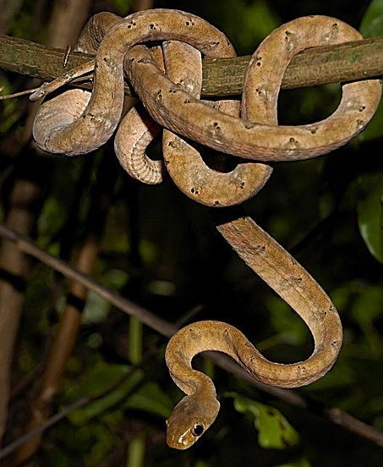
Medical Significance: No details of the venom are known, but the venom of a member of the same genus, Blanding’s tree snake, is toxic, so bites are best avoided.
Illustrations: Top Gabon, Bill Branch, middle two Christopher V Anderson, Cameroon, all lower pictures Konrad Mebert, near Kisangani, Congo.
Rufous Beaked Snake Rhamphiophis rostratus
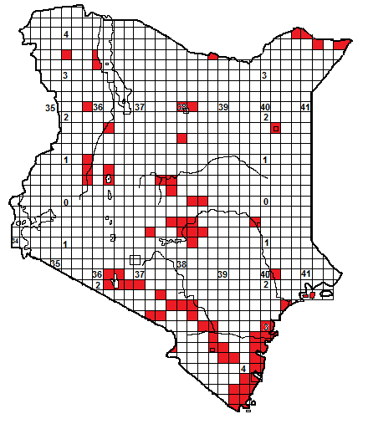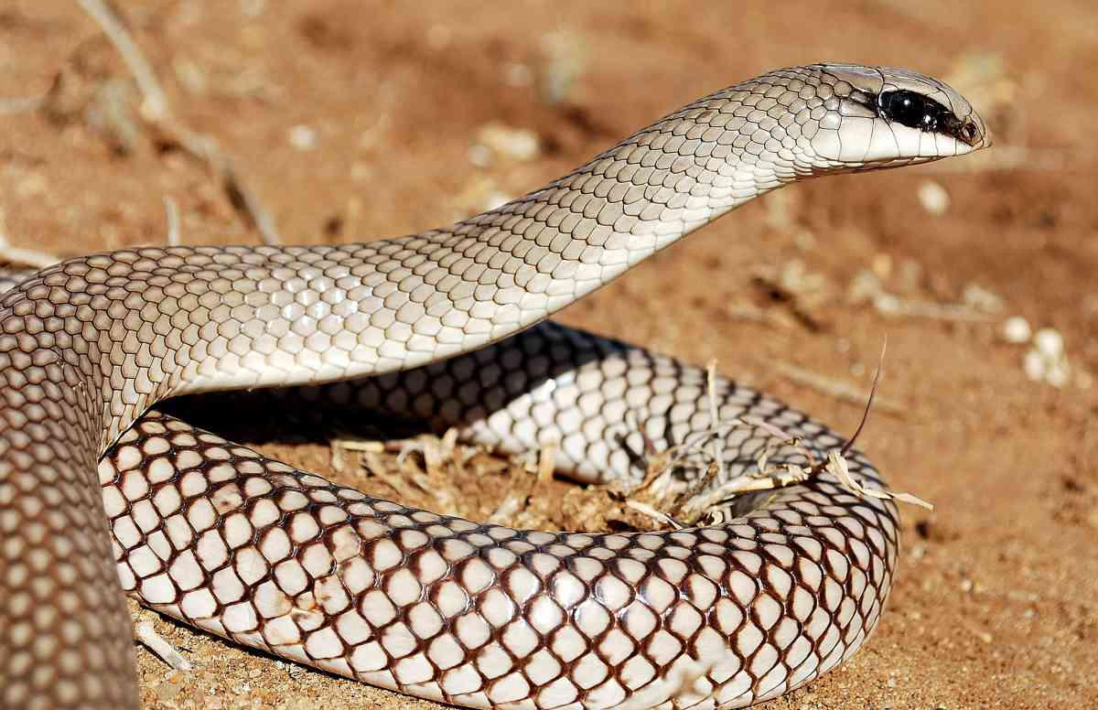
Local Names: None known
Identification: A fairly large, muscular rear-fanged snake, with a short head, pointed snout and a distinctive dark line through the large eye. Maximum size about 1.6 m, average 1-1.3 m, hatchlings 25-30 cm. Colour quite variable, usually brownish but may be white, pink, grey or orange. Often the scales on the back half of the body have lighter centres, giving a reticulate effect. Ventral scales are usually immaculate white or cream. Juveniles are heavily speckled irregular red-brown.
Distribution: Semi-desert, dry and moist savanna, coastal thicket and woodland, from sea-level to about 1 500 m altitude. Probably occurs throughout northern and eastern Kenya and the southern Rift Valley, save in near-desert areas, but records sporadic. May penetrate up river valleys in suitable areas, for example found around Muranga. Relatively common in eastern Kenya. Not known from southwest Kenya.
Natural History: Secretive, diurnal and largely terrestrial, although it will climb bushes and low trees. It spends much time in holes, looking for prey, and it can dig with its rostral scale. Fast moving, in the open often pauses with its head and neck raised, if threatened it may flatten the neck into a slight hood (see picture below). It lays clutches of 4 to 12 eggs. Hatchlings were observed in December in Tsavo National Park. Diet: a wide range of prey, including rodents, lizards, frogs and snakes, even arthropods. Captive specimens have been observed neck-wrestling over a prey item.
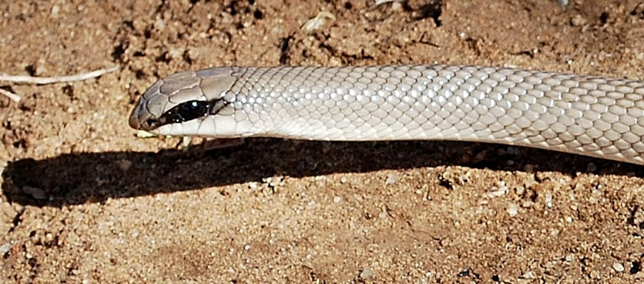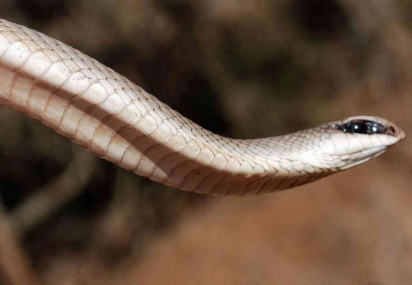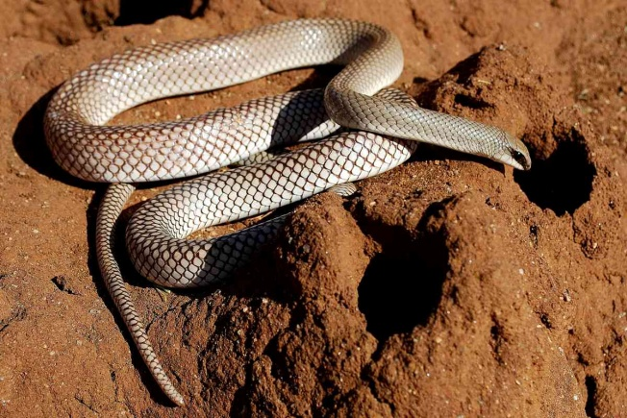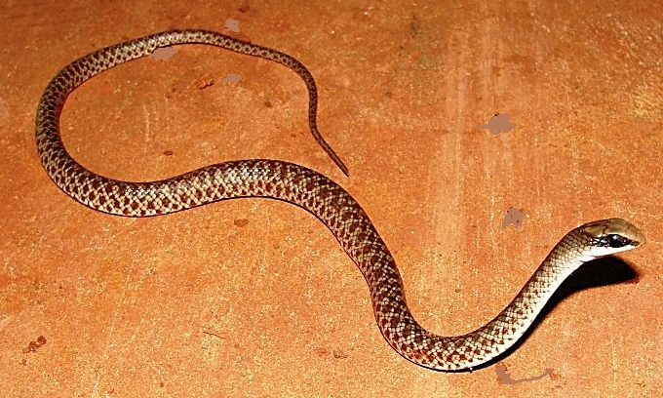
Medical Significance: Bites by this snake are unlikely, as they are alert, fast moving and non-aggressive. However, a clinical investigation of the venom found it was a potent neurotoxin, while amateur snake keepers have reported intense pain and swelling following a bite. It is a fairly large snake, so bites are best avoided.
Illustrations: Kajiado (except juvenile lower middle right, Shimba Hills, © Patrick Malonza), and bottom, Malindi.
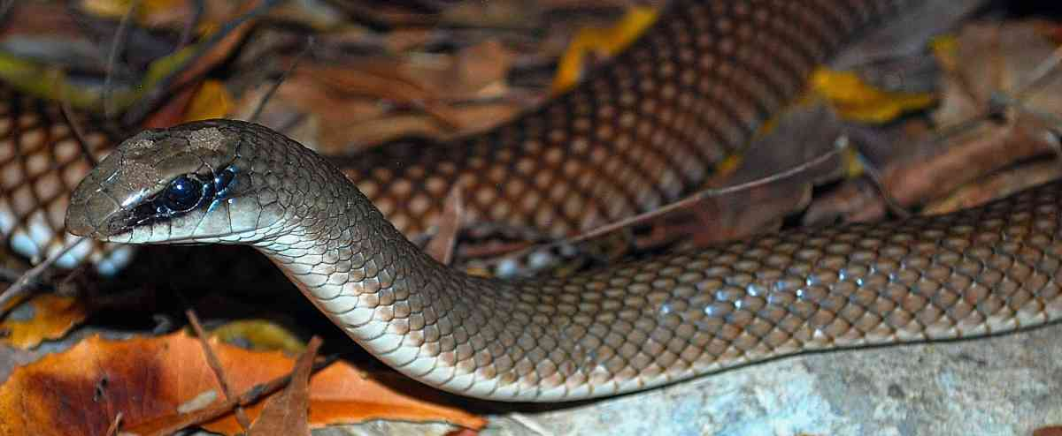

Red-spotted Beaked Snake Rhamphiophis rubropunctatus 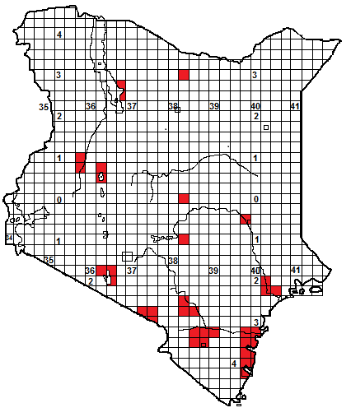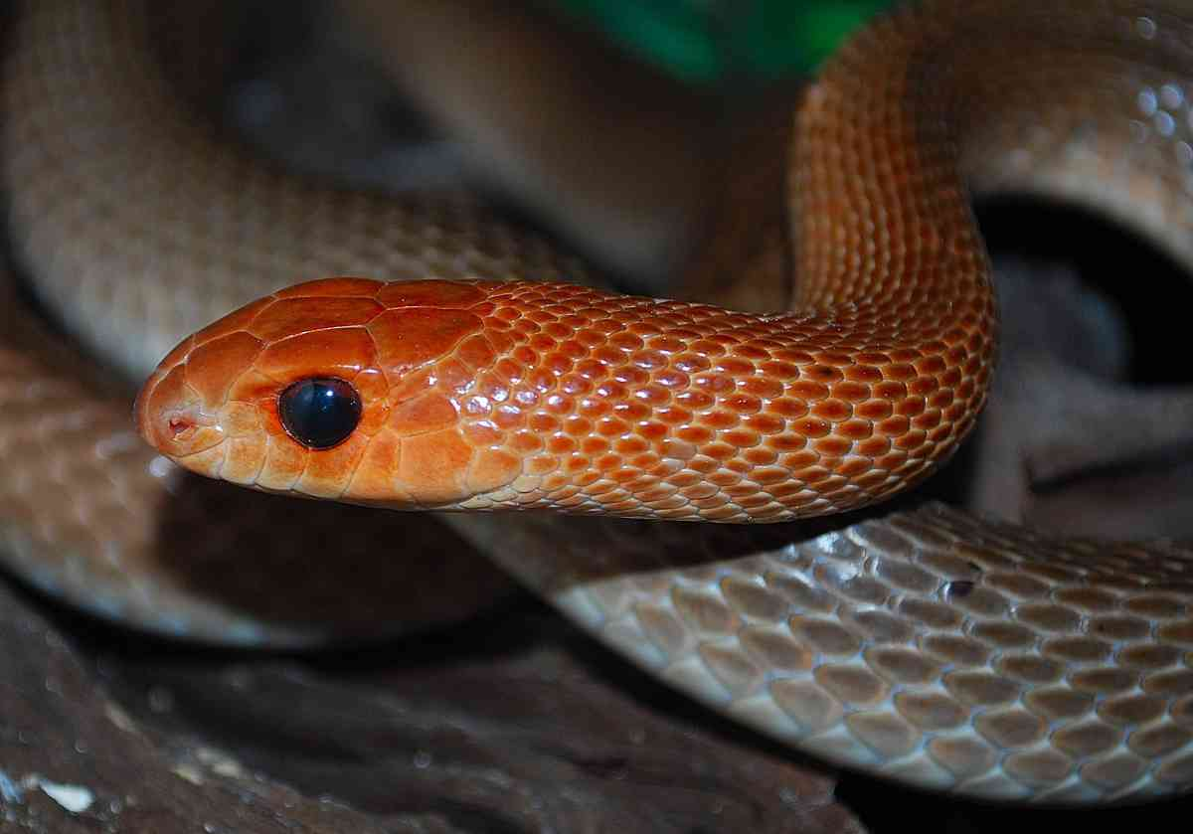
Identification: A big, grey or grey-brown, orange-headed rear-fanged snake, with a short head, pointed snout and a large distinctive dark eye. Maximum size about 2.5 m, average 1.2 – 2m, hatchlings around 30-35 cm. Colour usually grey, with an orange head, and immaculate white or cream ventrals Juveniles are heavily speckled irregular red-brown (see last picture). Note; in dry areas of East Africa a colour phase of the boomslang also has a red head and brown body. 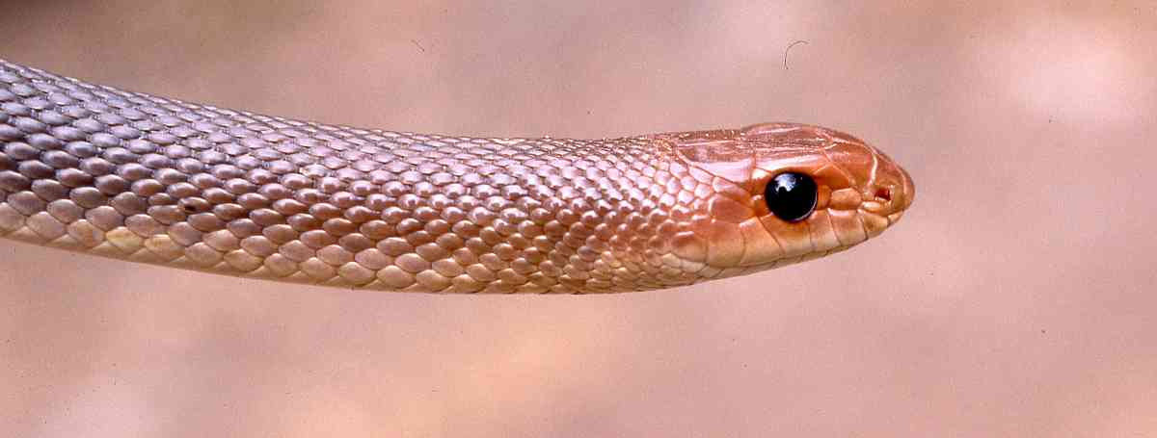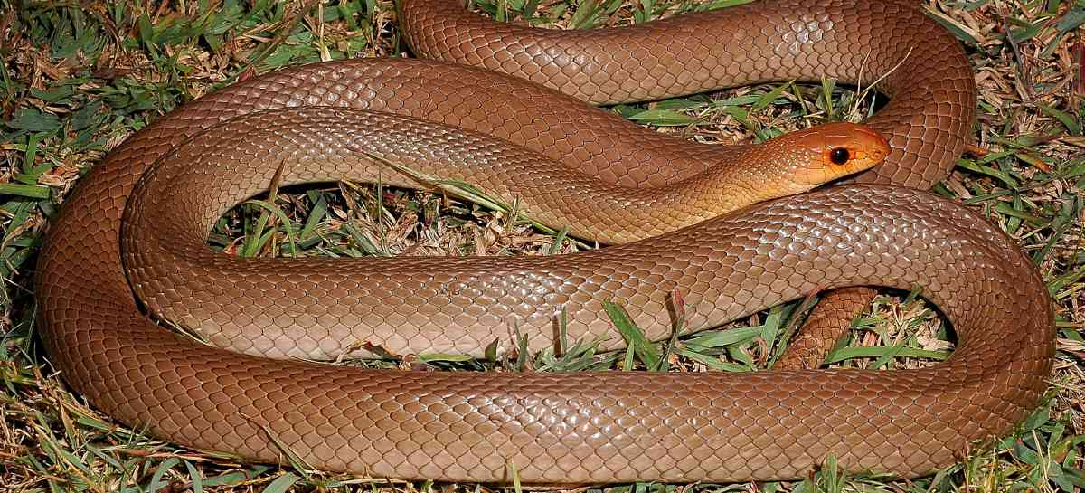
Distribution: Near-desert, semi-desert, dry and moist savanna, coastal thicket and woodland, from sea-level to about 1 200 m altitude. Widespread in eastern Kenya from the Magadi area eastwards through Tsavo and Ukambani to the coast (it is relatively common between Kilifi and Watamu, and in the Shimba Hills-Msambweni-Kwale area), probably widespread across northern Kenya but there are only handful of widely scattered records from there, and none from the extreme northeast.
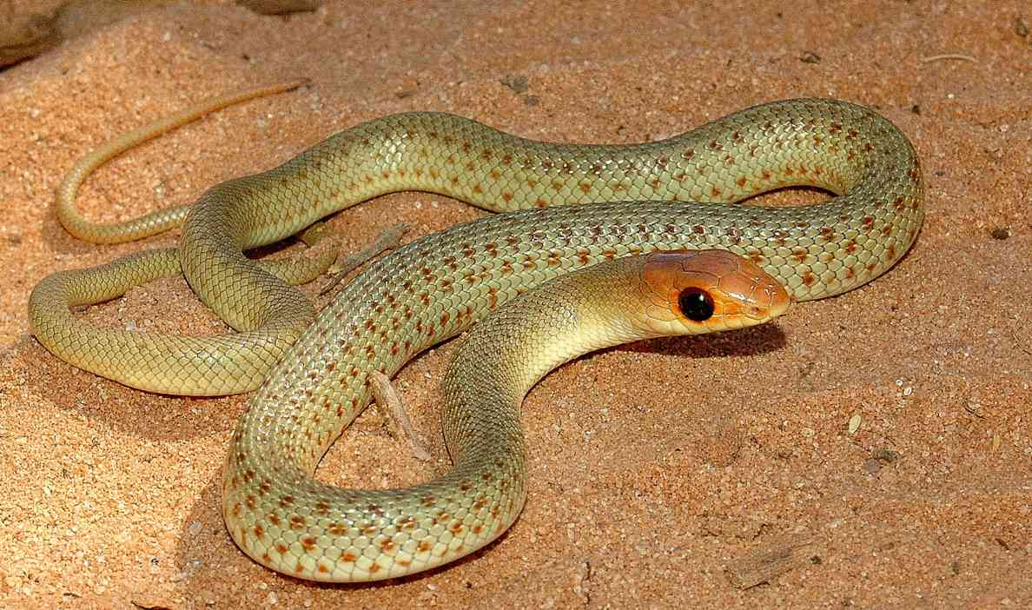
Natural History: Like the rufous beaked-snake, it is a secretive diurnal rear-fanged snake, and very fast moving, with quick jerky body and head movements. If stressed, it may elevate its body and flatten the neck, like a rufous beaked-snake. It spends a lot of its time in holes, hunting its prey, and when inactive shelters there, or in squirrel warrens, abandoned termitaria etc. It sometimes climbs into low bushes and trees. One was active in a barren lava field in the Dida-Galgalu desert in the middle of the day. Males have been observed neck wrestling. Doesn’t seem to be particularly common anywhere, with the exception of parts of the Kenya coast. A clutch of eight eggs has been recorded. Diet includes rodents and lizards.
Medical Significance: Bites to ordinary people by this snake are unlikely, as they are alert, fast moving and non-aggressive. Snake keepers report that this snake virtually never tries to bite, and nothing is known of the venom, but it is a fairly large snake, so bites are best avoided.
Illustrations: Watamu (top, upper middle), Lake Turkana (lower middle, © Eduardo Razzetti), juvenile near Haygeysa, Somaliland (bottom, © Tomas Mazuch).

